
MONASH HEALTHCARE INNOVATION SUMMER SCHOLARSHIPS (HISS)
PROJECT NAME: SeeSaw
DELIVERABLES NUMBER: 3
PROJECT LEAD: Anantyash Dixit
Stakeholder Map
Link: https://miro.com/app/board/uXjVP5Nbq7Y=/ *please note: the stakeholder map is next to the systems map*
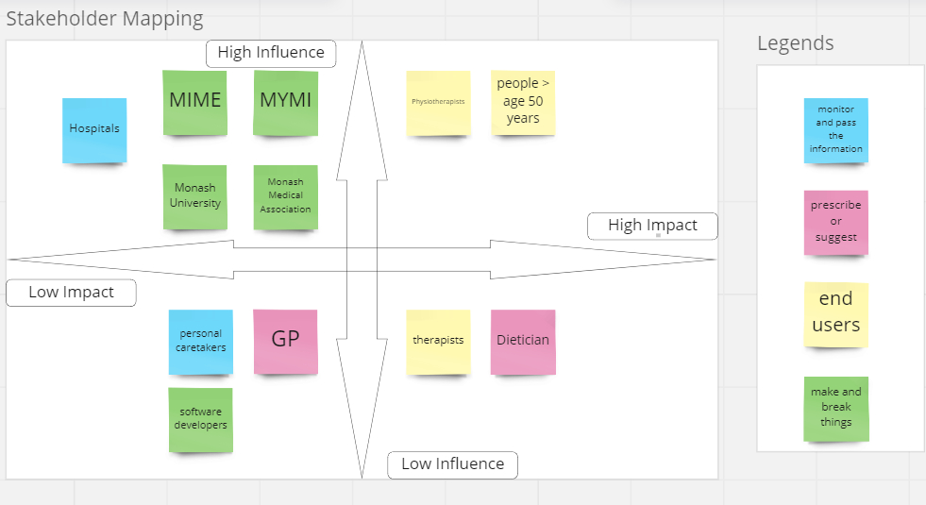

Systems Map

Link: https://miro.com/app/board/uXjVP6krBzI=/
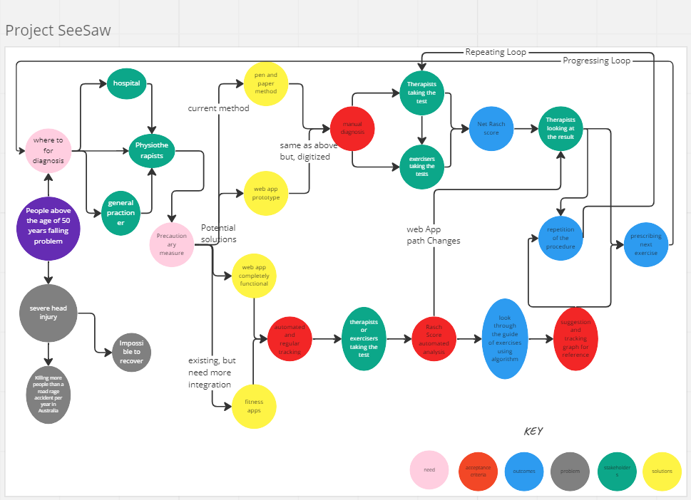

Solutions Ideation

- Criteria #1: The Solution will allow the clinicians and trainers to gain an insight about the progress of the exerciser - Progress and score tracking

- Criteria #2:The Solution will create a better way to store data on cloud services or servers;

- Criteria #3: The Solution will ease the process of taking tests with an interactive UI/UX - visual aids and images with questions for better demonstration(BIS-E);

- Criteria #4: The Solution will create a huge database to study and Improve the Scale(BIS-T)

- Criteria #5: The Solution will create a universal use and integration of information

- Criteria #6: The Solution will also Minimize the need for 2 or more people to complete the test for the individual - Exerciser will be able to take the test on its own

- Criteria #7: The Solution will aim contribute to the making of an ideal Balance Exercise Guide for Older People

Completely Addresses Criteria = Green
Partially Addresses Criteria = Yellow
Does Not Address Criteria = RedRe

 | Selection/Acceptance Criteria
Solution Description | Criteria #1 | Criteria #2 | Criteria #3 | Criteria #4 | Criteria #5 | Criteria #6 | Criteria #7
- A pen-paper based method to calculate the Rasch Score. | YelYellowYellowYellowlo | YelYellowYellowYellowlo | YelYellowYellowYellowlo | YelYellowYellowYellowlo | YelYellowYellowYellowlo | YelYellowYellowYellowlo | YelYellowYellowYellowlo
- A query based solution with friendly user interface. | YelYellowYellowYellowlo | YelYellowYellowYellowlo | YelYellowYellowYellowlo | YelYellowYellowYellowlo | YelYellowYellowYellowlo | YelYellowYellowYellowlo | YelYellowYellowYellowlo
- Google forms that are connected to an HTML based form links the data to a spreadsheet | YelYellowYellowYellowlo | YelYellowYellowYellowlo | YelYellowYellowYellowlo | YelYellowYellowYellowlo | YelYellowYellowYellowlo | YelYellowYellowYellowlo | YelYellowYellowYellowlo
- A Gyroscopic weighing machine, measures the real time weight, height and balance | YelYellowYellowYellowlo | YelYellowYellowYellowlo | YelYellowYellowYellowlo | YelYellowYellowYellowlo | YelYellowYellowYellowlo | YelYellowYellowYellowlo | YelYellowYellowYellowlo
- A Fitness Tracker, with the help of a device tracks your daily activity and show progress | YelYellowYellowYellowlo | YelYellowYellowYellowlo | YelYellowYellowYellowlo | YelYellowYellowYellowlo | YelYellowYellowYellowlo | YelYellowYellowYellowlo | YelYellowYellowYellowlo
- A personal caretaker, to observe and prevent people from falling | YelYellowYellowYellowlo | YelYellowYellowYellowlo | YelYellowYellowYellowlo | YelYellowYellowYellowlo | YelYellowYellowYellowlo | YelYellowYellowYellowlo | YelYellowYellowYellowlo
- An AI Based video processing software, observe and visualize the balancing using a 3D cam. | YelYellowYellowYellowlo | YelYellowYellowYellowlo | YelYellowYellowYellowlo | YelYellowYellowYellowlo | YelYellowYellowYellowlo | YelYellowYellowYellowlo | YelYellowYellowYellowlo
- A “Kinect joystic” with a joystic, recommend and run test to estimate the balancing ability of an individual. | YelYellowYellowYellowlo | YelYellowYellowYellowlo | YelYellowYellowYellowlo | YelYellowYellowYellowlo | YelYellowYellowYellowlo | YelYellowYellowYellowlo | YelYellowYellowYellowlo
- App on to help therapists see the calculated score from BIS. | YelYellowYellowYellowlo | YelYellowYellowYellowlo | YelYellowYellowYellowlo | YelYellowYellowYellowlo | YelYellowYellowYellowlo | YelYellowYellowYellowlo | YelYellowYellowYellowlo
- An integration with psych app to train individuals for balancing. | YelYellowYellowYellowlo | YelYellowYellowYellowlo | YelYellowYellowYellowlo | YelYellowYellowYellowlo | YelYellowYellowYellowlo | YelYellowYellowYellowlo | YelYellowYellowYellowlo

