
MONASH HEALTHCARE INNOVATION SUMMER SCHOLARSHIPS (HISS)
PROJECT NAME: RELAY
DELIVERABLES NUMBER: 4
PROJECT LEAD: MARIA ZARCO-VERA
Stakeholder map

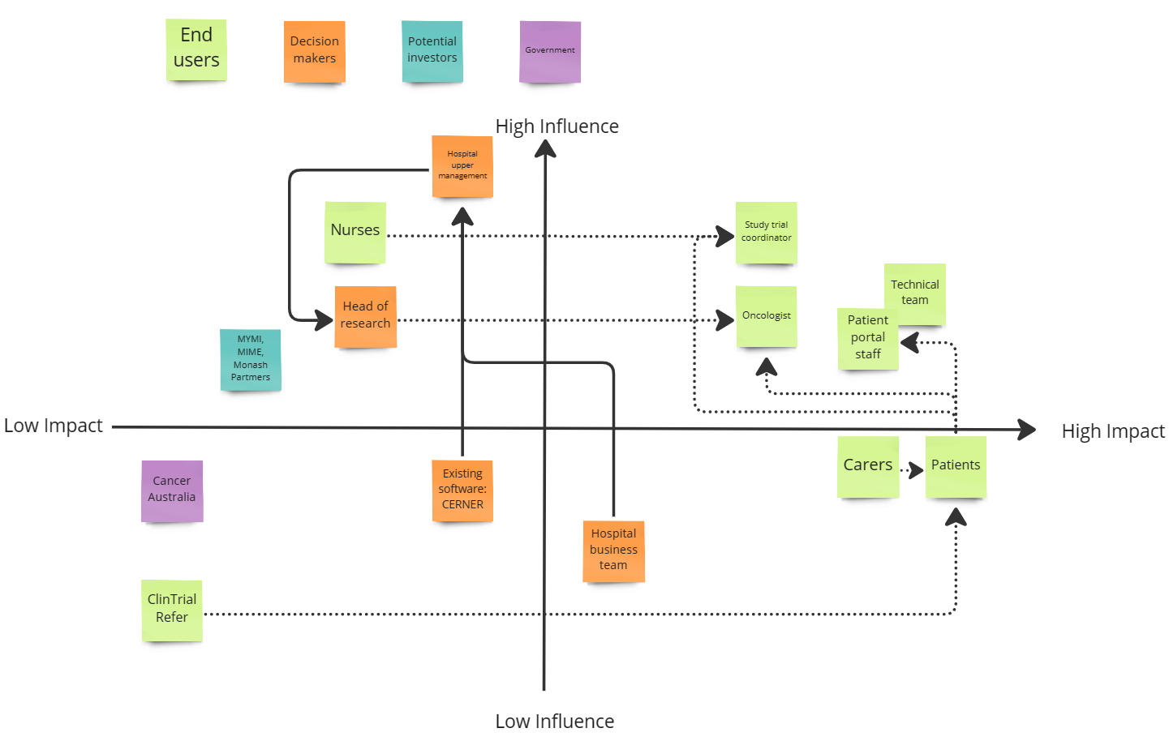

Systems map
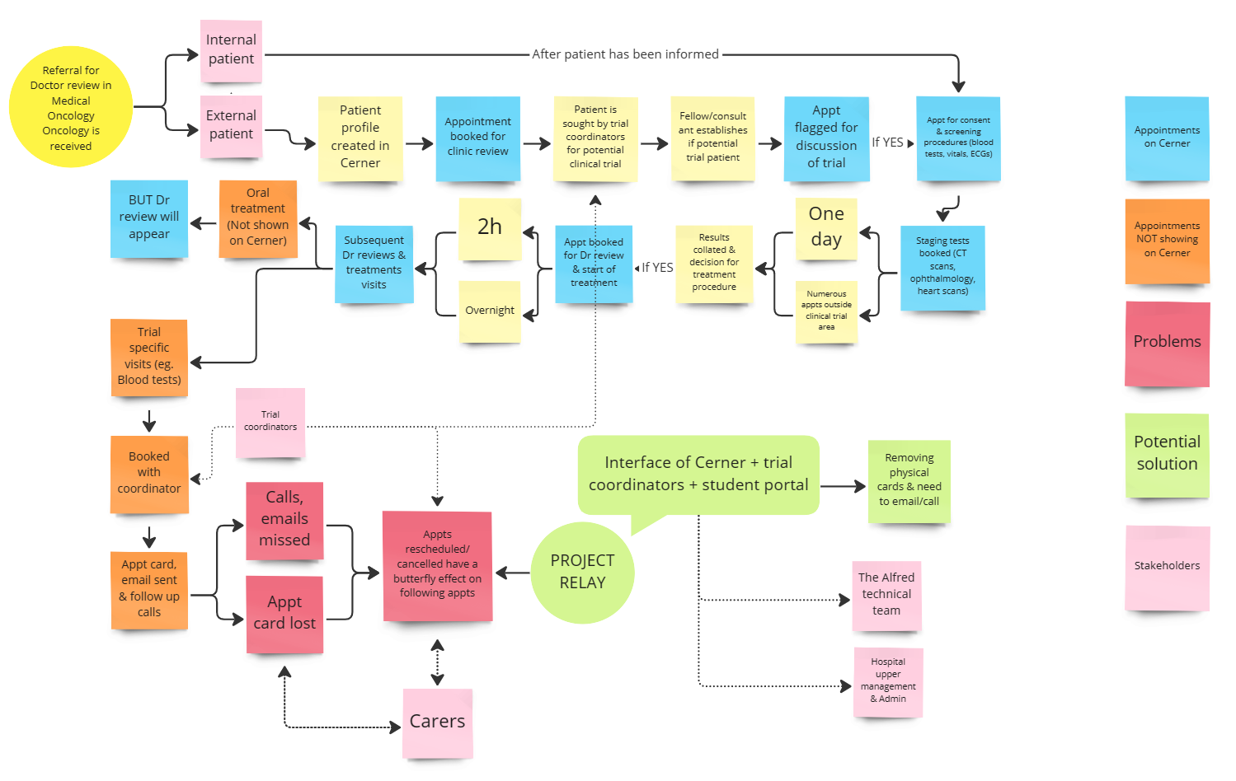

Solutions ideation

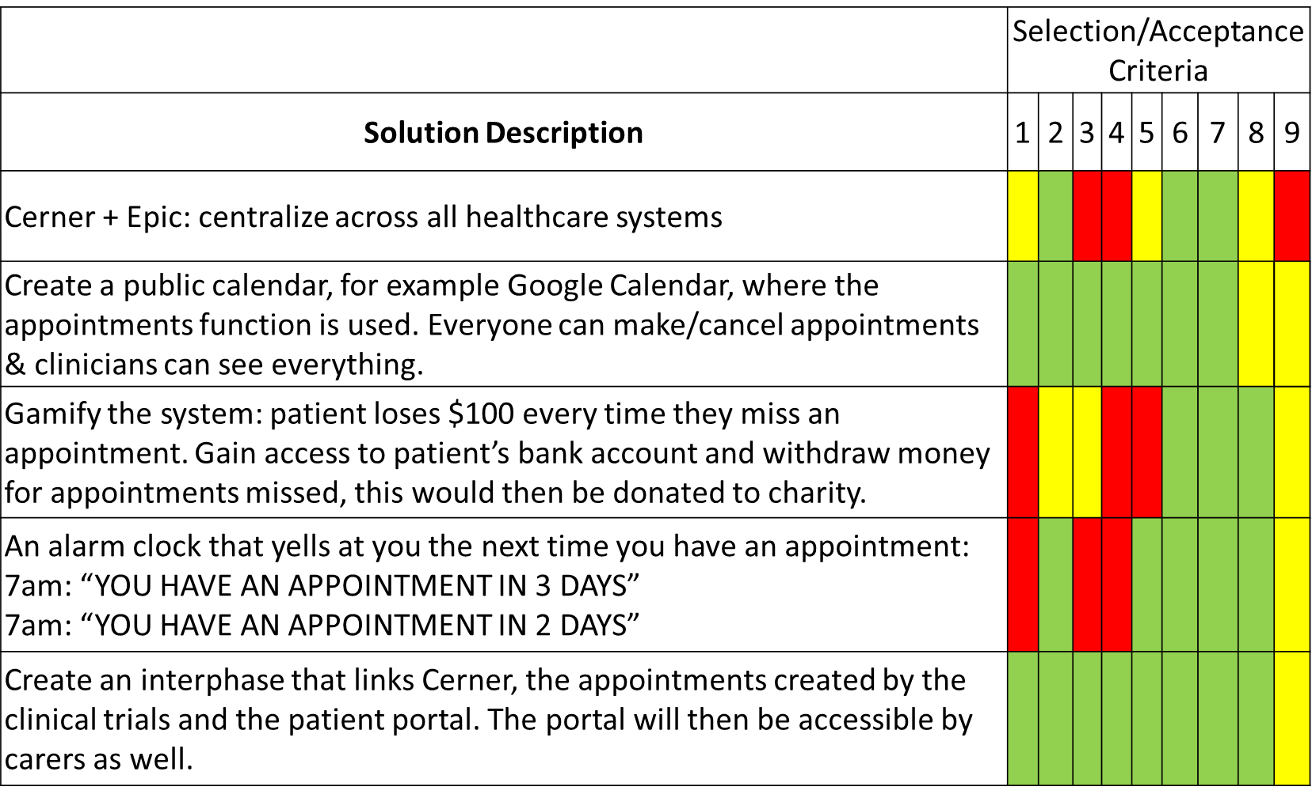

Acceptance Criteria

- The solution will lift the stress of missing appointments as well as prevent confusion related to miscommunication.
- The solution will be accessible by more than 50% of patients thus increasing the number of participants completing the clinical trials on time.
- The solution will be accessible by carers, as well as the patients themselves and study coordinators.
- The solution will decrease the repetitive workload imposed on clinical trial coordinators
- The solution will be intuitive and have a simple user interface personalised to the physical and mental barriers of the demographic.
- The solution must meet the target size of 75-100 patients per year, as well as the study coordinators involved.
- The solution must be scalable to other clinical trials at The Alfred, as well as its Partners and other hospitals in Victoria.
- The solution must include criteria that differentiates it from other appointment systems.
- The solution implementation should fit the capabilities of the project members

