
MONASH HEALTHCARE INNOVATION SUMMER SCHOLARSHIPS (HISS)
PROJECT NAME: Project Prompt
DELIVERABLES NUMBER: 3
PROJECT LEAD: Nicole Chek
Stakeholder map
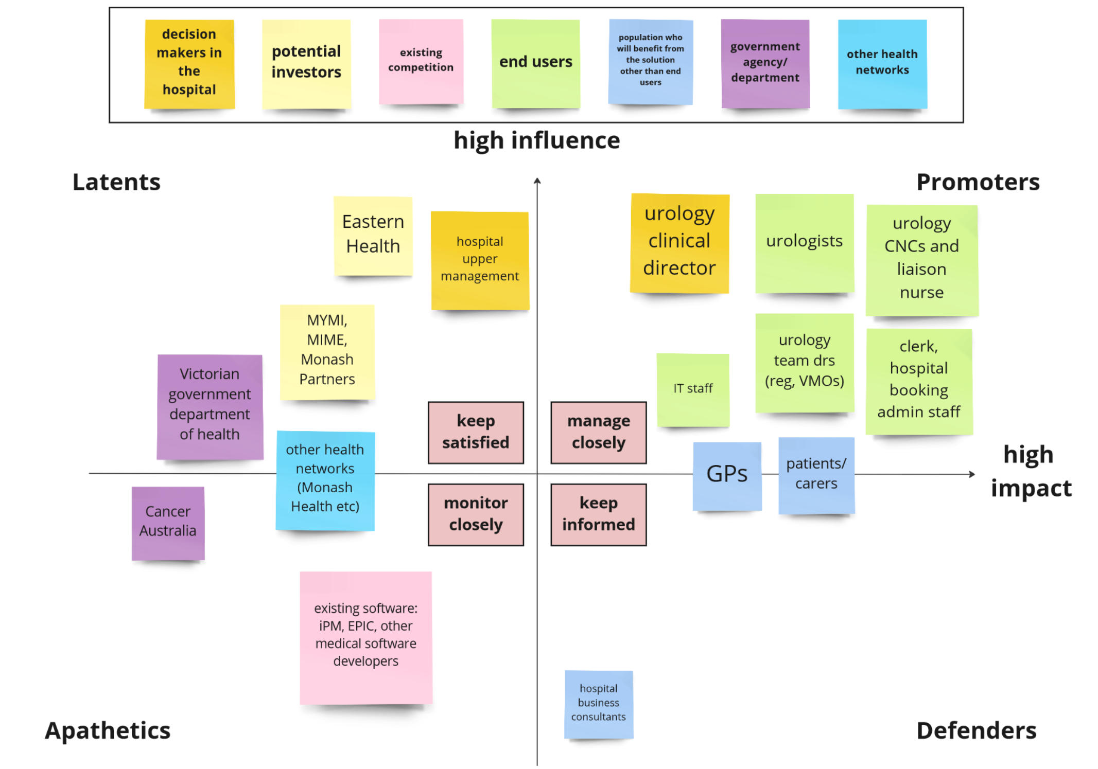

Systems map

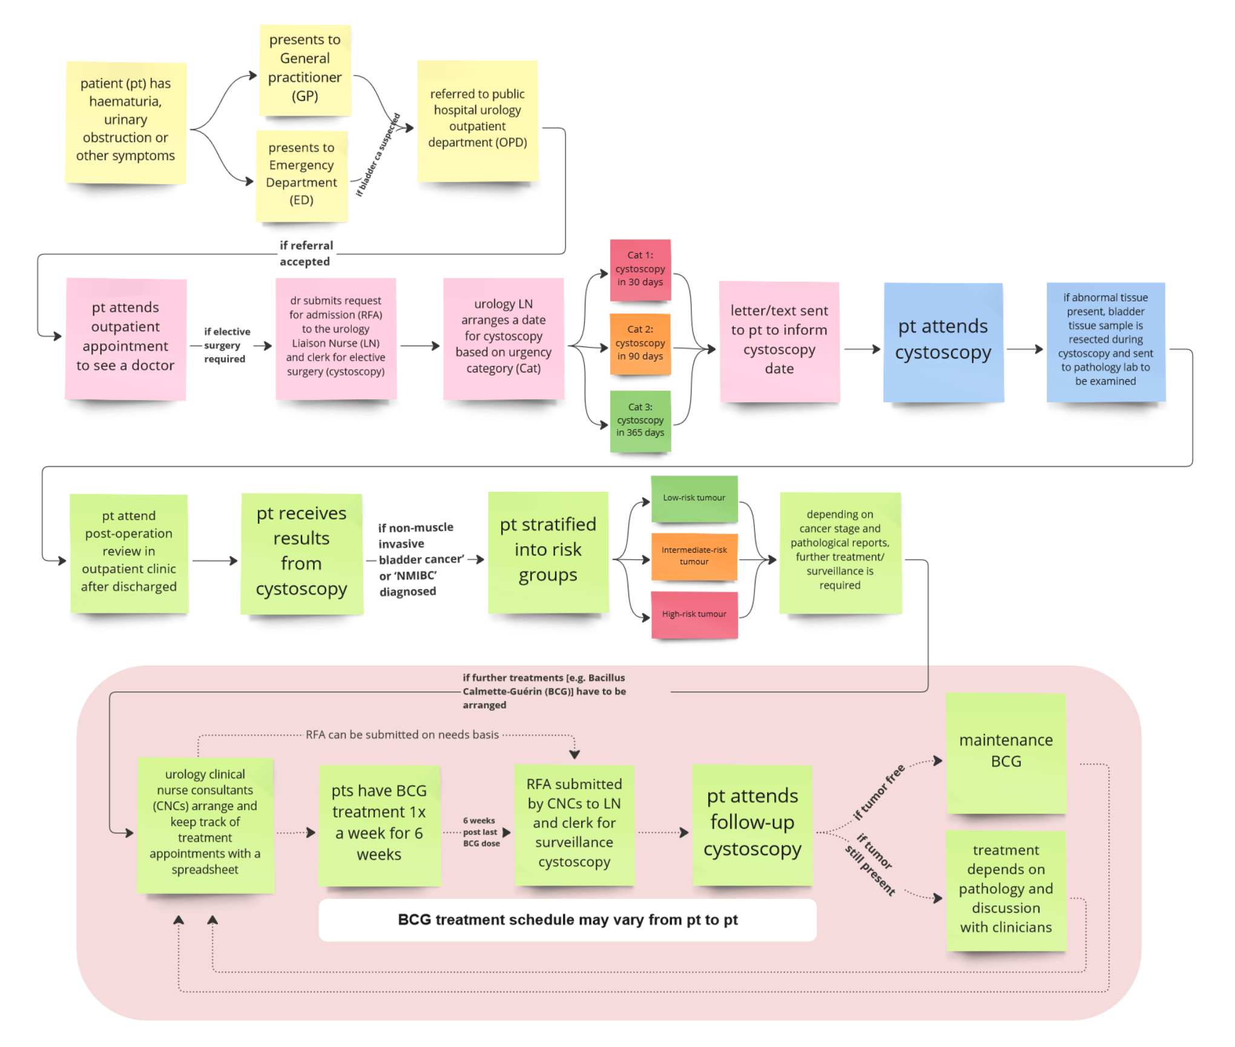

Solutions ideation
Acceptance Criteria
- Easy for the treating team to use and track patients’ treatment appointments.
- More affordable compared to current solutions.
- More accessible compared to current solutions.
- More efficient compared to current methods.
- Can be integrated into existing electronic systems (e.g. digital patient charts).
- Reduce missed or delayed appointments.
- Treatment schedule is shareable between urology team, GPs, patients and carers.
- Solution ensures the appointment schedule is tailored to each patient based on the cancer stage and pathology report.

Meets acceptance criteria
Partially meets acceptance criteria
Does not meet acceptance criteria
Not relevant to the acceptance criteria

Selection/
Acceptance Criteria
Solution Description | #1 | #2 | #3 | #4 | #5 | #6 | #7
1. A single apointment booking system for the urology team to key in and track outpatient appointment dates from the point when patients are referred to the team until they are formally discharged after undergoing appropriate treatment and surveillance follow-ups.
- The software should have a better UI and is easier to use compared to a spreadsheet.
- The system should also have a function to predict the treatment dates based on a patient's cancer type and stage.
2. An electronic tool (like a BMI calculator) that uses an algorithm to come up with specific dates of appointments after clinicians input a patient's cancer stage and pathology report finding. The tool should generate an individualised plan that can be shared between the treating team, cancer patients and carers.
- Pretty much like the tool in Idea #3, but more individualised.
3. Urology team liaise with Peter Mac Callum Cancer Centre to include bladder cancer in their care plan generator.
- Patients or clinicians can input the type and stage of cancer and the treatments they are receiving. Then, a care plan with a general follow-up schedule is generated.
- However, the follow-up plan is generalised so it may not be suitable for certain patients.
- The care plan generator does not have an option to create a care plan for bladder cancer at this stage.
- As the care plan generator is available to the public and not linked to the hospital's system, nurses have to save the follow-up schedule in the patient's file manually.
- Link to care plan generator: https://www.mycareplan.org.au/
4. Use AI to read patients' files to come up with a complete and individualised care plan.
- The care plan should be updated automatically should there be any changes in the treatment or pathology reports.
- However, there are a lot of privacy issues as it involves patient information.
5. Hire third party companies to create individualised treatment schedules on behalf of the urology team for each patient.
6. Urology team (including doctors, nurses and admin) have regular meetings to review bladder cancer patients treatment appointments.
7. Clinicians keep physical journals (e.g. diary) to record and keep track of patients’ appointments.
8. Online calendar that clinicians can manually enter patient information and keep track of treatment appointments.
9. (Current method) Urology clinical nurse consultants (CNCs) manually key in and track treatment appointments on a spreadsheet based on patient’s pathology reports.
- They have to refer back to this spreadsheet to make sure that they do not miss any patient's appointments.
- There have been situations when the nurses missed a few patients, resulting in missed or delayed treatments. The spreadsheet also does not have any formula to help calculate the next appointment date, so the nurses have to look at the calendar to figure when the next date for treatment is.
- As the spreadsheet is on a shared drive, there is a risk that the spreadsheet can be deleted. accidentally by other people.
- There were also cases when people not involved in a patient's care have tweaked information on the spreadsheet, which could potentially lead to problems such as patients being given the wrong appointment dates or they might miss their appointment entirely if the nurses are not aware of the change.
10. Include formulas in the spreadsheet so that the next treatment dates are calculated and displayed automatically. This will provide the treating team and patients a more accurate idea on when the next appointments are and can plan accordingly.
11. Create an electronic tool that is integrated into iPM to alert clinicians automatically when appointments are due. For example, clinicians will be alerted 2 or 5 days prior to a patient's appointment.
- This solution is not very relevant to the problem currently. However, it can serve as a function to reduce missed or delayed appointments.
12. Patients work out the dates of their next appointments themselves.
- They have to ring up the hospital to remind clinicians regarding their next appointment. *This is a very bad idea*
13. Hire someone to audit the spreadsheet regularly to check the appointment dates and ensure appointments are not missed.
14. A paper template with a guide for clinicians to decide the next treatment dates. The clinician has to complete the form by hand. The form template can then be photocopied and shared with GPs/patients/carers.
15. A digital template with a guide for clinicians to decide next treatment dates. The clinician can complete the form electronically. The completed form can then be saved electronically in the patient's file and shared with GPs/patients/carers.

