
MONASH HEALTHCARE INNOVATION SUMMER SCHOLARSHIPS (HISS)
PROJECT NAME: Project Pluto
DELIVERABLES NUMBER: 3
PROJECT LEAD: Lloyd Lok

Stakeholder map
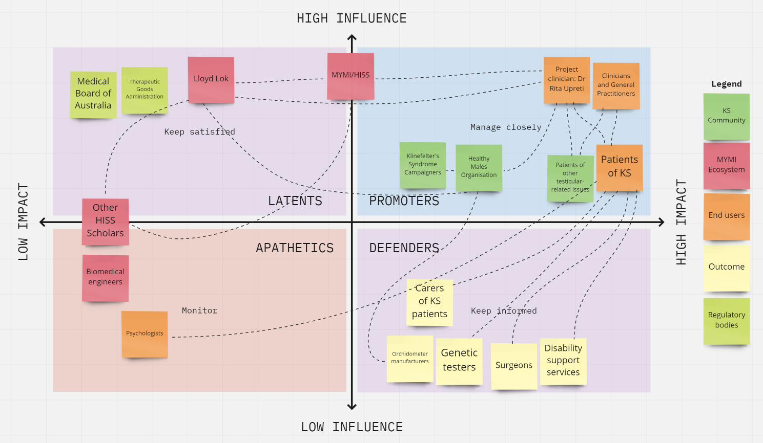

Systems map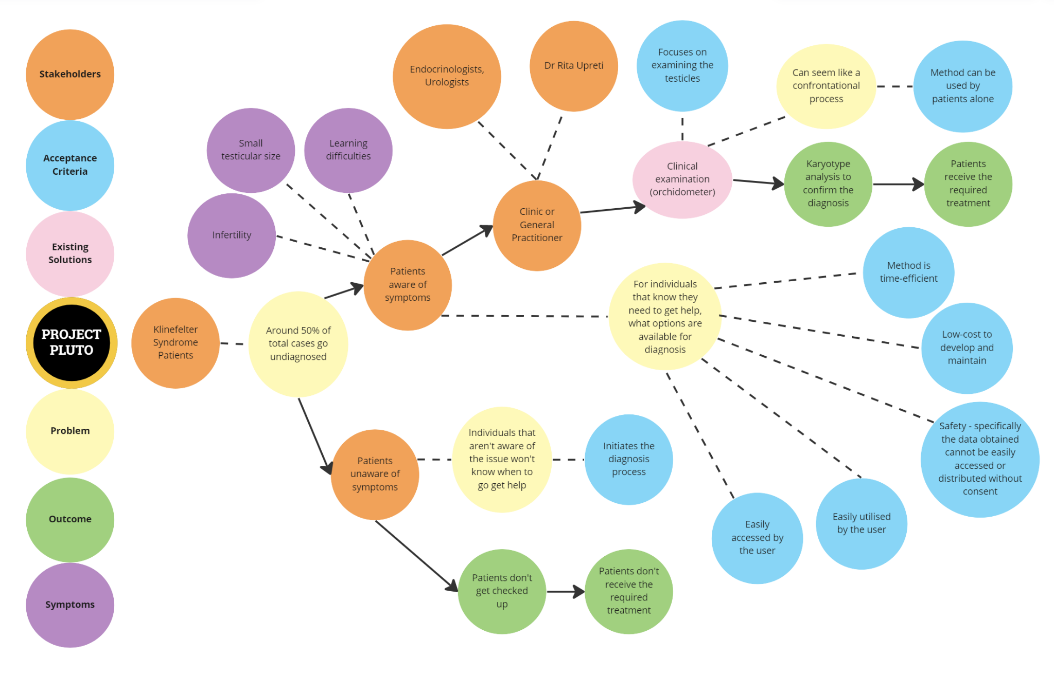
Solutions ideation
These solutions don’t target the awareness aspect of Klinefelter’s patients directly. Instead, these solutions can be promoted through the awareness tools, in order to inform patients of other simple methods that could be used to initiate diagnosis. This would target those undiagnosed patients who just want a different method of initial diagnosis. It is also important to note that the portion of undiagnosed patients that are unaware will be hard to target; the primary method of reaching them really just being through awareness campaigns.

Acceptance Criteria
- The solution will effectively initiate the diagnosis process.
- The solution is less confrontational and can be used by patients alone.
- The solution can be easily accessed by the user.
- The solution can be easily utilized by the user.
- The solution is safe, specifically the data obtained cannot be easily accessed or distributed without consent.
- The solution focuses on examining the testicles.
- The solution is low-cost to develop and maintain.
- The solution is time-efficient for the user.

 | Selection/Acceptance Criteria
Solution Description | Criteria #1 | Criteria #2 | Criteria #3 | Criteria #4 | Criteria #5 | Criteria #6 | Criteria #7 | Criteria #8
- App that provides step-by-step instruction on self-diagnosis process
  - How to complete genital examination.
- Testicular size estimation app that'll provide indication whether further steps should be taken
  - This method would be used by patients
- Testicular size estimation devices that can be used by doctors in the clinic
- A potential clinical decision support system that'll ask about some common first symptoms of KS patients
  - It will work like a calculator, used by the patient
- KS tests packages made available to purchase, containing a cheap orchidometer and instruction guide on how to measure
- Current method: genital examination
  - Visit clinics for a check-up
- Guide patients how to complete an examination at the clinic
  - Individual can get a thorough explanation from clinician/GP so that they can try to examine themselves in separate room
- An online chatbot, that contains many FAQs and how-tos for self-diagnosis of KS
- Improving telehealth consults so that patients can do examinations from home and in their own comfort
  - Obtain an orchidometer, and go through step by step process over the phone
- Promotional devices or objects that are oval/egg shape that can be given out so individuals can have an idea whether their testicles are abnormal size
  - Potentially soap
- Prenatal screening processes at birth
  - Karyotype analysis
- A instrument similar to a calliper which can be used instead of an orchidometer at the clinic
- Patient journey brochures/comics that patients can follow
- Make ultrasound more readily available at clinics
- Sexual intercourse toy which can give better representation of testicular size
- An outline sticker that can be stuck on a mirror
  - Patient stands a certain distance from the mirror and testicular size is determined to be normal, or smaller than usual
- Enforcing military obligations on young Australians, requiring medical examinations
- Disability support or learning support services should encourage young patients to obtain karyotype
- Clinics have free orchidometer to provide patients with, to use for initial diagnosis

