
MONASH HEALTHCARE INNOVATION SUMMER SCHOLARSHIPS (HISS)
PROJECT NAME: Nephros
DELIVERABLES NUMBER: 3
PROJECT LEAD: Nandini & Upani

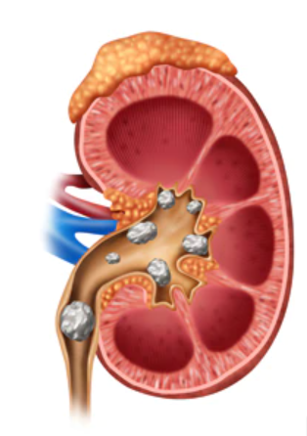

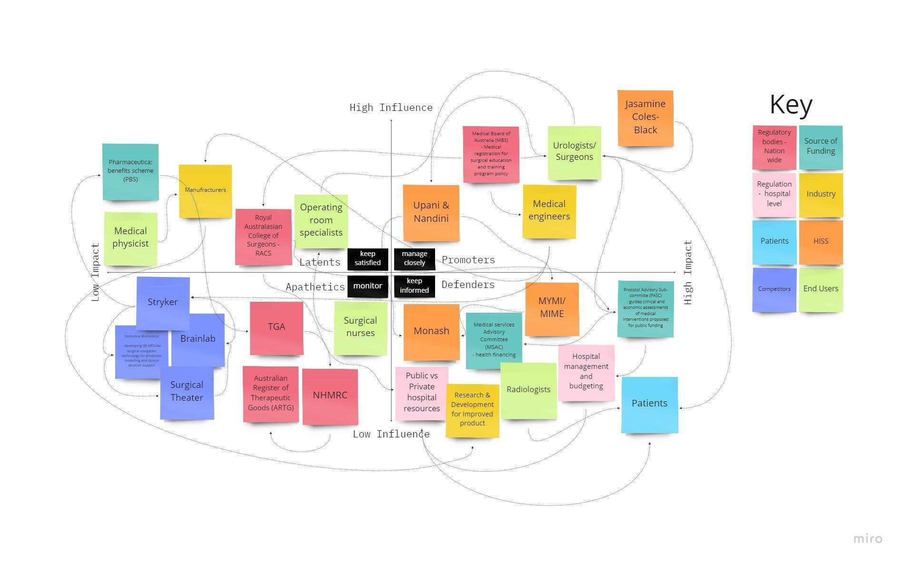
Stakeholder map
Systems map
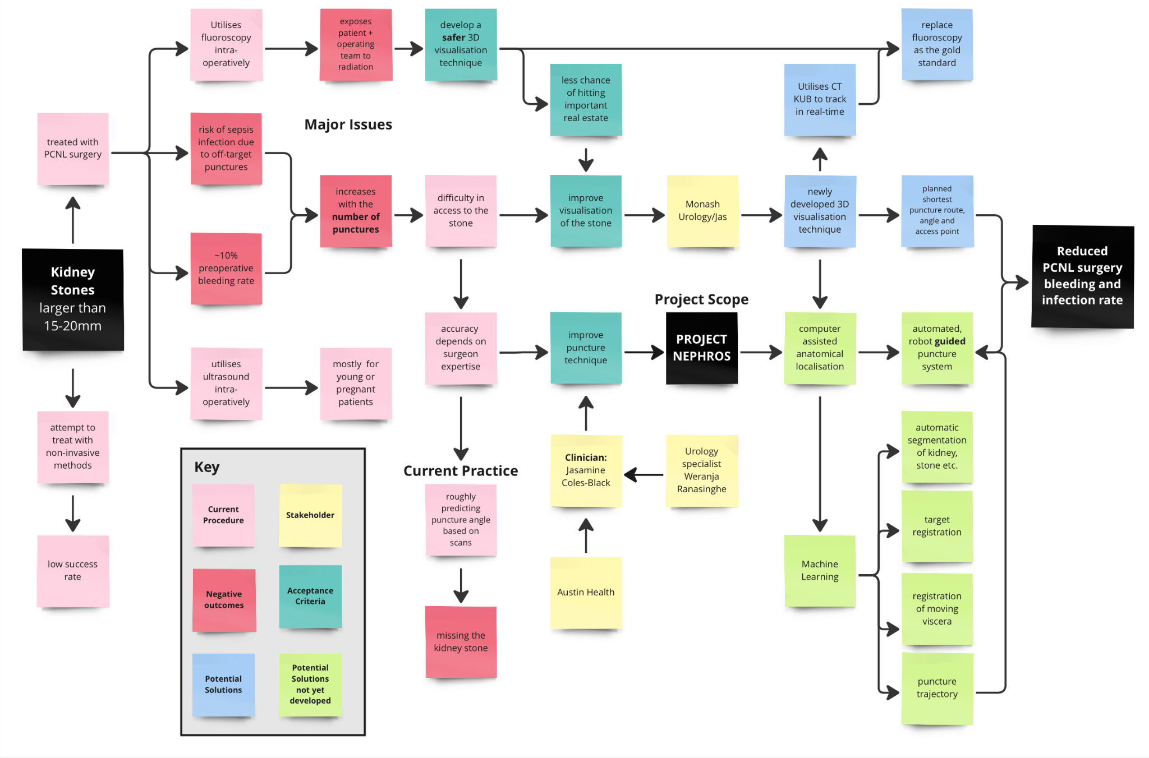

Solutions ideation:

Acceptance Criteria
- The solution will reduce the need for multiple punctures
- The solution will reduce levels of sepsis and bleeding rates.
- The solution will be easily incorporated into the existing healthcare system.
- The solution will allow surgeons to navigate real-time visuals of the kidney
- The solution will allow 3D visualisation, register stone location and plan the most optimal route of puncture.
- The solution is used with a visualisation technique that represents the size of the kidney stone accurately.
- The solution reduces operator dependency, increasing surgical confidence.
- The solution will be time neutral, result in lesser subsequent visits to the hospital for the patient due to decreased postoperative complications
- The solution will reduce radiation exposure for the patient and/or operating team.
Key:
Fulfils acceptance criteria
Somewhat fulfils acceptance criteria
Barely/does not fulfil acceptance criteria
Not applicable to solution

 | Selection/Acceptance Criteria
Solution Description | Criteria #1 | Criteria #2 | Criteria #3 | Criteria #4 | Criteria #5 | Criteria #6 | Criteria #7 | Criteria #8 | Criteria #9
- Current procedure
- Uses fluoroscopy to visualise the anatomy during PCNL surgery
- Real-time visualization during surgery
- 2D imaging technique, single x-rays
- exposes both patient and operating team to radiation
- It is relatively cheap to conduct
- Puncture accuracy is dependent on surgeon expertise, generally guesswork based on diagnostic CT scans

- Proposed solution - 3D visualisation + stereotactic surgical guidance
- Utilises the CT KUB reconstructed 3D visualisation technique created by Monash Urology
- Real-time imaging
- 3D imaging
- Exposes patient to radiation, but not operating team
- stereotactic system reduces operator dependency
- stereotactic system can utilise CT based imaging as well
- Current visualisation + stereotactic surgical guidance
- Uses fluoroscopy to visualise the anatomy during PCNL surgery
- Real-time visualization during surgery
- 2D imaging technique, single x-rays
- exposes both patient and operating team to radiation
- stereotactic system reduces operator dependency
- 3D visualisation + current puncturing method
- Utilises the CT KUB reconstructed 3D visualisation technique created by Monash Urology
- Real-time imaging
- 3D imaging
- Exposes patient to radiation, but not operating team
- puncture accuracy is dependent on surgeon expertise, generally guesswork based on CT scans
- Overall advantage of better imaging will give a better idea of the location of the stone
- Ultrasound visualisation + current punctuation method
- Uses ultrasounds to visualise the anatomy during PCNL surgery
- Real-time visualization during surgery
- 2D imaging technique
- Puncture accuracy is dependent on surgeon expertise, generally guesswork based on diagnostic CT scans
- Use highly targeted electromagnetic radiation to precisely break up the stone and reduce need for intraoperative maneuvering

Less maneuvering will decrease the risk of bleeding. However radiation may damage surrounding tissue and internal structures.

- Tissue bleeding
- A small piece of body safe material at the end of the probe that can balloon out to apply pressure to adjacent tissue to prevent tissue bleeding.
- Balloon retracts when bleeding stops due to clotting (timing determined by operating team) and the probe is pulled out of the keyhole puncture
- Bleeding and sepsis prevention/treatment
- Increase postoperative antibiotics or treatments to prevent sepsis infection
- Prescribing blood-clotting factors to reduce hemorrhaging post operatively
- On the tip of the needle add thermal element to stop bleeding - current standard of care (heat clots blood)
- Make a detector that makes a high frequency sound as the end of the probe approaches the kidney stone
Use a detector specific for the components of the stone. e.g. calcium. Probe beeps at a higher frequency and volume as the probe gets to the constituents of the stone
- Develop a drug to break down kidney stones - no more kidney stones
- Drug that can be delivered through surgical tube (trocar) directly to the stone location
- Drug will target large masses of calcium and mineral deposits
- Remove the affected kidney - with the entire stone

