
MONASH HEALTHCARE INNOVATION SUMMER SCHOLARSHIPS (HISS)
PROJECT NAME: NEMO
DELIVERABLES NUMBER: 3
PROJECT LEAD: David Levitz & Vishnu Sivakumar
Stakeholder map

Please refer to the next page.

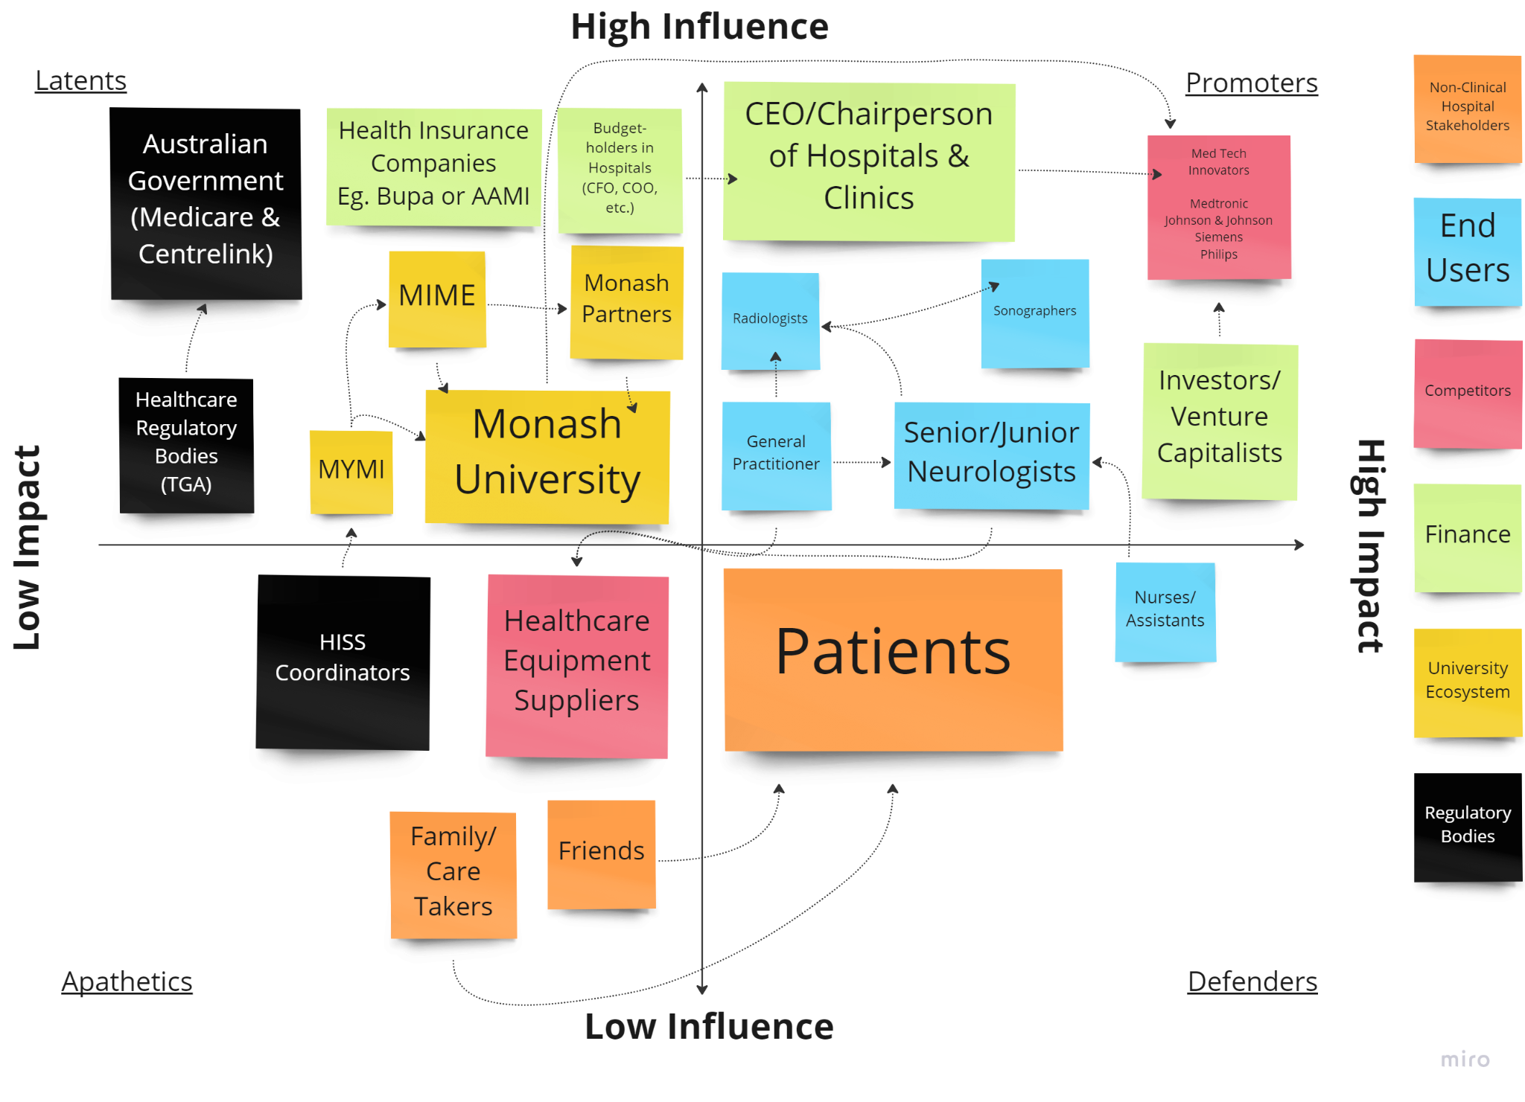

Stakeholder, Online Whiteboard for Visual Collaboration (miro.com)
Systems map
[insert systems map here, ideally page-long to ensure legibility]
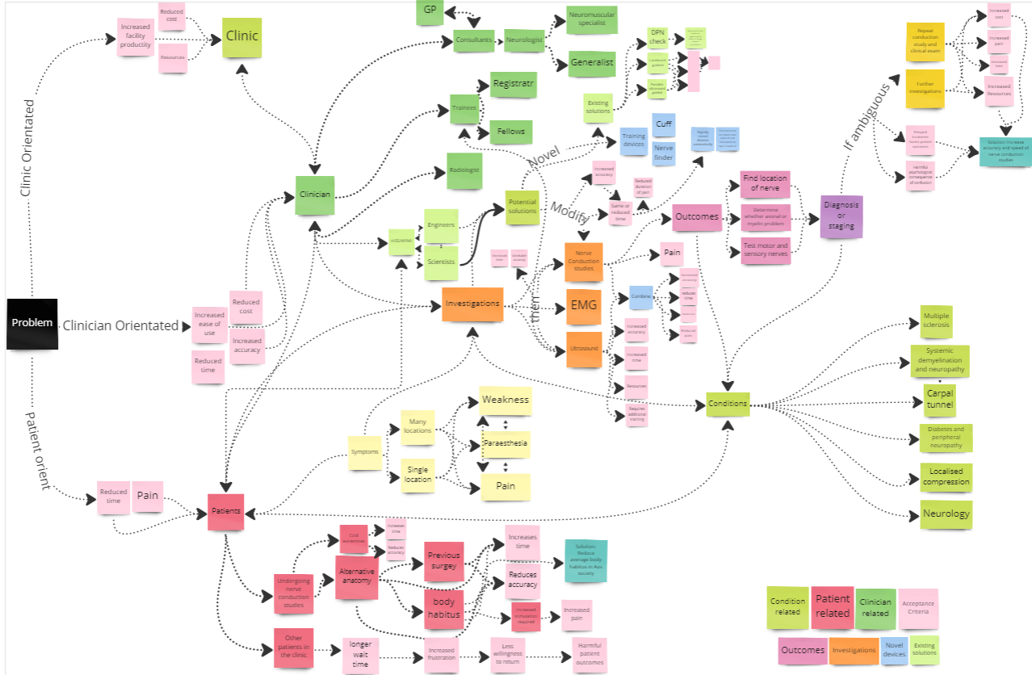
Easier to be viewed on the micro: HISS 2022/2023, Online Whiteboard for Visual Collaboration (miro.com)
Solutions ideation
[feel free to use template below, or choose alternative based on legibility]

 | Selection/Acceptance Criteria
Solution Description | Cost neutral (amber) /reducing (green) | Time neutral (amber) /reducing (green) | Doesn’t Require Additional Specialised Training | Reliability/Accuracy of Results | Patient Comfort | Ability to function effectively in patients with the difficult anatomy | Ease of use | Additional comments
- Landmark guided
- NCS accompanied with ultrasound
- Reversed Transducer Attachment
- Nerve Finder Using Light |  |  |  |  |  |  |  | Limitation is the nerves are buried deep an IR only penetrates superficially
- Stimulator Cuff and Recorder Cuff
- Stimulator cuff with positive feedback to the recorder cuff. Gradual increase in electrode intensity only of relevant nerves |  |  |  |  |  |  |  | Potentially to reduce pain: (Positive feedback -> Gradual increase of stimulation in electrodes that have been sensed by the receptor)
- Stimulator sleeve with recorder attached to the end
- Area mapper using ultrasound
- Ultrasound with markers on either side
- Ultrasound with one centralised marker
- NCS accompanied with MRI
- Population level lifestyle interventions to reduce rates of obesity |  |  |  |  |  | N.A.
- Digital roller to measure distance
- Measure electromagnetic waves transmitted secondary to the nerve conduction
- Insert needle to contact the nerve to confirm the location with paraesthesia
- Improve training by incorporating VR models to practise patients with difficult body habitus
- Measure impedance or resistance to localise position of nerve |  |  |  |  |  |  |  | Already somewhat used -> Look more into this
- Hire patients with difficult anatomy to attend training sessions for neurologists so they can have more practice
- Put a small electrode probe stimulator onto the skin to induce paraesthesia when over the nerve. Use this as a guidance of where to place the probe. Frees a hand as welll
- Look at history to put most difficult patients in room with most experienced clinician

