
MONASH HEALTHCARE INNOVATION SUMMER SCHOLARSHIPS (HISS)
PROJECT NAME: Project LYMB
DELIVERABLES NUMBER: 3
PROJECT LEAD: Mohairees Idzhan
Stakeholder map
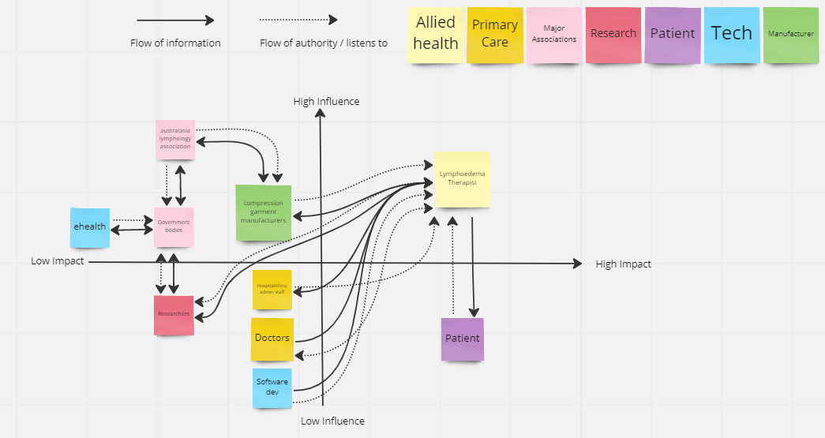

Systems Map
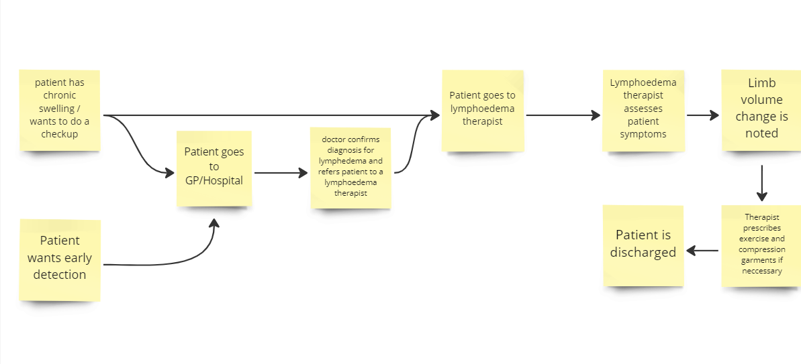

Solutions ideation

 | Selection/Acceptance Criteria
Solution Description | Criteria #1  Saves the clinician time | Criteria #2  Intuitive and easy to use UI/UX | Criteria #3  Easily integrate into clinician workflow | Criteria #4  Able to quickly filter through compression garment | Criteria #5  Facilitates diagnosis/treatment process | Criteria #6  Data can be visualised and represented well
- Lymbase.com
- SOZO Impedimed
- Pen and paper
- Electronic Medical Record
- Phone to scan and analyse patient limb
- CT-scan of limb
- 3D-visualisation of limb using AI and scanning through skin techniques
- Hire assistant to do measurements while clinician administers exercise
- Use bioimpedance spectroscopy to gather limb data
- Machine learning to predict suitable compression garment for patient
- “Smart”band around limb to automatically gather limb data
- Use water displacement to determine limb volume
- Dynamically adjustable compression garment
- Robotic device to measure limb fluid using compression
- Robotic device to measure limb dimension using lasers
- Calculator to determine appropriate compression garment size using limb size
- Suck out extracellular fluid from tissues with pump
- Remove hardened skin by filling it down
- Melt the hardened skin layer /dissolve it
- Make patient measure limb for themselves

