
MONASH HEALTHCARE INNOVATION SUMMER SCHOLARSHIPS (HISS)
PROJECT NAME: Project Impetus DELIVERABLES NUMBER: 3 PROJECT LEAD: Daniel Lin
Stakeholder map
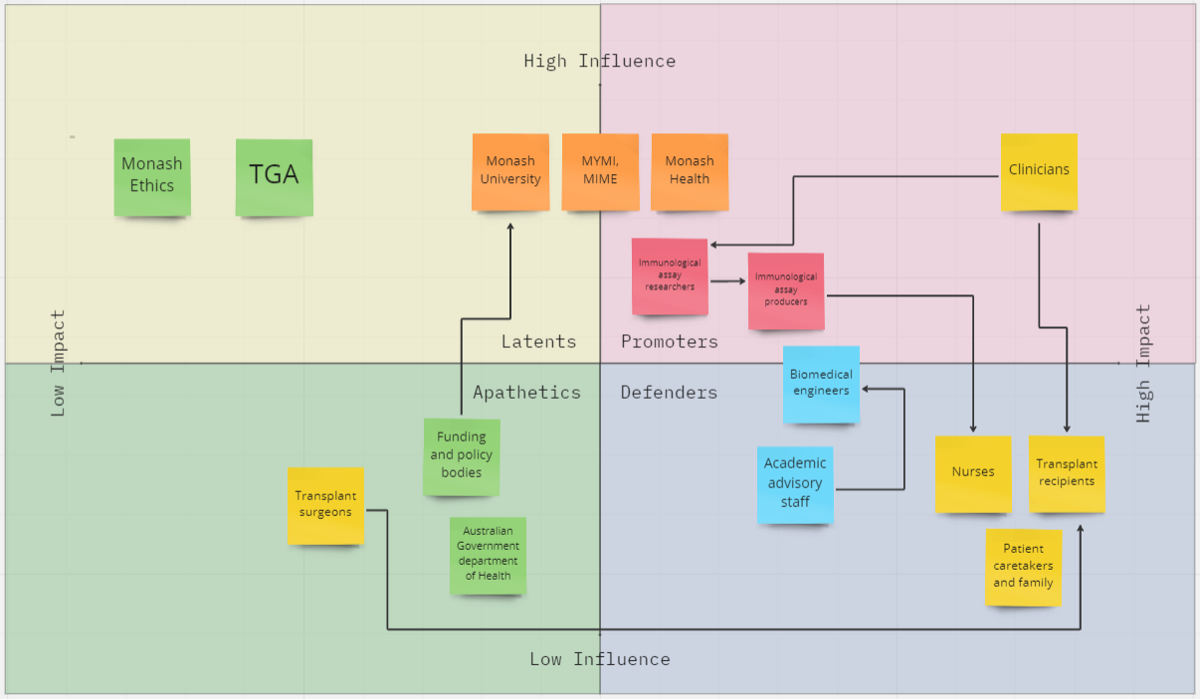
Systems map
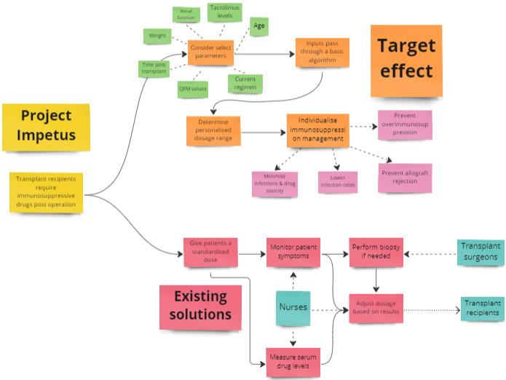

Solutions ideation

- Using the solution, clinicians should be able to determine a suitable range of immunosuppressants to prescribe a patient based on a set number of parameters
- The solution should have a basic functioning algorithm that can at least crudely relate the input parameters to an output range
- The solution should be able to identify patients at high risk for developing infections
- The solution should allow for more intensive clinical monitoring
- Implementation of the solution should result in lower rates of infections and rejection than current methods

Completely Addresses Criteria = Green
Partially Addresses Criteria = Yellow
Does Not Address Criteria = RedRe

 | Selection/Acceptance Criteria
Solution Description | Criteria #1 | Criteria #2 | Criteria #3 | Criteria #4 | Criteria #5
- Give a standardised initial dose and modify dosage over time based on patient symptoms
- Give a standardised initial dose and modify dosage over time based on drug serum levels
- Give a standardised initial dose and modify dosage over time based on monitoring drug serum levels and patient symptoms
- Develop a device that can continuously monitor drug serum levels in patients
- Develop an implant that continuously monitors serum drug levels in patients to allow for more freedom of movement
- Develop an implant that can monitor serum levels of multiple drugs in patients
- Modify dosage of a single drug based on measuring serum levels of an assay
- Modify dosage of a single drug based on measuring serum levels of multiple assays
- Modify dosage of multiple drugs based on measuring serum levels of an assay
- Modify dosage of multiple drugs based on measuring serum levels of multiple assays
- Use a pre-calculated table/dictionary of serum drug levels vs administered dosage to determine dosage
- Use organoids grown from patients’ stem cells as transplants to minimise graft rejection to minimise drug dosage and hence drug-related complications
- Investigate gene therapy approaches to modify protein expression on transplanted tissues to render local immunosuppression
- Manipulate dendritic cells in patients to promote tolerance induction
- Develop a medication that does not need to be personalised so patients can receive a standardised dose and the excess will be excreted dependent on patients’ individual factors
- Resort to surgical alternatives to transplantation
- Have a personal assistant monitor a transplant patient to look out for symptoms
- Give patient educational resources so they can look for symptoms themselves, and report them to their doctors

