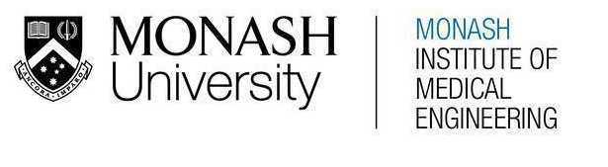
MONASH HEALTHCARE INNOVATION SUMMER SCHOLARSHIPS (HISS)
PROJECT NAME: Project Embrace
DELIVERABLES NUMBER: 3
PROJECT LEAD: Sue Liu

Stakeholder map

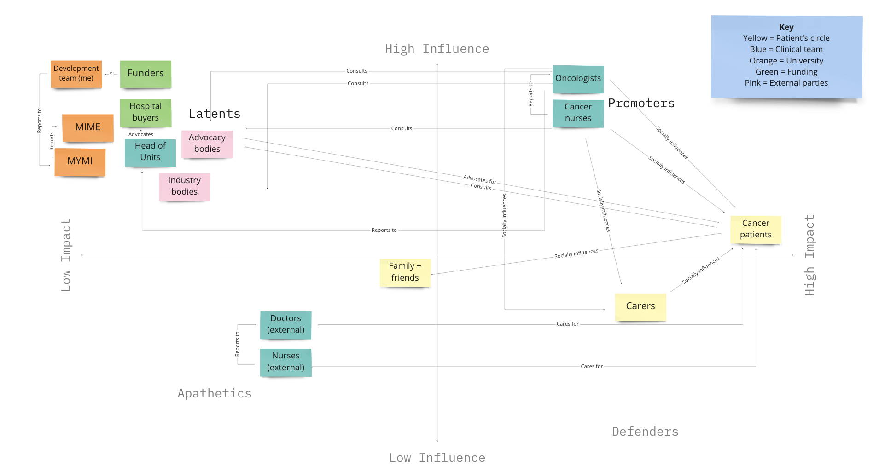

Systems map
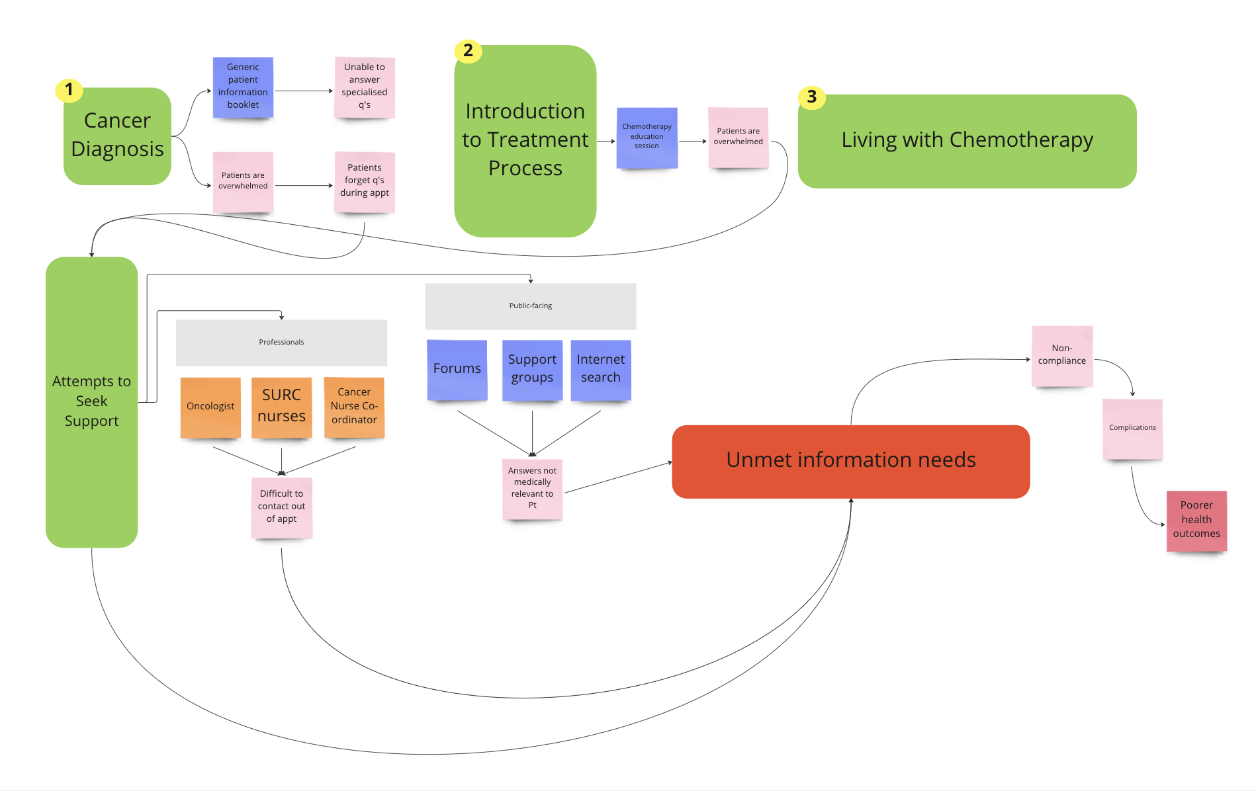

Solutions ideation

 | Selection/Acceptance Criteria
Solution Description | Increases patient confidence | Accessible via devices, Internet | Accessible to elderly and CALD | Information can be specific | Delivered by HCP | Easily integrated into workflow
- Patient emails team  Patient directly emails the treating team with any questions, treating team must monitor this inbox and reply | Y | Y | N – have limited tech access, team speaks primarily English | Y | Y | N – HCP don’t have time to monitor inboxes
- Patient phones team  Patient directly phones the treating team with any questions, treating team must be able to pick up phone within reasonable time and reply | Y | Y | N – have limited tech access, team speaks primarily English | Y | Y | N – HCP don’t have time to take extra calls
- Monthly “Town Hall” on Zoom for patients  Clinic hosts monthly video call with all current patients who can ask questions and have them answered live | Y | Y | N – have limited tech access, team speaks primarily English | Y | Y | Y
- Patient Facebook group  Patients can be added to a Facebook group and post questions to be answered by other patients or the team | Y | Y | N – have limited tech access, team speaks primarily English | Y | Y | N – HCP don’t have time to monitor
- Q&A website run by Alfred team  Patients are able to ask questions on a similar format to Quora, which are answered by the clinical team and viewable by other patients | Y | Y | ? – can be translated, simple to click to access | N – can be generalised to make it accessible to the public | Y | Y – can do in their own time, question bank builds up
- FAQ document  Published document available in print form with pre-generated questions being answered by the clinical team | Y | Y | ? – can be translated, simple to click to access, can be printed | N | Y | Y – once off, but could be updated
- Chemotherapy education session run by nurses  Dedicated education session run by nurses in either a one-to-one or group format for patients who are preparing for chemotherapy | Y | Y – in-person, or can run online | Y – face-to-face format, can bring in translator | Y – patients can ask questions on the fly | Y | N
- 24/7 national helpline  Helpline run by healthcare professionals for patients to call to ask any questions they have | Y | Y | ? – could be translated, may have poor tech access | Y | Y | N
- FAQ website  Online website listing pre-generated questions being answered by the clinical team | Y | Y | ? – can be translated, can be printed if needed | N | Y | Y – once off, but could be updated as needed
- Encrypted patient-doctor messaging application  Patients can privately message the clinical team who reply – this may also include other features like appointment reminders | Y | Y – will need to download specific app + access to Internet | N – have limited tech access, team speaks primarily English (however could be translated) | Y | Y | N – HCP don’t have time to monitor
- Patient group chat with team  Patients are in a group chat to collaboratively discuss and ask questions from the clinical team. May have an “anonymous” feature | Y | Y | N – have limited tech access, team speaks primarily English | Y – but may be too personal to ask | Y | N – HCP don’t have time to monitor
- Q&A chatbot run by nurses  The Alfred website has a live chatbot feature for patients to message the clinical team and receive answers from a nurse/member of the clinical team | Y | Y | N – have limited tech access, team speaks primarily English (however could be translated) | Y | Y | N – HCP don’t have time to monitor
- Q&A AI chatbot  The Alfred website has a live chatbot feature for patients to message the clinical team. It is AI, so requires initial/ongoing training. | Y | Y | N – have limited tech access, team speaks primarily English (however could be translated) | N – AI may not recognise | ? – initial training data has input from HCP | N – too many resources to monitor/train
- Phone application with information about chemotherapy  Phone application for patients to download with information about chemotherapy, organised into different sections based on aspects of chemotherapy | Y | Y | N – have limited tech access, team speaks primarily English (however could be translated) | N – can be generalised to make it accessible to the public | Y | Y – once off, could be updated as needed
- Public Q&A website eg. Quora  Patients utilise existing public-facing Q&A websites to have questions answered by members of the public (may not be HCP) | N/? – depends on if able to find answer or if they trust the public | Y | N – have limited tech access, answers primarily in English (however could be translated) | Y | ? – may not be answered by HCP | Y – team doesn’t have to monitor/answer as other members of the public may answer
- Engaging with existing Reddit forums eg. r/medicine  Patients may utilise existing subreddits eg. r/medicine, r/cancer, r/chemotherapy to find pre-existing answers or post new questions to be answered by members (may not be HCP) | N/? – depends on if able to find answer or if they trust the public | Y | N – have limited tech access, answers primarily in English (however could be translated) | Y | ? – may not be answered by HCP | Y – team doesn’t have to monitor/answer as other members of the public may answer
- Weekly newsletter with submitted questions sent to patients  The clinical team circulates a newsletter to all patients with answers to questions that have been asked that week | Y | Y | N – have limited tech access, answers primarily in English (however could be translated) | N – can be generalised to make it accessible to the public | Y | ? – team doesn’t have a lot of time but can be less frequent
- Providing patients with a question checklist  Patients are provided with a list of questions to ask their HCP about their cancer + treatment to ask during their consultations | Y | N/A | Y – can be translated, used in face-to-face setting and by other carers | N | Y | ? – may require consultations to be longer to answer all questions
- Pre-existing support groups  Patients attending existing support groups attended by other cancer patients may ask questions to each other; facilitator is not HCP | N/? – depends on if able to find answer or if they trust the public | N/A | ? – face-to-face, primarily speaks English but can have different languages | Y | N | Y – team not involved
- Provide patient with relevant list of resources for each kind of problem ie. signposting  Patients are guided to specific services/websites for categories of questions eg. cancer pathophysiology, | N/? – depends on if able to find answer or if they feel confident finding answers | Y | N – requires good tech ability | N | ? – depends on resource | Y – utilises pre-existing resources (which may or may not continue to be updated)

