
MONASH HEALTHCARE INNOVATION SUMMER SCHOLARSHIPS (HISS)
PROJECT NAME: EBoard
DELIVERABLES NUMBER: 3
PROJECT LEAD: Sahil Bhatia
Stakeholder Map
Link: https://miro.com/app/board/uXjVP6krBzI=/ *please note: the stakeholder map is next to the systems map*
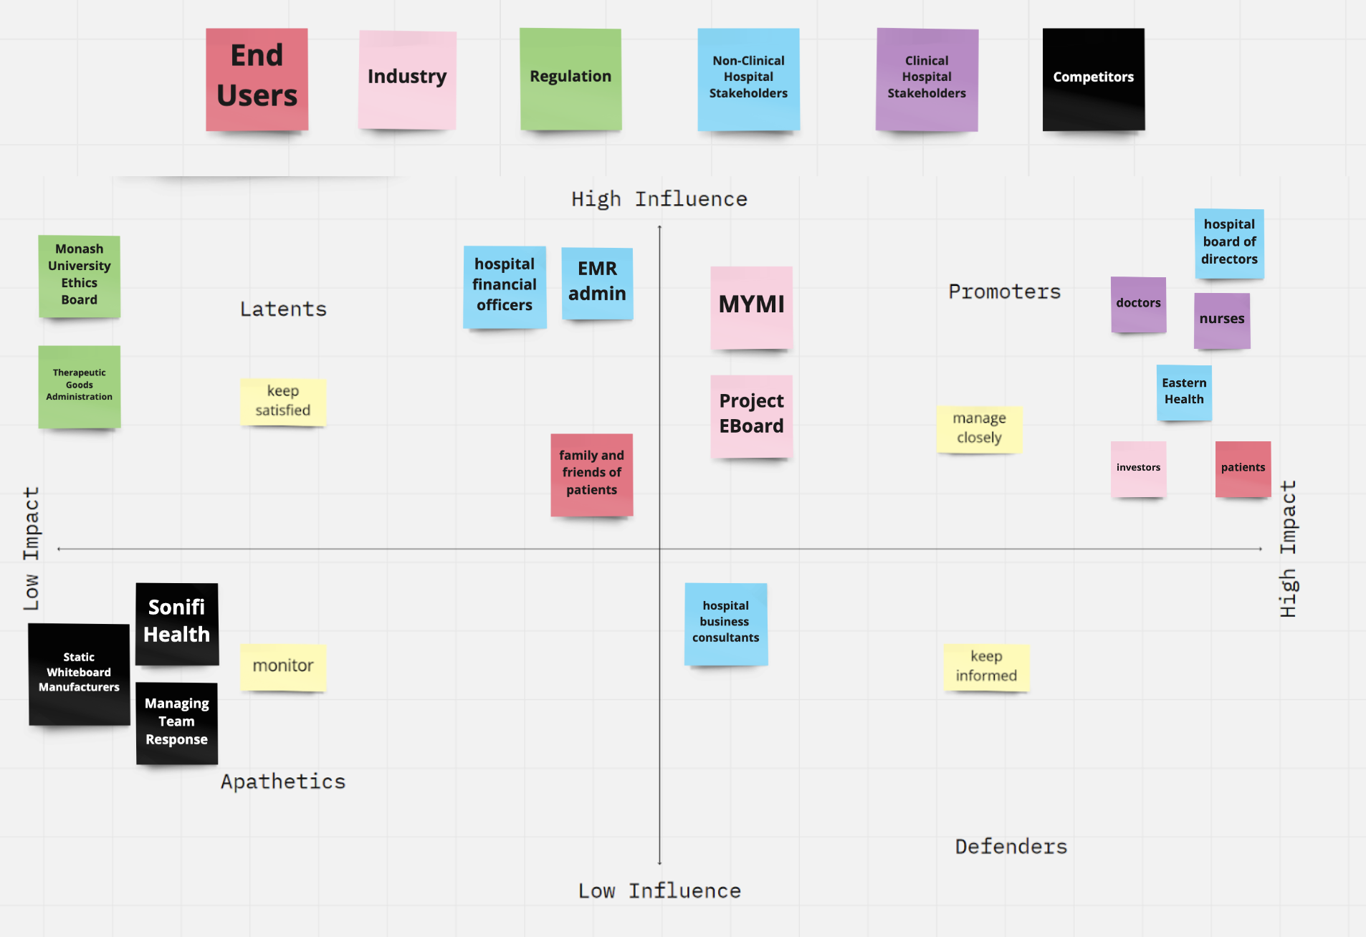

Systems Map

Link: https://miro.com/app/board/uXjVP6krBzI=/
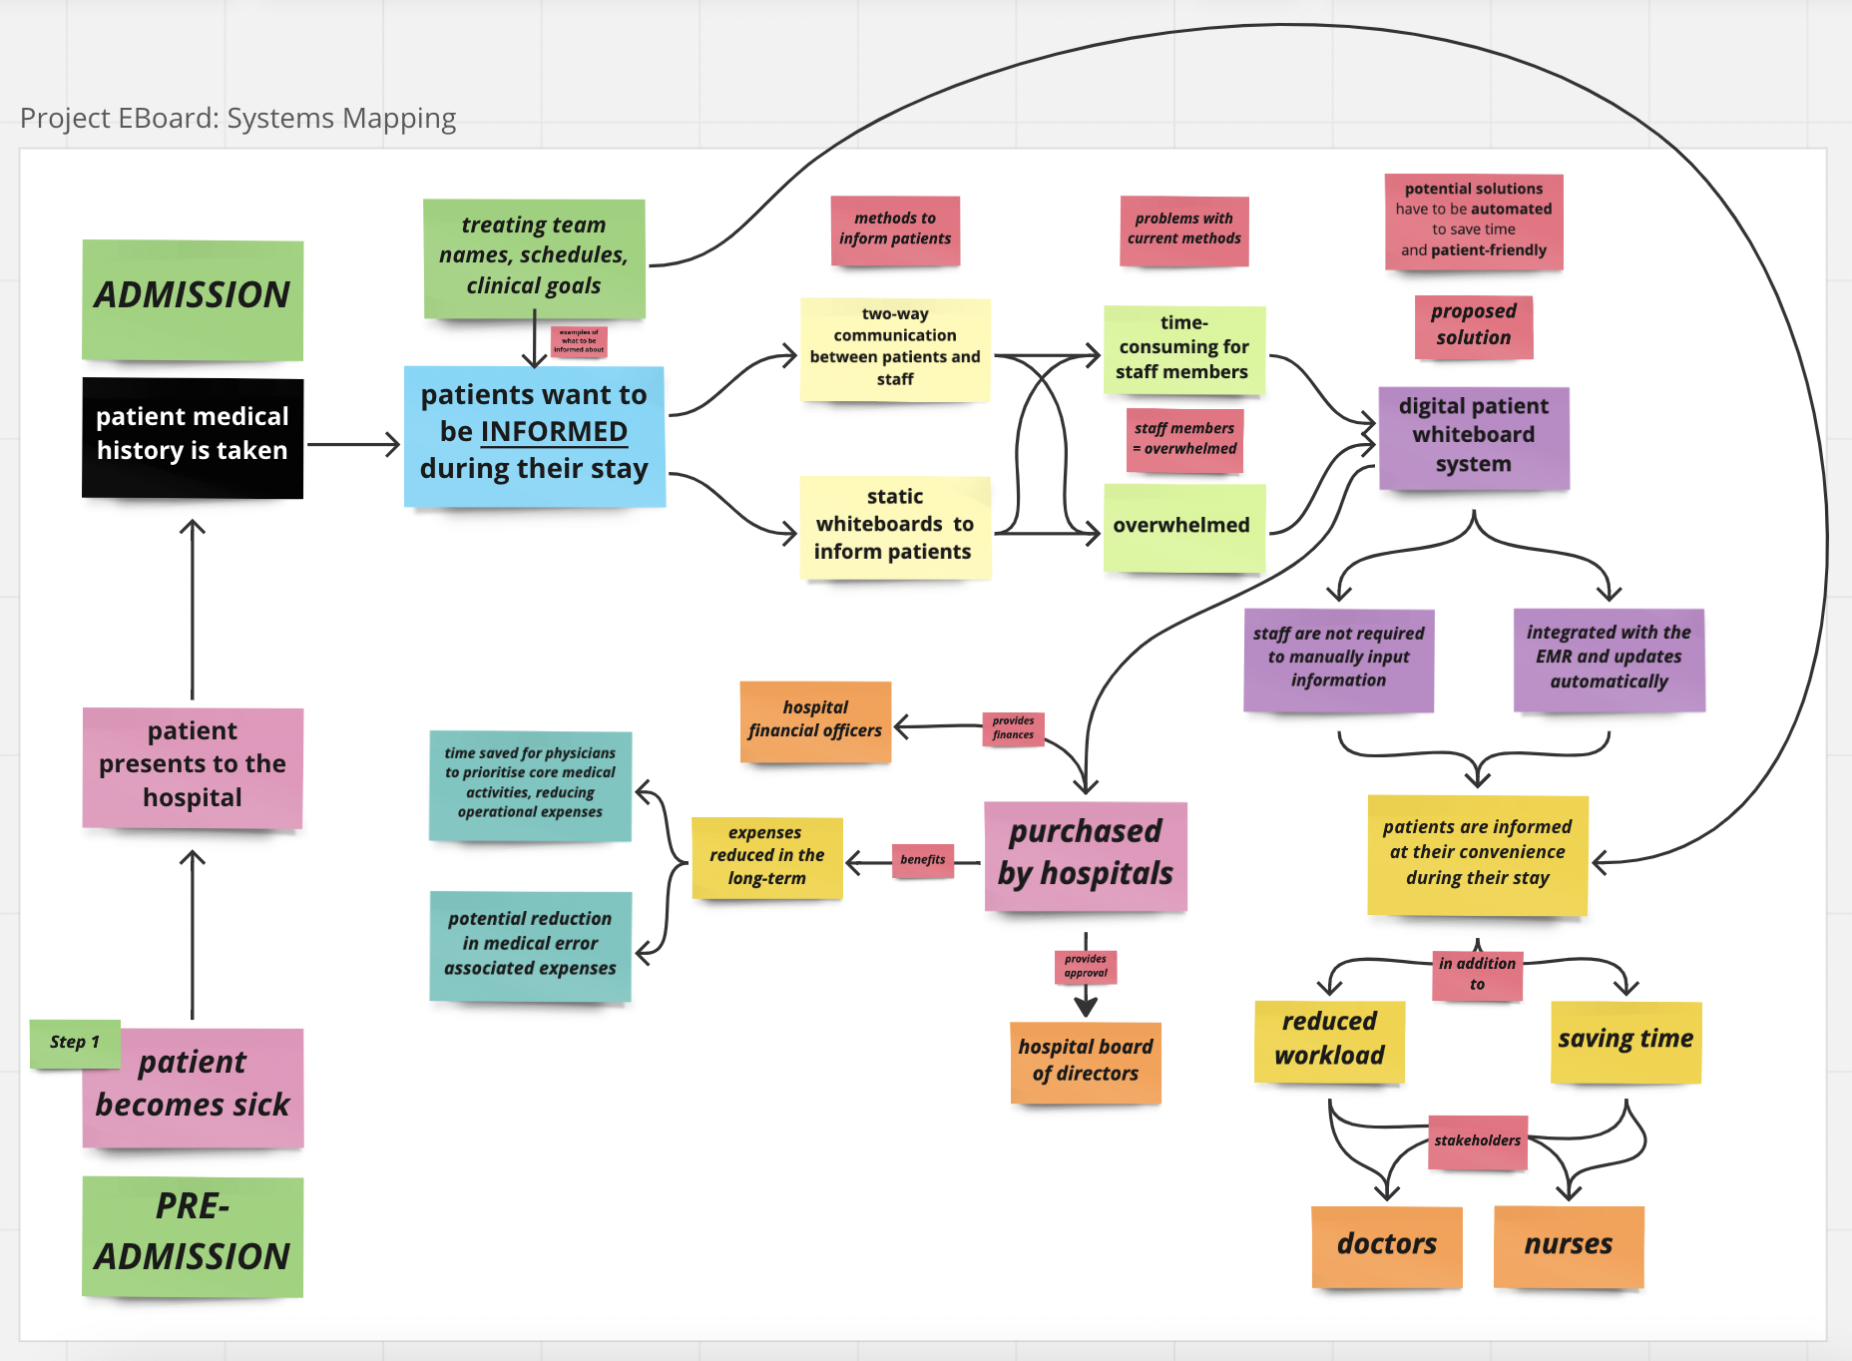

Solutions Ideation

- Criteria #1: Affordable for hospitals, given that it is a one-off cost (as opposed to being subscription-based) to purchase the electronic whiteboards for emergency department rooms;

- Criteria #2: Improves patient satisfaction, given that patients will be better informed of their stay in the hospital and other pertinent health-related details;

- Criteria #3: Improves clinician satisfaction, both as a byproduct of patient satisfaction increasing and workflow cohesiveness improving;

- Criteria #4: Smartphones can potentially be used, in combination with a physical digital whiteboard, to display the information (assuming the solution involves directly inputting information as opposed to automatically from the EMR itself)

- Criteria #5: Static whiteboards are rarely utilised in the emergency department due to the inconvenience of manually inputting information

Completely Addresses Criteria = Green
Partially Addresses Criteria = Yellow
Does Not Address Criteria = RedRe

 | Selection/Acceptance Criteria
Solution Description | Criteria #1 | Criteria #2 | Criteria #3 | Criteria #4 | Criteria #5
- A digital portable tablet solution that displays the patient’s EMR information. | YelYellowYellowYellowlo | YelYellowYellowYellowlo | YelYellowYellowYellowlo | YelYellowYellowYellowlo | YelYellowYellowYellowlo
- A watch solution that, upon scrolling through, allows patients to view information in the most condensed way (friendly user interface). | YelYellowYellowYellowlo | YelYellowYellowYellowlo | YelYellowYellowYellowlo | YelYellowYellowYellowlo | YelYellowYellowYellowlo
- VR glasses that, upon wearing, allow patients to see their own EMR data. A “physician version” VR glasses version can be made that displays all patient EMR data. | YelYellowYellowYellowlo | YelYellowYellowYellowlo | YelYellowYellowYellowlo | YelYellowYellowYellowlo | YelYellowYellowYellowlo
- A TV screen, attached to the patient’s bedroom wall, that displays their EMR data. | YelYellowYellowYellowlo | YelYellowYellowYellowlo | YelYellowYellowYellowlo | YelYellowYellowYellowlo | YelYellowYellowYellowlo
- A mobile phone application that connects to every hospital EMR. Patients can use this app to access their EMR and health data. | YelYellowYellowYellowlo | YelYellowYellowYellowlo | YelYellowYellowYellowlo | YelYellowYellowYellowlo | YelYellowYellowYellowlo
- A QR code system, placed in each hospital bedroom and connected to each patient’s EMR data. Upon scanning the QR codes, patients can access their EMR data. | YelYellowYellowYellowlo | YelYellowYellowYellowlo | YelYellowYellowYellowlo | YelYellowYellowYellowlo | YelYellowYellowYellowlo
- A private encrypted video communication application, that doctors can use to video call patients, to explain to them their test results and upcoming schedules. | YelYellowYellowYellowlo | YelYellowYellowYellowlo | YelYellowYellowYellowlo | YelYellowYellowYellowlo | YelYellowYellowYellowlo
- A “smart patient wristband” with a QR code that, upon scanning with a mobile phone, can be used to view a patient’s key information. | YelYellowYellowYellowlo | YelYellowYellowYellowlo | YelYellowYellowYellowlo | YelYellowYellowYellowlo | YelYellowYellowYellowlo
- Education on how to use whiteboards efficiently and effectively - training staff members. | YelYellowYellowYellowlo | YelYellowYellowYellowlo | YelYellowYellowYellowlo | YelYellowYellowYellowlo | YelYellowYellowYellowlo
- An iPad in every patient room for the patient to keep track of their health information, doctors/nurses names and medications in the hospital. | YelYellowYellowYellowlo | YelYellowYellowYellowlo | YelYellowYellowYellowlo | YelYellowYellowYellowlo | YelYellowYellowYellowlo
- A self-reporting application for patients to use in real time, to report their own symptoms and jot down their questions (this information is sent to the staff members). | YelYellowYellowYellowlo | YelYellowYellowYellowlo | YelYellowYellowYellowlo | YelYellowYellowYellowlo | YelYellowYellowYellowlo
- Clinicians can record voice memo summaries with important information for that day - patients can play this recording whenever they want. | YelYellowYellowYellowlo | YelYellowYellowYellowlo | YelYellowYellowYellowlo | YelYellowYellowYellowlo | YelYellowYellowYellowlo
- One page summary solution, whereby a one page summary of the patients’ EMR data, using natural language processing. This can be printed and given to patients. | YelYellowYellowYellowlo | YelYellowYellowYellowlo | YelYellowYellowYellowlo | YelYellowYellowYellowlo | YelYellowYellowYellowlo
- Staff members can write down important dot points on a sticky note, such as “Physician: Dr Smith, Upcoming MRI at 1pm”, etc, and this can be given to the patients. | YelYellowYellowYellowlo | YelYellowYellowYellowlo | YelYellowYellowYellowlo | YelYellowYellowYellowlo | YelYellowYellowYellowlo
- Staff members can spend 1-2 minutes vocally summarising to each patient their upcoming schedules, clinical goals and answering any questions they have. | YelYellowYellowYellowlo | YelYellowYellowYellowlo | YelYellowYellowYellowlo | YelYellowYellowYellowlo | YelYellowYellowYellowlo

