
MONASH HEALTHCARE INNOVATION SUMMER SCHOLARSHIPS (HISS)
PROJECT NAME: Project Dolphin
DELIVERABLES NUMBER: 3
PROJECT LEAD: Maya Wilmshurst

1.0 Stakeholder map

1.1
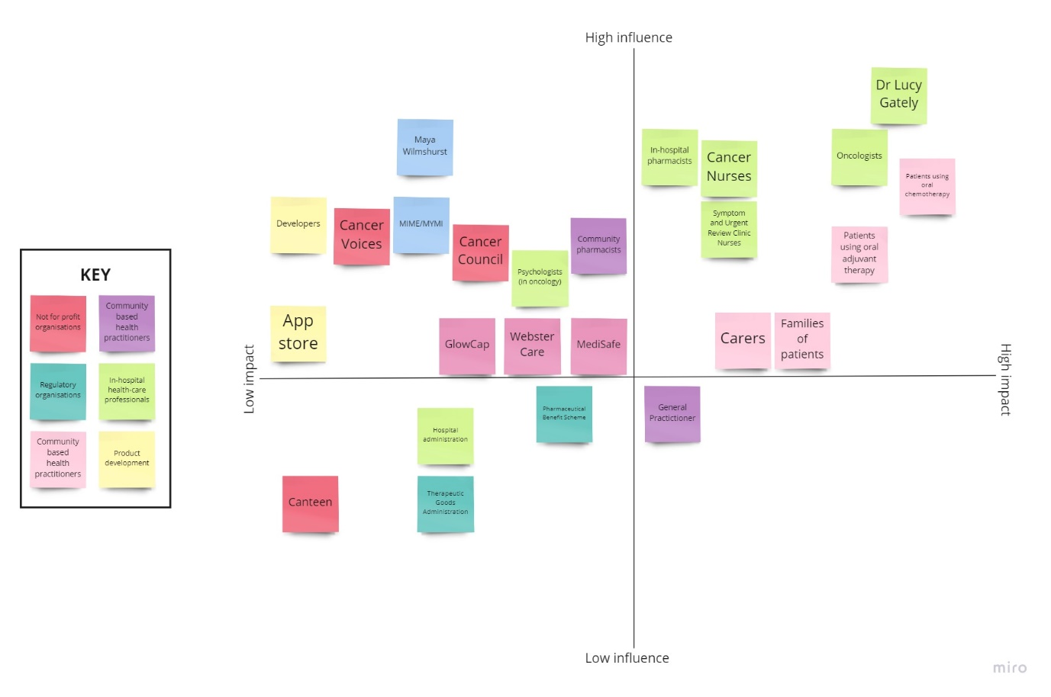

1.2
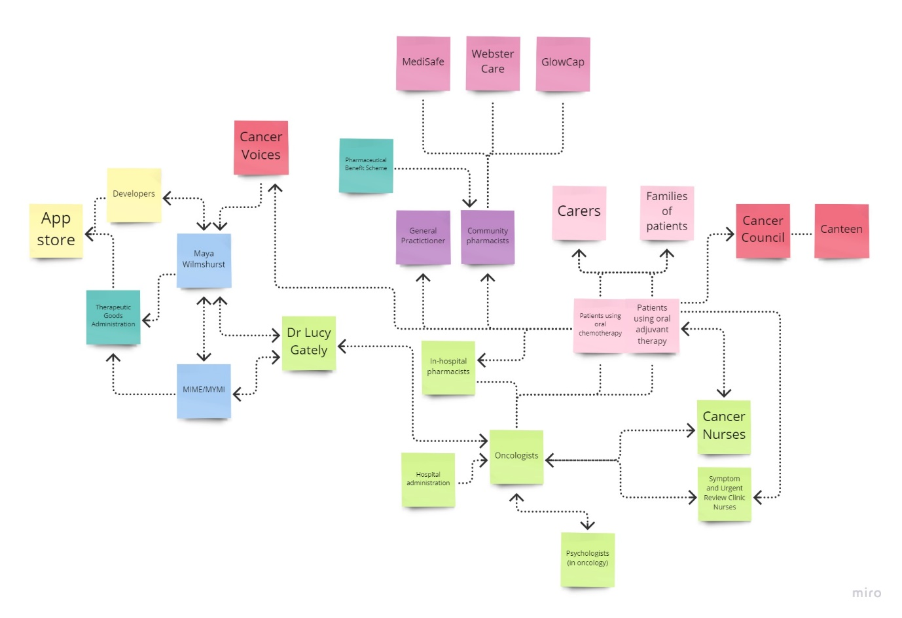
2.0 Systems map

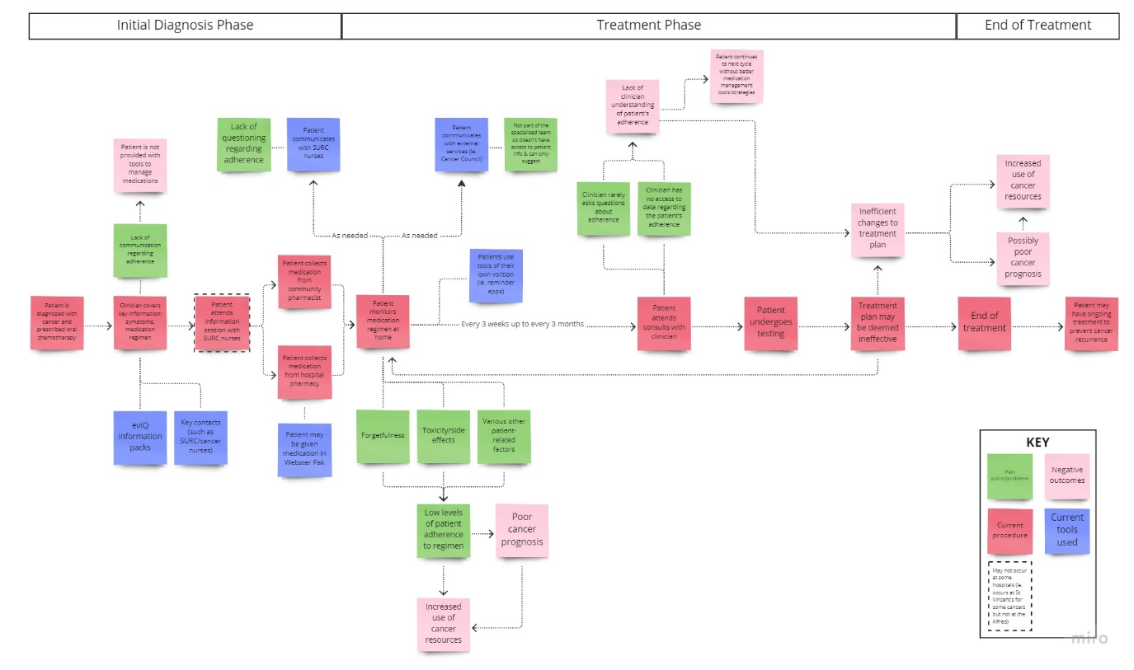

Solutions ideation

Please see link:
https://rowan-pressure-3e1.notion.site/Solutions-Ideation-0849056795e749e29b363c800c5d1f32

