
MONASH HEALTHCARE INNOVATION SUMMER SCHOLARSHIPS (HISS)
PROJECT NAME: Activus
DELIVERABLES NUMBER: 3
PROJECT LEAD: David Cheng
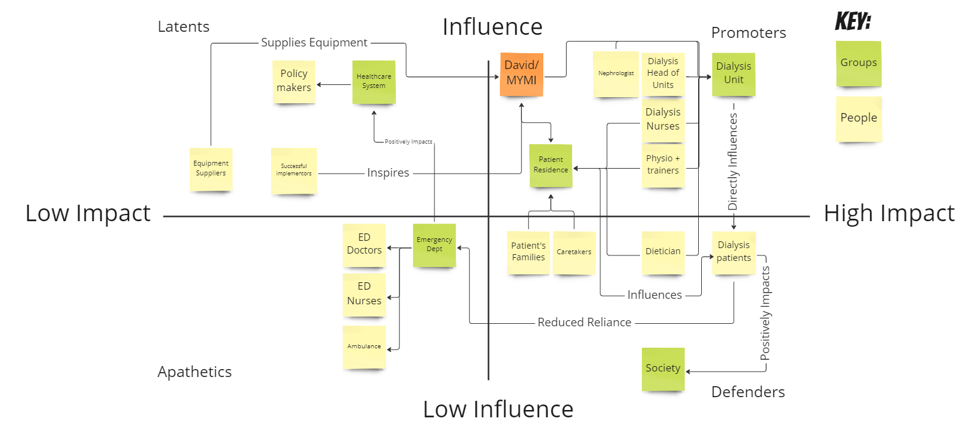
Stakeholder map

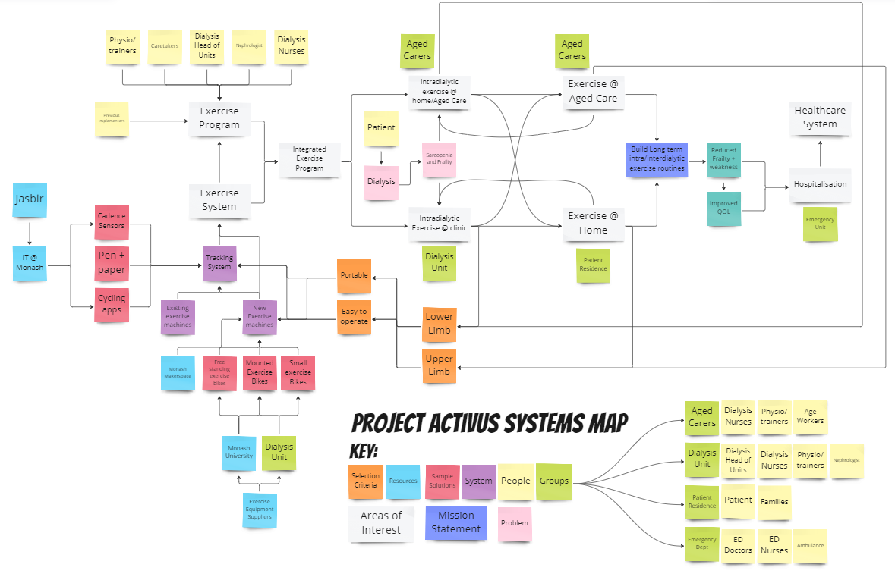
Systems map

Solutions ideation
 | Selection/Acceptance Criteria
Solution Description | Portability / easily accessible. | Ease of use | Progress track | Adherence | Clinical/home setting | Upper/lower limb exercises
- Exercise groups where patients have to attend on a schedule | No | No | Half | Half | No | Yes
- App that connects small exercise bikes to track progress, play games, etc. | Yes | Half | Yes | Yes | Half | Yes
- Zwift style accompaniment – riders will be able to race each other and see their progress on a location basis. | Yes | Half | Yes | Yes | Half | Yes
- Second hand exercise equipment for social sessions as a group | No | Yes | Half | Half | No | Yes
- VR based exercising solution (horror VR to make the patients ride faster). | No | No | Yes | Yes | Half | Yes
- Portable dialysis device (e.g backpack sized) with a more secure needle insertion location to make exercising easier – exercise while receiving therapy. | Yes | No | Yes | Half | No | Yes
- Swimming/warm water physio exercises – easier to move around. (Water dialysis unit) | No | No | Half | Half | No | Yes
- AI model that tracks patient’s progress and gradually alters training plans depending on their performance | Yes | Yes | Yes | Half | Half | Yes
- Consult r/fitness on reddit | Yes | No | No | No | No | No
- Manual intradialytic and interdialytic exercise. Manual tracking through nurse. | Yes | Yes | Half | Half | Yes | Yes
- Use blood flow restriction training so patients don’t have to lift heavy weights/engage in strenuous exercise but still get benefits. | Yes | No | No | No | Half | Yes
- Use interactive displays (Android tablets) to run exercise programs | Half | Half | Yes | Yes | Yes | Yes
- QR code or NFC tag on the exercise machine so that patients can automatically connect and track progress on their phones | Yes | Half | Yes | Yes | Yes | Yes
- Group TV that monitors everyone’s progress in a group setting. | No | Yes | Yes | Yes | Half | Yes
- Chromecast like device that casts information from the exercise machine to a TV. | Yes | Half | Yes | Yes | Yes | Yes
- USB token key that plugs into a universal system – plug and cycle. Data is shown on a screen/casted to a TV. | Half | Yes | Yes | Yes | Yes | Yes
- Internet enabled exercise machines – patients log in every time. | Half | No | Yes | Half | Half | Yes
- Monetary incentive program – cycle kilometres for offset in expected hospital costs. | Yes | Yes | Yes | Half | Half | Yes
- Retrofitted exercise equipment to cast + track exercise to a TV or another screen. | Yes | Yes | Yes | Yes | Half | Yes
- Dialysis gym | N/A | Yes | Yes | Yes | No | Yes

