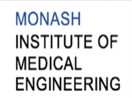


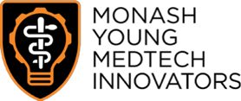

MONASH HEALTHCARE INNOVATION SUMMER SCHOLARSHIPS (HISS)
PROJECT SENTINEL: MONITORING SYSTEM FOR PATIENTS RECOVERING FROM ISCHAEMIC STROKES
DELIVERABLES WEEK 3
PROJECT MEMBERS: Calvin Zheng, Diana Kovaleva
1.1 Existing Solutions
Solution | Description | Gaps
NIHSS | Stands for the National Institutes of Health Stroke Scale.  It is a neurological test done by clinicians to determine the severity of a stroke suffered by a patient. The test involves 11 main checks for:  - Level of consciousness  - Horizontal extraocular movements  - Visual fields  - Facial palsy  - Arm motor drift  - Leg motor drift  - Limb Ataxia  - Sensation  - Language/aphasia  - Dysarthria  - Extinction/inattention  These tests have been optimised to be as objective as possible, but subjective errors may still occur. This is not too much of an issue as the human error is accounted for by using a range of values to categorise the patient, instead of a discrete value.  No specialised equipment is needed for any of the tests.  This test can be done at any time and does not require any preparation, but it is expected for the patient to be on a bed. | - This testing does not focus on the ground truth (it does not look at the actual damage to the brain).  - It requires a trained clinician to be present to conduct the test.
MRI | MRI stands for magnetic resonance imaging. Large magnets are used to create strong magnetic fields which temporarily realigns water molecules in the patient’s body; radio waves are then used to cause the aligned atoms to generate signals.  MRI scans do not use any radiation and are usually non invasive and painless, however some specific scans may require an injection of dye to increase the quality of the scan.  MRI specifically scans soft tissue such as the brain, heart and bone marrow, and is commonly used to detect soft tissue damage and organ damage, such as those created by a stroke.  Specialists are required to run the MRI scan and also to process the images afterwards.  The patient journey is quite simple: patients have to change into a hospital ground and make sure they have nothing metallic on them before entering the machine. After the scan, patients are free to leave.  An MRI scan takes up to two hours to take, and then a day minimum to process and analyse the images.  Economic cost: $700 - $1000 per scan | - Requires expensive equipment that is also rare.  - Requires specialists to operate  - Is dangerous to patients with metallic implants  - Some patients may experience side effects from the dye.  - Patients are confined in a small space which may be uncomfortable and trigger claustrophobia.  - MRI scans take a lot of time to run, process, then analyse.  - Only provides static images of the brain.  - Sometimes requires patients to fast, depending on the type of scan.
CT | CT stands for computerised tomography. Multiple x-rays of the patient are taken from different angles and spliced together to create a cross section of the bones, blood vessels and soft tissue within the body.  Due to the usage of x-rays, CT scans have a limited number of safe uses per day for each patient (Usually 3).  Some CT scans require the patient to ingest or inject dye to improve the quality of the scan.  The patient's journey, without needing dye, is very quick; they change into a hospital, take the scan, and are then free to go.  If a patient needs dye, then they need to take a drink or IV half an hour before the scan, and must not eat up to 4 hours before the scan.  The imaging takes up to 30 minutes and image processing/analysis can take up to a day at the fastest. | - Uses ionising radiation  - Requires expensive equipment  - Requires specialists to operate  - Only provides static images of the brain.  - Some patients may experience side effects from the dye.  - Sometimes requires patients to fast, depending on the type of scan.  - Limited number of recommended uses per day.
ECG/ Holter monitoring | Post-stroke → 24 hour Holter monitoring to check for atrial fibrillations. Decreases chances of recurrent stroke.  Economic cost: $80 - $140 per session.  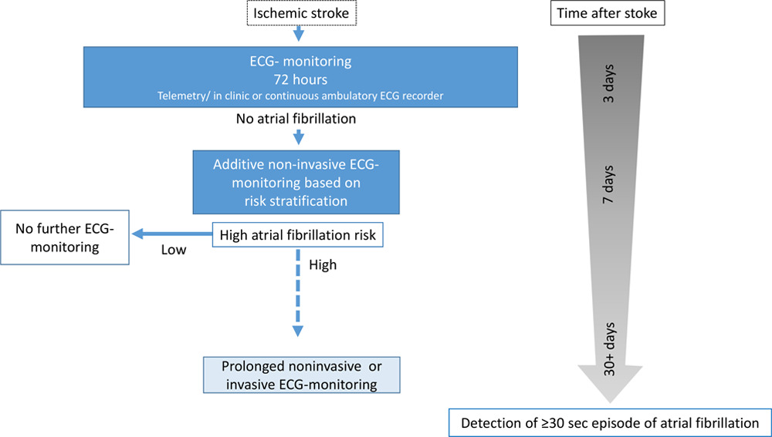 | Does not provide information about the brain post stroke.
Medication adherence apps | PostStroke Manager → mobile, digital and sensor-based technology for patient adherence.  Tablet records physical activity, blood pressure and ECG signals.  Communication tool, medication schedule, medical records platform, and psychometric screenings (anxiety, depression, etc.)  Enables communication between disconnected healthcare sectors.  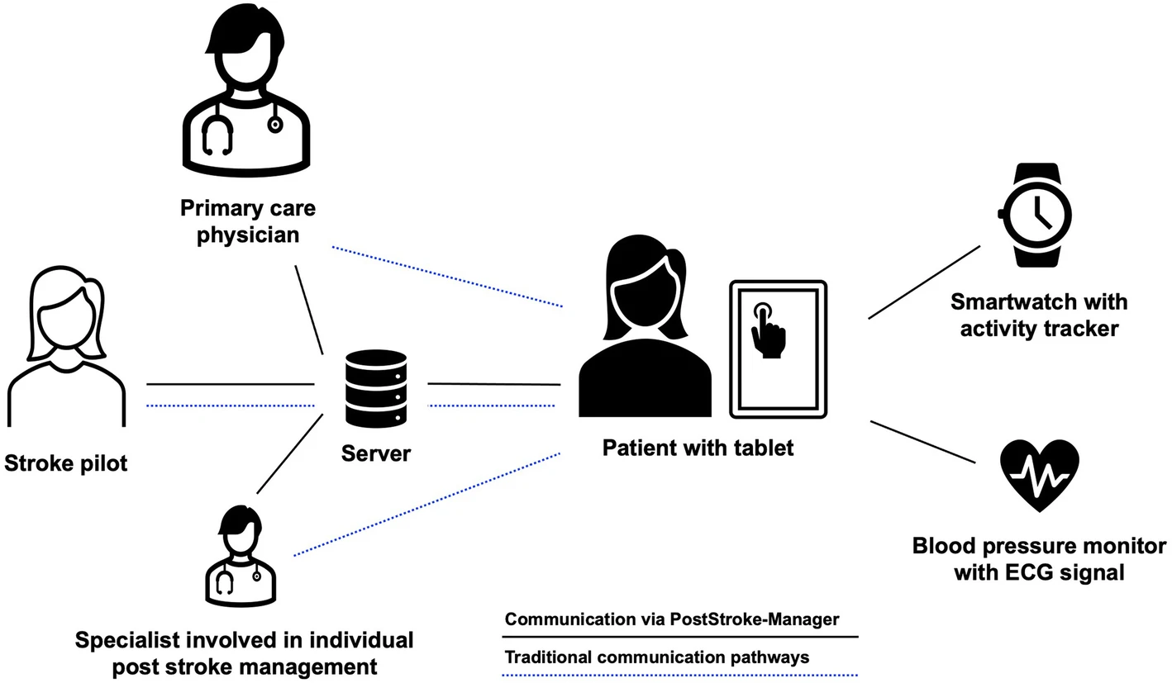 | Based on out-patient setting, not in-hospital solutions.  An element of self-reporting, which may be unreliable.  Patient adherence to medications is not guaranteed, only the medication schedule is being posted; there are no prompts for taking the medication.  No continuous monitoring components, the data is being viewed a few times per week.  No direct indication of brain activity, focused on metrics to rule out other diagnoses.
EMTensor | Non-invasive portable scanning technology. Does not require specialists to operate.  Ambulance arrives → portable device can be carried in an ambulance. Patients’ stroke type can be diagnosed on the spot to be sent to the appropriate hospital department.  → clinician (neurologist or radiologist) can receive scans of the patient remotely and prepare hospital staff for the arrival of the patient.  Patient arrives at the hospital → can be monitored continuously in case of hemorrhagic stroke and once per day for ischaemic stroke patients. Alerts the doctors and staff of change in condition and potential patient relapse. Can alert of patient condition in real time and remotely. Can be used in patient rooms or ICU (patients in various conditions can be monitored). Non-invasive and portable, so can be brought to the patients.  Post-recovery monitoring → patients scanned on a monthly basis after being discharged from the hospital to monitor progression. Can be done remotely; reduces burden on the patient to travel to the hospital and undergo physical examination. Reduced burden on clinicians and hospital personnel to physically examine patients post-treatment. Resources can be diverted to treating patients in critical conditions.  Unknown economic costs, as the project is still in the process of being commercialised, but anticipated to be expensive. | Continuous monitoring of ischaemic stroke patient  Does not use existing equipment → need to buy machinery
EEG | Non-invasive portable scanning technology. Does not require specialists to operate.  The idea behind this solution is to use an EEG to record signals from the brain and then use inverse algorithms to determine where the signals are coming from. Damaged sections of the brain should not be producing any signals and thus will show up as a dark spot. Brain activity recovery should be seen in real time using this method. An EEG specialist is needed to read the output.  The patient journey for this method involves the patient coming into the hospital and getting initial treatment first before getting placed into a hospital bed for recovery where an EEG cap can be placed onto the patient to monitor them. This cap will be left on until either the patient is fully recovered and no longer needs monitoring, or for temporary durations for cleaning purposes.  Economic cost: $200 - $250 per patient for 24 hours of continuous monitoring. | - Low resolution  - Current algorithms create a bit of error.  - Is a new solution that will need time and resources to develop.
Mobile stroke unit (stroke bus) | Custom-built specialist ambulance with a built-in CT scan, full range of stroke treatment drugs and a range of qualified specialists. Needed personnel include: stroke neurologist, CT radiographer, stroke nurse specialist and two paramedics (including MICA paramedics). The unit is sent out when the patient displays very clear signs of stroke.  Approximately $200 per patient serviced. | Need for specialists to operate the machinery and administer drugs.  Need to identify the patient as being a stroke patient before sending out the ambulance.

1.2 Acceptance Criteria
- Easy for hospital staff to read and interpret
- Offers continuous surveillance of the patient’s neuronal activity over a period between 30 minutes and 24 hours
- Does not require an operator to be continuously present to function.
- Provides a ground truth about the state of the patient, and the severity and stability of the stroke.
- Cheap enough for the average hospital to be able to use it on every stroke patient simultaneously.
1.3 Solution Alignment:
Solution | 1 | 2 | 3 | 4 | 5
NIHSS
MRI
CT
ECG
apps
EMTensor
EEG
Mobile stroke unit

1.4 Patient Journey

