
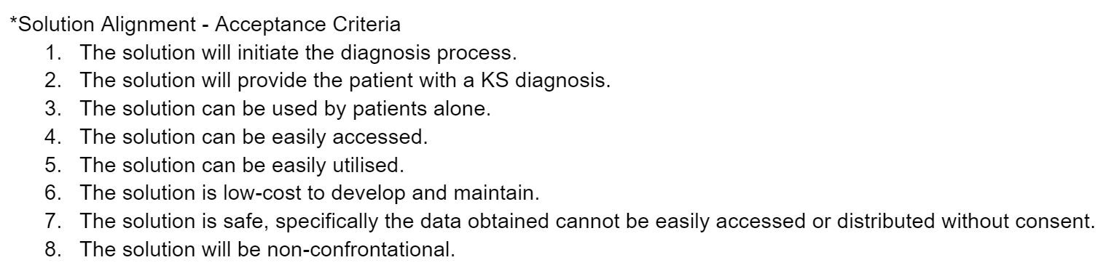
MONASH HEALTHCARE INNOVATION SUMMER SCHOLARSHIPS (HISS)
PROJECT NAME: Project Pluto
DELIVERABLES NUMBER: Week 3
PROJECT LEAD: Lloyd Lok
Existing Solutions

Solution | Clinical profile | Economic profile | Utilisation profile | Emerging profile | Acceptance Criteria (Low/Medium/High) |  |  |  |  |  |  |  | Alignment Solution | Gaps in solutions
 |  |  |  |  | 1 | 2 | 3 | 4 | 5 | 6 | 7 | 8 | Alignment Solution | Gaps in solutions
Genital examination (using orchidometer)  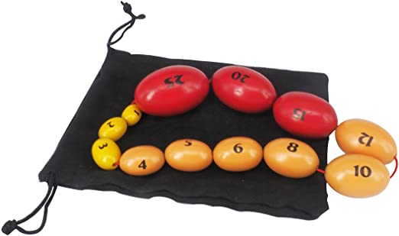  A process through which practitioners or clinicians determine the volume of a patient’s testicular size by making comparisons to an orchidometer - an instrument containing large beads of different volumes (mL). | Through sight and feel of the testicles, and comparisons to an orchidometer, practitioners can identify whether patients have abnormal testicular size.  Since testicular size is the primarily affected anatomy, this method can provide indication to whether the primary symptom of KS (small testicular size) is present. | To obtain a genital examination, patients visit a clinic to see a practitioner.  Unsure whether the cost required for an examination falls under a body check-up, and whether Medicare covers these visits (To be clarified with clinician).  The orchidometer instrument can cost around $150 (26). | Currently, when men require a genital examination, they visit a clinic. At the clinic, the examination will be completed by a practitioner or clinician using an orchidometer. | Orchidometers have been a long used instrument, dating to 1943 when it was invented by Schonfeld. The solution has raised the potential need for other volumetric estimation methods (22). |  |  |  |  |  |  |  |  | AC 1 - The solution will definitely initiate the diagnosis, if not diagnose patients with KS  AC 6  AC 7 - Practitioners will maintain confidentiality, the information will likely be safe and not distributed freely. | AC 2 - The solution may provide a presumptive diagnosis of KS for adults, however in prepubescent or peripubescent a karyotype analysis is required for a definitive diagnosis (18).  AC 3 - If patients can obtain an orchidometer, they can attempt to complete a self-examination, though this would only initiate the diagnosis and would require practitioners to confirm.  AC 4,5 - Additionally, according to clinicians, this current method may not be entirely accessible nor useable, as many clinicians don’t actually own an orchidometer, and don’t have much experience due to lack of patient visits for diagnosis.  AC 8 - Primary concern is the confrontational aspect of an in-person genital examination.
Karyotype through blood analysis  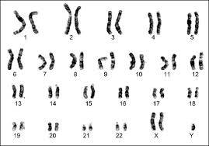  A karyotype is a form of blood analysis that obtains the size, number, appearance of chromosomes (20). | A sample of blood is taken from patients which is sent to laboratories to conduct a karyotype analysis. This analysis will display the sets of chromosomes through the use of stains (23). Most importantly if the sex chromosomes display at least one supernumerary X chromosome, this is indicative of KS. | The cost of karyotype blood analysis can be rebated through Medicare, which may cover part of the cost, the remainder which patients would need to pay upfront. Additionally the turnaround time is around 6-12 weeks (24).  For non-Medicare card holders, a genetic screening through karyotyping could cost around $360 (25). | If patients enter a clinic exhibiting many of the relevant symptoms to KS, the practitioner may request a karyotype blood analysis on behalf of the patient. A karyotype is less likely to be completed for adults, if primary symptoms are prominent. | Traditional methods of karyotyping will use chemical staining. New methods such as fluorescence microscopy are emerging (23). |  |  |  |  |  |  |  |  | AC 1,2 - The solution will both initiate and certify the diagnosis.  AC 7 - Karyotype analysis will be kept confidential to patients and their practitioners.  AC 8 - Mostly not confrontational, only aspect possibly could be when obtaining blood samples. | AC 3 - Karyotyping cannot be done by individuals on their own.  AC 4,5 - Patients can only obtain a karyotype analysis if recommended by a practitioner.  AC 6 - Though Medicare may cover some of the costs for a karyotype analysis, there will still be a cost involved for individuals, and even greater costs for those that are not Medicare card holders.
Ultrasound for testicular volume  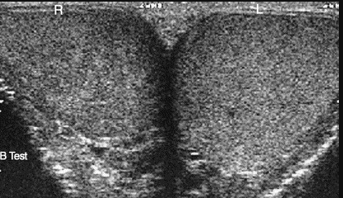  A testicular ultrasound will scan the extreme at different angles, conducting a three dimensional examination on the testicle. | Ultrasound imaging emits high-frequency waves directed towards the target anatomy, these waves are reflected, creating an image (28) | According to MBS, the fee for scrotal ultrasound is $113.95. This can be bulk-billed (covered b y Medicare) depending on the GP, as well as if the individual meets certain criteria (29,30) | Patients may enter a clinic exhibiting symptoms of KS, or potentially even other symptoms that urge the need for an ultrasound. The practitioner may request an ultrasound on behalf of the patient. | In future, there is still emerging potential for ultrasound machines to be faster and also contain greater memory for storing data. |  |  |  |  |  |  |  |  | AC 1 - Completing an ultrasound will initiate the diagnosis process, by providing an accurate estimation of testicular volume, which may prompt further review.  AC 7 - Practitioners will maintain confidentiality, the information will likely be safe and not distributed freely. | AC 2 - The ultrasound alone will not be sufficient for a diagnosis, as it is not just important for practitioners to see the size, but also feel.  AC 3 - Ultrasound cannot be done by individuals on their own.  AC 4,5,6 - Lack of ultrasound services due to lack of funding as well as shortage of ultrasound technologists (27).  AC 8 - The requirement to take of clothing and be scanned could potentially be confronting to some individuals.

State of the Art Summary
The process starts as patients begin exhibiting potential KS symptoms, and decide to visit a clinic to obtain a diagnosis. At the clinic, one of the existing methods will be utilised to confirm the diagnosis. Different methods may be used depending on age of patient, for instance, to definitively diagnose prepubescent patients, a karyotype is required, whilst adults could be diagnosed through a genital examination. If patients do get diagnosed with KS, depending on symptoms, the patients will get treated. The most prominent treatment is androgen therapy like testosterone replacement therapy which will increase the testosterone levels in the body. Additionally, if KS is diagnosed early in life, patients can obtain education support, and communication therapy. If patients are not diagnosed with KS, they will not require treatment.

