
MONASH HEALTHCARE INNOVATION SUMMER SCHOLARSHIPS (HISS)
PROJECT NAME: NEPHROS
DELIVERABLES NUMBER: 2
PROJECT LEAD: Nandini Pandya & Upani Mapala-Gamage

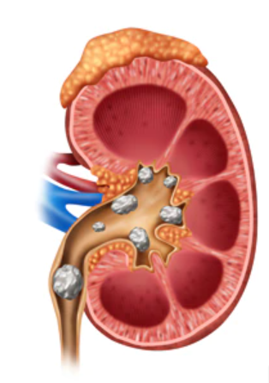

1.5 Existing solutions

Flow chart of visualisation techniques used during diagnosis
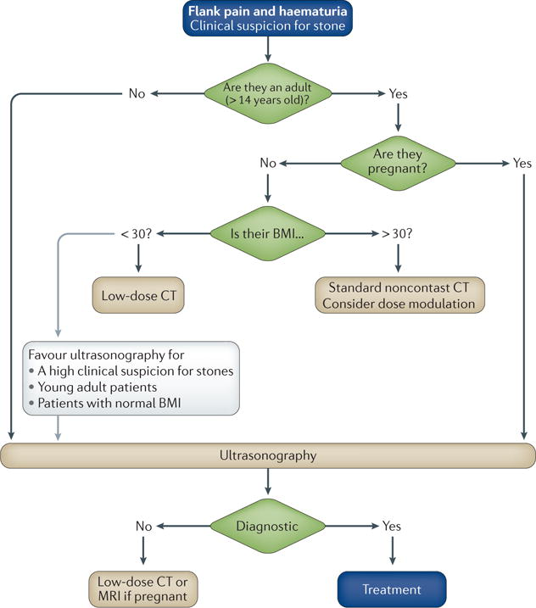

Since our focus is on kidney stones that qualify for PCNL surgery (the preferred procedure of choice for large and complex stones). The visualisation technique we are focused on is which will aid this surgery and therefore would be placed into the ‘treatment’ block of the diagram

The table below explores the current solutions for visualisation of kidney stones for PCNL and the extent to which they meet each acceptance criteria. It also analyses existing and similar surgery techniques that may be used in combination with a particular visualisation technique in order to fulfil our mission of reducing complications during PCNL kidney stone surgery.

Visualisation Technique | Clinical | Economic | Utilisation | Emerging + Solution Landscape | Solution Alignment | Gaps in Solution | Acceptance criteria
 |  |  |  |  |  |  | 1 | 2 | 3 | 4 | 5 | 6 | 7 | 8
Ultrasound-guided PCNL  (UGPN) | First-line imaging modality for pregnant or paediatric patients (<14 years old).  Produces detailed images of the body using high frequency sound waves - these bounce back off different tissues and produce an real-time image [ADIA] | Ave. upfront cost - $217 [Australian diagnostic imaging association]  Cost: 5x that of KUB x-ray*  Ill patients usually need multiple scans in the course of diagnosis and treatment, creating a substantial financial burden.  On the medicare benefits scheme and patients reimbursed | Used by: Radiologists, Surgeons, surgical nurses, Operating room staff  The ultrasound may be used in real-time or images may be taken and the trajectory for puncture estimated. | N/A | Does not use ionising radiation therefore is a safer procedure than others. | Ultrasound is very low resolution in comparison to other visualisation techniques.  Sometimes shadows can overestimate the size of the kidney stones
X-ray (KUB) | Intravenous pyelogram (x-ray exam of urinary tract) is performed (x-ray dye injected) to map out anatomy of the kidney | Ave. upfront cost - $111 [Australian diagnostic imaging association]  On the medicare benefits scheme and patients reimbursed | Used by: Radiologists, Surgeons, surgical nurses, Operating room staff | N/A | Allows for better visualisation of the urinary tract and the ureter.  Kidney stones have relatively clear visibility.  Location and size of stone can be calculated. | Intravenous pyelogram, dye injection can cause side effects such as nausea and metallic taste.
CT | Gold standard scanning method  Computed tomography uses x-ray equipment to obtain multiple images of the body from different angles. Computer processing is then used to produce images of the body in cross-sections [ADIA] | Ave. upfront cost - $454 [Australian diagnostic imaging association]  CT Cost: 10x that of KUB x-ray* roughly (cost above after government subsidy)  On the medicare benefits scheme and patients reimbursed | Used by: Radiologists, Surgeons, surgical nurses, Operating room staff  CT exploits the different degrees to which body tissues absorb radiation, multiple data points are processed into 3D image | N/A | CT scan has the ability to assess the spatial relationship of the kidney relative to the stone in a 3D format - depicting visuals of access site, assess risk of pleural or bowel injury and predict success of fluoroscopic access for upper pole puncture [fluoroscopy guided]  The sensitivity for detecting stones is the highest of all the available modalities, few large stones are missed. | Radiation: exposure of patients from 20-50mSv is considered safe. A typical CT of the abdomen and pelvis without contrast exposes patients to 15 mSv (which is relatively safe).  A clinician can choose to do a contrast or non-contrast to visualise the stone better [fluoroscopy guided]  Also exposing patients to ionising radiation (very low levels).  This scan is contraindicated in pregnant women.
Fluoroscopy-guided PCNL  (FGPN) | Allows X-rays to be viewed in real-time with the use of a contrast agent. Most procedures use a non-toxic barium sulphate as a contrast agent [ADIA] | Cost:$66.36 [Medicare benefits schedule]  On the medicare benefits scheme and patients reimbursed | Used by: Radiologists, Surgeons, surgical nurses, Operating room staff | N/A | Allows viewing of X-rays in real time with contrast | Radiation risk to staff and operators overtime but can be reduced by increased safety measures  Steep learning curve, harder to implement [fluoroscopy guided]
3D Visualisation (Developed my Monash Urology) | CT KUB data is segmented to reconstruct the renal collecting system, stone location and volume, renal parenchyma, lung bases, overlying thoracic ribs and vertebrae | Cost: difficult to approximate yet considering it uses data from several scans from different angles along with image process software - very high  Although it is in the process of obtaining government subsidy | Used by: Radiologists, Surgeons, surgical nurses, Operating room staff | While Monash Urology and other groups in the literature have used 3D reconstructions to cognitively plan PCNL puncture, automation of this process has yet to occur.  Potential to develop target registration of kidney stone location. | Allows accurate visualised to stone location and size | No optimal access point or access angle data outputted and must be roughly estimated by the surgeons during the procedures - but has potential to be developed further  Difficult to find trial results that indicate the time effectiveness of the tool
MRI | Magnetic resonance imaging - does not use X-rays, so no radiation is involved.  MRI uses powerful magnet and radio-frequency pulses to collect information - detailed view of soft tissues. | Ave. upfront cost - $526 [Australian diagnostic imaging association]  Cost: 30x that of KUB x-ray* roughly (cost above after government subsidy)  On the medicare benefits scheme and patients reimbursed | Used by: Radiologists, Surgeons, surgical nurses, Operating room staff | Further developments are expected to enhance each imaging modality for the evaluation and treatment of kidney stones in the near future. A proposed algorithm for imaging patients with acute stones in light of the current guidelines and a randomised controlled trial could aid clinicians (pubmed) | Provides the possibility of 3D imaging without exposure to radiation (pubmed) as no X-rays are involved, only magnets and radio-frequency pulses. | Currently stones are difficult to visualise (pubmed).  Has low sensitivity and can produce false negative results [NHS]  Cannot be used in patients with cardiac pacemakers, vascular stents, cochlear implants. However, hip and knee replacements and metal rods are safe  Slowest of all the visualisation techniques
*relative costs of visualisation techniques in the US [study here], derived from values published by the American College of Radiography and American Urological Association

Surgery Techniques | Clinical | Economic | Utilisation | Emerging + Solution Landscape | Solution Alignment | Gaps in Solution | Acceptance criteria
 |  |  |  |  |  |  | 1 | 2 | 3 | 4 | 5 | 6 | 7 | 8
Neuro and sinus (Stereotactic) | Intraoperative guidance system (IGS) - Image guided therapy (IGT)  Surgical plan is devised. One of two methods are used:  1.The localisation procedure uses a linked system where angle-sensing devices are used to determine position of a point centred by a mechanical linkage arm. This is frame based [IGT]  2.Unlinked systems - that uses devices such as cameras, magnetic sensors and microphones to receive positional data from a pointer within the patient [IGT] | IGT uses images collected preoperatively including fluoroscopy, ultrasound, CT, MRI and PET scans.  Relatively novel technology (5 years+)  A huge cost to the hospital and the government - little to no cost to patients.  However we are yet to determine whether accessibility to such technologies is found in a public and/or private health systems | Used by: Radiologists, Surgeons, surgical nurses, Operating room staff  Also maintenance engineering present onsite to help maintain and also initially train staff on usage & functions | Covers several points on the acceptance criteria (if translated into a kidney setting):  Reduces bleeding rates/inaccurate punctures  Increased accuracy  Increase surgical confidence  Greatly impact the technological landscape → optimal solution  Future developments may include a completely automated 3D reconstruction of the body systems and a robot assisted surgery. | Expecting to translate into a surgery guidance system of other body parts such as the highly complex and vascular kidneys.  High resolution real time guidance. Helps surgeons optimally place skin incisions, calculate access angle and access point.  Helps safely guide surgical targets and precisely localise vital anatomical structures [IGT] | Currently mathematical guidance algorithms specific to neuro and sinus surgery and not enough research into other body systems.  Also robotic assistance during surgery configured to the brain and sinus surgery and research not well defined to apply to other body systems.
Orthopaedic (Stereotactic) | Intraoperative guidance system (IGS) - Image guided therapy (IGT)  Guidance mechanism very similar to that of Neuro and sinus surgeries however bones and related structures do not require the need for certain imaging techniques (due to no soft tissues in question)  The mechanical linkage arms and algorithms would also differ due to location on the body and difference in surgical technique and objective. | IGT use images collected preoperatively including fluoroscopy, ultrasound, CT, MRI and PET scans.  Relatively novel technology (5 years+)  A huge cost to the hospital and the government - little to no cost to patients.  However we are yet to determine whether accessibility to such technologies is found in a public and/or private health systems | Used by: Radiologists, Surgeons, surgical nurses, Operating room staff  Also maintenance engineering present onsite to help maintain and also initially train staff on usage & functions | Covers several point on the acceptance criteria (if translated into a kidney setting):  Reduce imprecise drills and cuts  Increased accuracy  Increase surgical confidence | Expecting to translate into surgery guidance system of other body parts such as the highly complex and vascular kidneys | Currently mathematical guidance algorithms specific to orthopaedic surgery and not enough research into other body systems.  Also robotic assistance during surgery configured to the joints and bone systems and research not well defined to apply to other body systems.

Acceptance Criteria
- The solution will reduce the need for multiple punctures
- The solution will reduce levels of sepsis and bleeding rates and is able to retain organ function.
- The solution will be easily accessible and can be incorporated into the existing healthcare system.
- The solution will allow surgeons to easily navigate visuals of the kidney, register stone location and plan the most optimal route of puncture.
- The solution is used with a visualisation technique that represents the size of the kidney stone accurately.
- The solution better assists operators during the procedure also increasing surgical confidence.
- The solution will be time neutral - result in lesser subsequent visits to the hospital for the patient due to decreased postoperative complications - quality of life
- The solution will be as safe or safer compared to existing solutions
1.5D Failed solutions
Currently used methods of imaging such as CT scans, MRIs, ultrasounds or fluoroscopy used in isolation or 1-2 imaging techniques combined to performed surgery would be considered as failed solutions as only a few points from the acceptance criteria are met and it does not resolve the mission statement problem: reducing bleeding rates, improving imaging resolution real-time and 3D visualisation with surgical suggestions provided for the surgeon.

State of the Art Summary
Choosing the correct imaging modality for kidney stones involves many factors including the clinical setting, patient body anatomy/build, cost, and tolerance of ionising radiation. Multiple visualisation techniques are available but widespread clinical use is currently limited to CT, ultrasonography, and kidney ureter bladder (KUB) plain film radiography (X-ray) (Pubmed)

1.WORKFLOW: Gold standard - CT scans and ultrasound
- When a patient arrives with a kidney stone, clinicians aim to treat using non-invasive methods such as increase hydration (so that stones of a smaller size may pass off on their own)
- If stones are larger than 7mm and unable to pass off on their own, methods such as shock-wave lithotripsy can be sed to break stones into smaller pieces so that they may pass off on their own.
- If the stones are between 7mm-20 mm in size then shock-wave therapy may be painful for the patient and not effective. Therefore surgery is suggested - Percutaneous nephrolithotomy (PCNL)
- CT scans are taken (several angles), the surgeons map the stone location on the printed scan charts and roughly calculate the route of the puncture.
- During the surgery an ultrasound probe is used to provide a real-time image of the direction of the puncture needle and the stone in reference.
- Multiple punctures may need to be made in order to reach the exact location of the stone to ensure no remnants are left behind (can happen if the access angle is inaccurate and only some sections of the stone are visible).
- An Endoscope is also used to visualise the ureter and the stone once successful puncture is made to site.

Pain points - estimation in location of puncture and access angle - this can result in multiple punctures as destination is not reached, leading to increased rates of infections (sepsis), more post surgical complications for the patients and increased operating time.

2.Technologies and services are relevant to your project and why they are important
- Related surgery route and puncture angle calculation algorithm/software
- Machine learning - the system can automatically recognise segments of organs or body systems from inputted scans to accurately overlay and construct a 3D image
- Advanced surgical robotics and accompanying technologies such as high definition camera and microphone

