1.5 Existing Solutions
SOLUTION | Clinical solution profile | Economic solution profile | Utilisation profile | Solution Alignment | Gaps in Solution
SOZO Impedimed  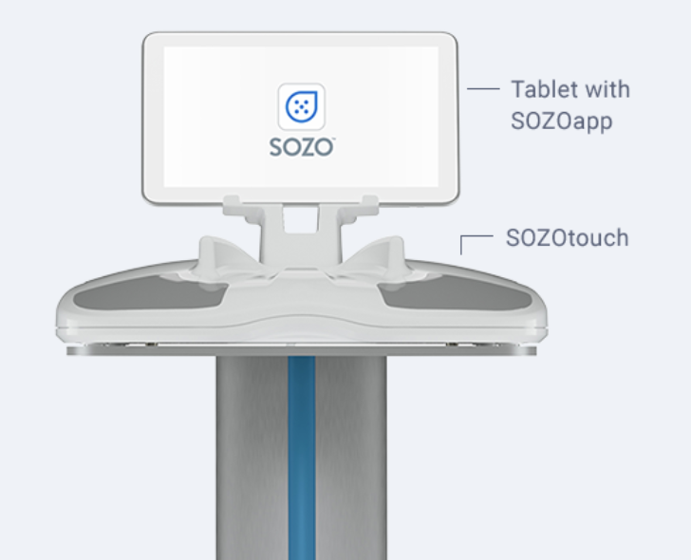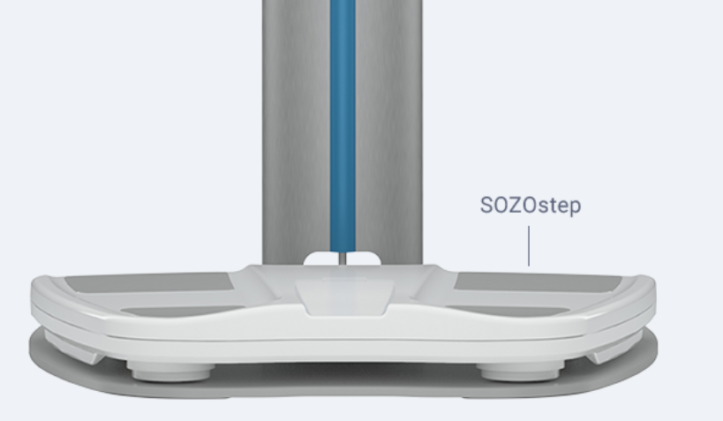 | Uses BIS (Bioimpedance spectroscopy) to measure and track critical information to aid clinicians in managing chronic disease and maximising patient health. Fast results, less than 30 seconds to measure fluid changes.  Patient is usually there at the start of their journey and the middle where measurement of fluid volume like extracellular fluid levels is required. | SOZO device - $9995  L-Dex software - $1500 for 36 months  Hospital pays for device and software subscription, most of it is covered by medicare/insurance | Where L-Dex scan is required, the patient steps on the device and places their hand on a dedicated area where an extremely low-strength electrical current passes through the body and impedance is measured. Algorithms are used to determine fluid levels and tissue composition | This solution is quick, easy, accurate, less prone to clinical errors as all measurements are done on the device, therefore providing therapists with a fast and easy way to track lymphoedema. Comes with necessary software features such as graphing results and intuitive UI. Automatically syncs with electronic medical record | Does not offer compression garment search capabilities
Pen & Paper/Whiteboard   | A pen and paper or whiteboard and  markers can be used by clinicians to record and store measurements.  Can be used at any time of the patient journey | Pen - $1 (Varies widely)  Notebook - $4 for A4 240 pages  Health specialists can purchase their own ones or use the ones that are available at the hospital where the hospital is one that purchases it. | Health specialist will measure limb dimensions with a measuring tape and note it down in a notebook. Next, clinicians can calculate the volume of the limb by approximating the limb to have a certain simplified geometry. | Convenient and easy to use method to track patient’s limb sizes. | Lacks an easy to use method to find the appropriate compression garment. Can be time consuming. Manual measurement is prone to clinical errors. Papers are also prone to being damaged/lost easily when not kept properly
Electronic Medical Record  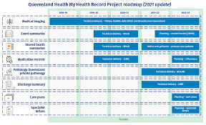 | A digital record of a patient’s medical record. Clinician enters data into the system or data can be synced from supported services. | Paid for by the government, according to The Guardian, the government has spent $2bn on EMR. | When a clinician wants to update a patient’s record, the clinician can log into the system and open the patient’s history where the clinician can then update the patient’s details. | Improves time efficiency for clinicians by providing a means for data to be safely stored and easily shared and accessible by clinicians, therefore improving convenience | Does not offer compression garment search capabilities. Not widely adopted therefore causes inaccessibility issues.
Lymbase.com   | Software which allows clinicians to monitor and track a patient’s lymphoedema progress and quickly offer suitable compression garments for the patient. Mostly used during the treatment process where it is crucial to monitor how a patient is responding to prescribed treatment. | Free for patients and clinicians. Business model involves getting compression garment manufacturers to pay in order to have their products listed on the website. | Instead of using pen and paper or an excel spreadsheet to store patient data,a clinician inputs patient data into the website. Data can also be visualised to show how a patient is progressing across their treatment duration. Clinician can also rapidly find a suitable compression garment for patient through filters and other parameters. | This solution saves the clinicians time as it provides a quick filter system to look for suitable compression garments for patients. It also has a built-in limb volume calculator therefore clinicians do not have to spend time manually calculating limb volume for patients. | UI/UX needs some improvement as current users complained that it can be slightly complex to navigate

State of the art summary
Patients are usually referred to a physiotherapist by a doctor. A physiotherapist first starts by reading any of the notes in the referral, after which they proceed to take some measurements of the affected limb. A tape is used to measure the width and circumference of the affected limb. The measurements are then noted down on pen and paper, after which limb volume is calculated manually using arithmetic and by simplifying the limb shape to a simpler geometry for ease of calculation. Following that, should a compression garment be required to manage the symptoms, the physiotherapist will need to manually consult physical catalogues of compression garments from various manufacturers in order to find one that is suitable for the patient’s limb size. Finally, the physiotherapist prescribes the patient some exercises if necessary as part of the treatment if necessary and subsequently a treatment plan before discharging the patient.

Not much technology is used, only measuring tape, pen, paper, calculator/excel spreadsheet.

