WEEK 3 DELIVERABLE: PROJECT EBOARD
SAHIL BHATIA

EXISTING SOLUTION ANALYSIS

Overview of solution | The current solution used in the emergency department are static whiteboards with whiteboard markers. These are currently used by medical staff, including nurses and clinicians. It is used to document key information, such as dietary requirements (ie. “diabetic/fluid restriction/fluid resuscitation”) and staff member names (ie. “Dr Jones/Nurse Cathy”). This current solution requires legible writing skills.
Clinical solution profile | The information that a clinician or nurse may add to a whiteboard may differ based on patients and their unique presentations. For example, a diabetic patient will have more strict dietary requirements compared to non-diabetics and this will need to be strictly followed to prevent complications - thereby, making a note on the patient’s whiteboard that they are “diabetic”. In an emergency department, key information that may be added would depend on the severity of their presentation.
Economic solution profile | Mathematical Calculations  Whiteboards  ~ $20/whiteboard x 20-30 whiteboards = $400-$600 one-off payment  Whiteboard Markers  ~ $5/whiteboard marker x 6 months = $30 / year to replace the whiteboard markers  Hospital whiteboards are no different to standard static whiteboards and would cost anywhere from $15 to $30, given that small-medium sized whiteboards are used in emergency departments. Additionally, whiteboard markers cost approximately $5 - assuming that whiteboard markers are replaced every 2 months, this will cost a total of $30 a year to replace whiteboard markers.  The cost of these whiteboards and whiteboard markers is paid for by the hospital.
Utilisation solution profile | - The patient is admitted to hospital and taken to a room  - Their medical history is taken by the clinician and this information is stored on the EMR  - The nurse locates a whiteboard marker (colour of choice is preferential)  - The nurse may write on the whiteboard key points such as patient’s name and/or dietary requirements and/or staff member names  - If the patient is discharged or moves rooms, the whiteboard is updated by erasing notes (using a hand, tissue or eraser)
Emerging solution profile | * This criteria does not apply to this project as this is an old/traditional project. Please see the state of the art summary for features which may be added to improve the traditional static whiteboard *

EXISTING SOLUTIONS TABLE
SOLUTION | How: Why/What | Solution Alignment | Gaps in Solution
Two-Way Communication   | A traditional way for clinicians and patients to communicate with each other, using two-way communication and medical-friendly language to convey important information. | This is the most common method of communication in the ED wards, whereby clinicians communicate to patients details of their stay they should be aware of, including clinical diagnosis, goals and clinical staff names. | * information is not stored in a way that patients can access information said in the future - they rely on their own memory  * information may be lost in translation if a clinician uses patient-unfriendly language  * information may be forgotten by patients  * given the time-constraints of physicians and nurses, there is a possibility of communication being incomplete or incorrect
Static Whiteboards  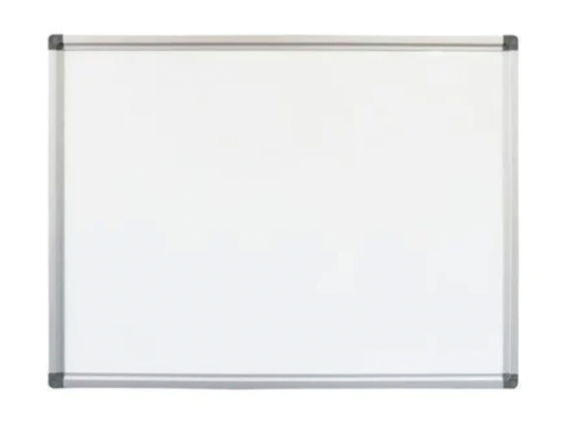 | These static whiteboards can act as a source of pertinent information for staff and patients. Staff can benefit from knowing dietary requirements and the patient’s name, whereas patients can benefit from knowing the treating team’s names and their treatment goals. | This is a relatively easy and straightforward way to communicate pieces of information to other clinicians and patients; however, it often only contains key words as opposed to large pieces of information.  They are also a cheap solution given that the whiteboards can be repeatedly used (by simply erasing previous information); meaning they don’t need to be continually purchased and replaced. | * Whiteboards are required to be erased of previous information and constantly updated given the unpredictable nature of the ED where room changes are continuous.  * It may be exhausting and inconvenient for ED staff to manually input information onto these static whiteboards whilst also balancing the strenuous environment of an ED ward.
Managing Team Response  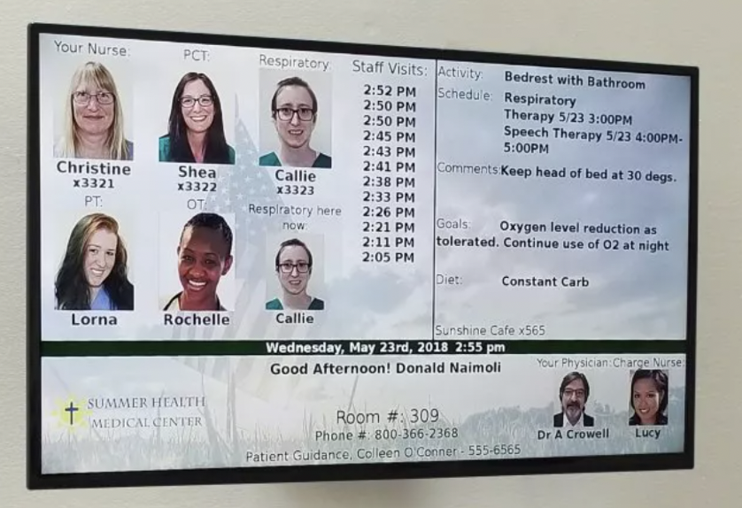 | An electronic patient room whiteboard that digitally displays important information for clinicians and patients in the ED ward. This whiteboard can connect to existing hospital EMR’s (electronic medical records) for easy communication between clinicians and patients. | This whiteboard aligns with both the goals of clinicians and patients - patients can be aware of who their treating team is and their goals, whereas the treating team can be aware of any dietary requirements (or restrictions) as well as their clinical timeline.  Furthermore, ED staff do not have to manually input this information on a whiteboard - instead, this information is drawn from the electronic medical record. | * There is no way for patients to interact with the digital whiteboard (such as through the use of scannable QR codes or forms to ask questions)  * there is no reason for admission, which could be important in cases of medical emergencies where medical records are not on hand
Sonifi Health  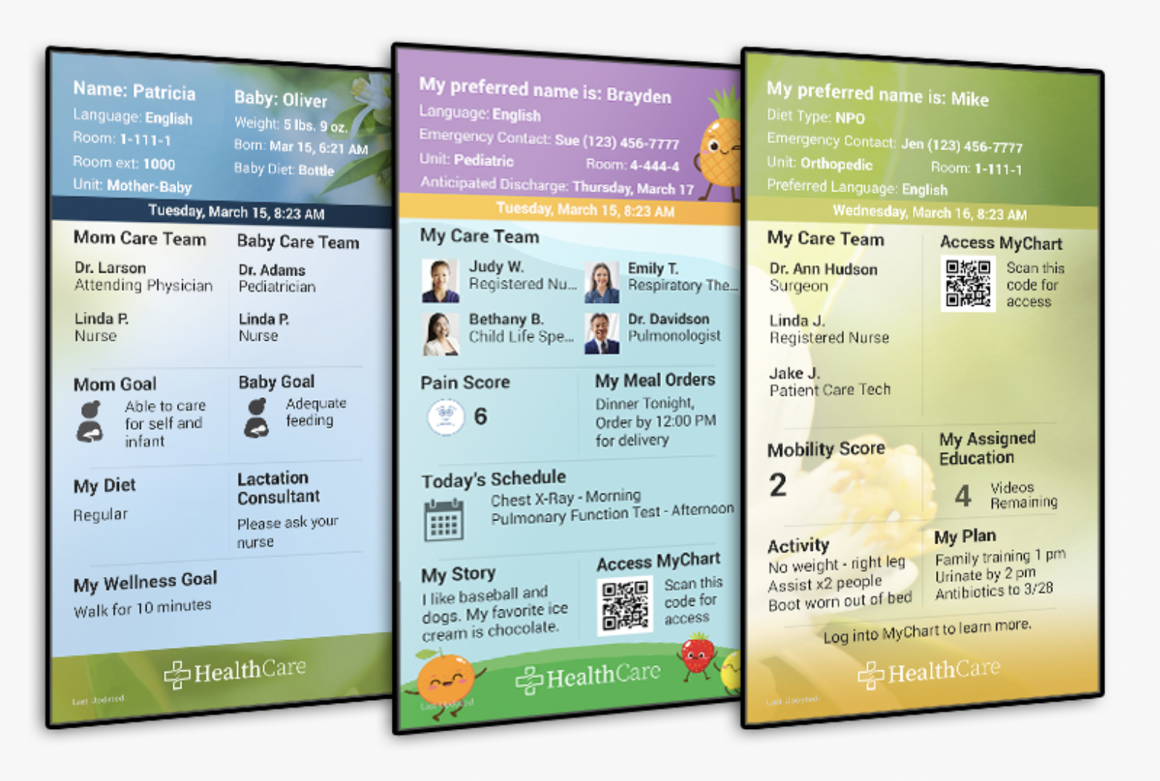 | Along with QR codes for patients and clinicians to access the particular patient’s medical charts. | This solution aligns well with the unique needs of patients who may want the treating team to better know the patient personally (such that the patient is treated and not their disease) - this is found in the “My Story” section and the “preferred name” section. The whiteboard is interactive, with the addition of scannable QR codes for patients to access their medical charts (lab test values). | * there is no reason for admission, which could be important in cases of medical emergencies where medical records are not on hand

FAILED SOLUTIONS
* not applicable due to the relatively novel nature of this technology (failed solutions could not be identified amongst the solution landscape *
STATE OF THE ART ANALYSIS

- Give a summary of the workflow from beginning to end of the currently accepted standard of care for your problem and population
- List the technologies and services used by the patient on their journey from beginning to end of their treatment.
- Highlight key “pain points” in this system - areas where care is less than what it should be

A patient is admitted to a hospital with a presentation and taken to the hospital, where their medical history is taken by the clinician - this information is then stored on the EMR. The most commonly used method of communication with patients is two-way communication, but important pieces of information are stored on a whiteboard. The nurse locates a whiteboard marker (colour of choice is preferential) and they (may) write on the whiteboard (a hardware product) key points such as patient’s name and/or dietary requirements and/or staff member names. If the patient is discharged or moves rooms, the whiteboard is updated by erasing notes (using a hand, tissue or eraser).

The primary pain points in this workflow include:
- The inconvenience of locating a whiteboard marker
- The inconvenience of manually writing information onto the whiteboard
- The inconvenience of updating the whiteboard with new information once the patient moves rooms or is discharged

2. List which technologies and services are relevant to your project and why they are important. This may be technologies you have to accommodate or incorporate in your solution

- Whiteboard marker - acts as a tool to deliver information
- Whiteboard - acts as a display for information

Features that may be added to the existing solution include:
- A scannable QR code for patients to be able to access their test values
- Information on the whiteboard is drawn straight from the Electronic Medical Record (EMR)
- Pictures with accompanying names of the treating team

