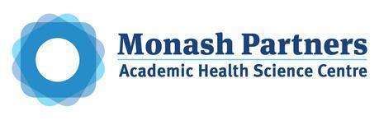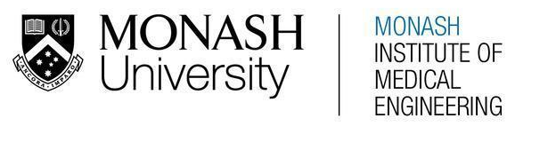
MONASH HEALTHCARE INNOVATION SUMMER SCHOLARSHIPS (HISS)
PROJECT NAME: Project Dolphin
DELIVERABLES NUMBER: 2
PROJECT LEAD: Maya Wilmshurst
1.1 Existing Solution Analysis

Please see the attached document for a summary of each solution and analysis of acceptance criteria alignment.
https://rowan-pressure-3e1.notion.site/Deliverable-2-Project-Dolphin-Existing-Solution-Analysis-1fe8837a40364a39a591c11d095f6982

  - Summary of Solution Landscape
There are a number of solutions that track adherence and/or symptoms (1, 2, 3 (for period), 4, 6, 7). These solutions improve communication between patient and clinician - if used appropriately, they can allow the clinician to gain an understanding of the adherence of the patient (as well as the symptoms that may be affecting this) and develop strategies or new treatment plans to help the patient to overcome this. A number of the solutions also serve as reminders to patients to take medication (1, 2, 5 as well as others to a lesser extent). These more directly increase adherence by targeting one of the key factors preventing patients from having a 100% adherence rate: forgetting.
The key issue with this field of solutions is that:
- Few (if any) of these are specifically targeted towards cancer patients (this includes other apps like MediSafe currently on the market). This means that their reminders and features aren’t targeted to the unique challenges and requirements posed by chemotherapy regimens, even if they allow for the tracking of these medications.
- Few of these solutions directly target one of the other key factors leading to patient non-adherence: drug toxicity/side effects. They don’t give information on how to manage symptoms and often do not track symptoms well. MediSafe for example does not provide as easy way of comparing symptom and nonadherence trends. The app also relies on the patient providing all of the information regarding their medication regimen (it would be helpful if that app knew and could factor in key information like “this medication must be taken at least 20 minutes before eating” to help patients know when to schedule in the medication).

2. State of the Art Summary

Current Workflow

The following diagram details the end-to-end workflow for a cancer patient prescribed with orally administered chemotherapy. The pain points in this process are also identified.
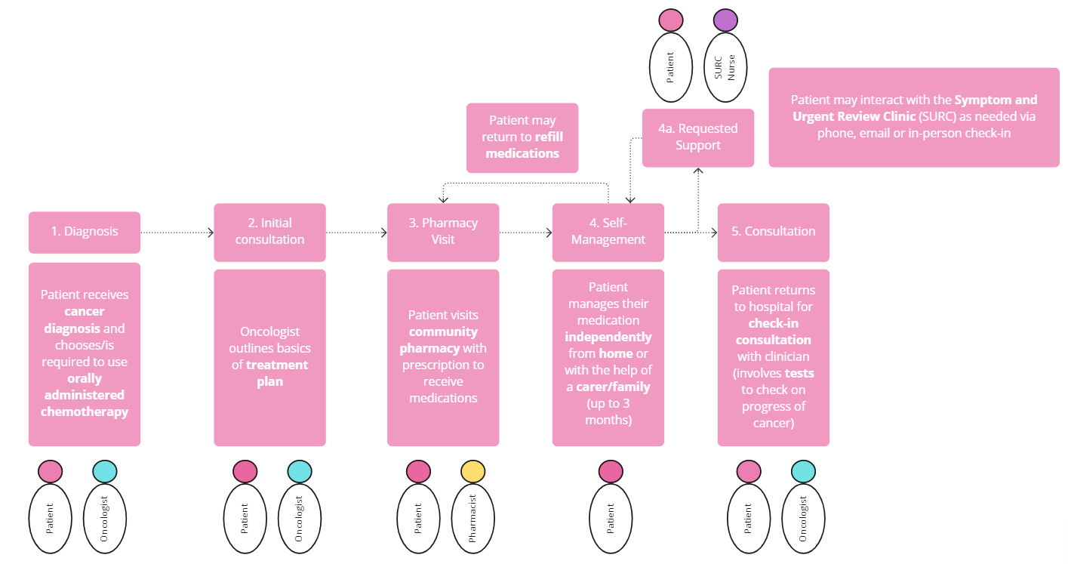
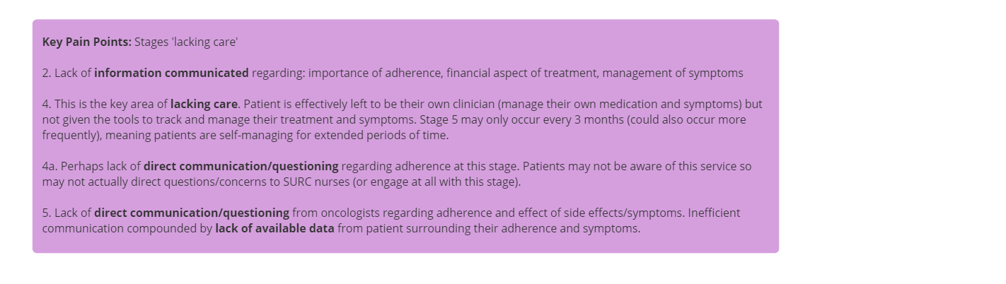

Technologies and services relevant to project:
There are relatively few technologies or services embedded into the healthcare system at this stage.

Symptom and Urgent Review Clinic (SURC):
- Supports patients who are experiencing side-effects or symptoms during their treatment
- Patients are able to reach out to the SURC nurses at any time via phone, email or by presenting to the clinic
- SURC nurses generally hear from patients on oral therapy when they experience symptoms of disease or side-effects of treatment, when seeking approval to commence a new cycle, or if needing routine monitoring (bloods/ECGs/etc..) or medication supply.
- Some patients may not know about this service

Information brochures/websites:
- Upon diagnosis, patients may receive brochures/pamphlets/directions to websites with key information regarding their treatment. This may include the nature of the treatment regimen, details about common side effects etc.

