
MONASH HEALTHCARE INNOVATION SUMMER SCHOLARSHIPS (HISS)
PROJECT NAME: Project Blooming
DELIVERABLES NUMBER: 2
PROJECT LEAD: Jacinta Patel
- Mission Statement: To develop a solution that aids transgender women and gender diverse individuals, in self-monitoring breast development (i.e., breast size and shape) to gauge satisfaction with gender affirming hormone therapy.

2.1 Existing Solution Analysis:
Solution | Overview | Clinical and Utilisation Profile | Economic Profile and Gaps
3D Modelling | - Cis women for reconstructive and cosmetic breast surgery procedures+ after breast cancer  - Has been tested on Transwomen  - Natural Shape Methods  - Considers volume, shape, and surface area | - Done through a 3D device such as a laser scanning machine measuring the distance between target pints on the breasts to the scanner, and stereo camera using several synchronised cameras places at different angles.  - Done standing and can produce a colour-coded map  - The breast boundary is defined, and the breast area of the 3D model is selected. A chest all is then simulated by software. The selected breast area and simulated chest wall are superimposed to achieve a closed object in which the volume is calculable. | - 3D devices can cost $20-100K  - Accurate in determining the true boundary of the breast  - To increase reliability images taken at different times must be standardised/
Water Displacement (in situ) 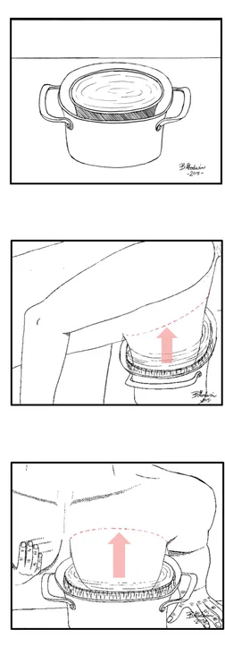 | - Cis women for reconstructive and cosmetic breast surgery procedures  - Natural Shape Methods  - Considers only volume | - Breaker/cylinder  - Bucket/jar  - Patients are placed in prone (down) position or on their knees and the breasts is immersed in water in a container; then the volume displaced is calculated | - Method is not recommended because patients are often unable to immerse their breast in water fully or over immerse. This leads to inconsistent definition of chest wall resulting in low reproducibility.  - approximate the posterior wall to a plane surface
Cast  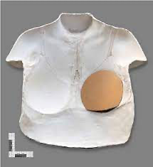 | - Cis women for reconstructive and cosmetic breast surgery procedures  - Natural Shape Methods  - Considers only volume | - Plaster striped done standing  - Thermoplastic sheet done half-seated and takes about 25 mins  - The material is place on or around the patient’s chest for 1-5 mins and removed after the cast forms. The cast is then filled with water or sand to calculate the volume | - Thermoplastic sheet costs $20-$150  - There is manual compression during the application that can cause variability  - approximate the posterior wall to a plane surface
MRI  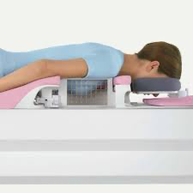 | - Cis women for reconstructive and cosmetic breast surgery procedures  - Has been tested on Transwomen  - Stereological/Cavalieri’s method  - Considers only volume  - Used in a clinical setting | - The patient is placed in prone (facing down) position and wears a breast coiled to avoid compression of the breasts.  - This is done in a hospital setting.  - Researchers manually define breasts and then calculate volume using summed layers.  - Can also assess breasts implant  - Can take 30 mins to an hour | - Accurate in determining the true boundary of the breast
Computed Tomography (CT) 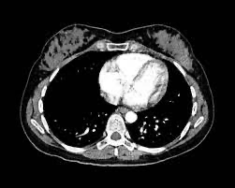 | - Cis women for reconstructive and cosmetic breast surgery procedures  - Stereological/Cavalieri’s method  - Considers only volume  - Used in a clinical setting | - Similar to MRI  - Takes 20 to 30 minutes | - Accurate in determining the true boundary of the breast  - Radiology exposure is not recommended
Ultrasound 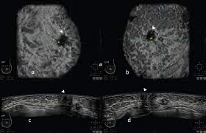 | - Cis women for reconstructive and cosmetic breast surgery procedures  - Stereological/Cavalieri’s method  - Considers only volume  - The device is used by a medically certified sonographer. Used in a clinical setting | - Usually done in a supine position (face upwards) and the probe of the ultrasound machine scans are performed on the chest at 1-cm intervals. The area of each slice is measured.  - Takes 15-30 mins | - The segmentation of the plane and plane thickness are controlled mentally by the operator this operator dependent.
Grossman–Rounder measuring device 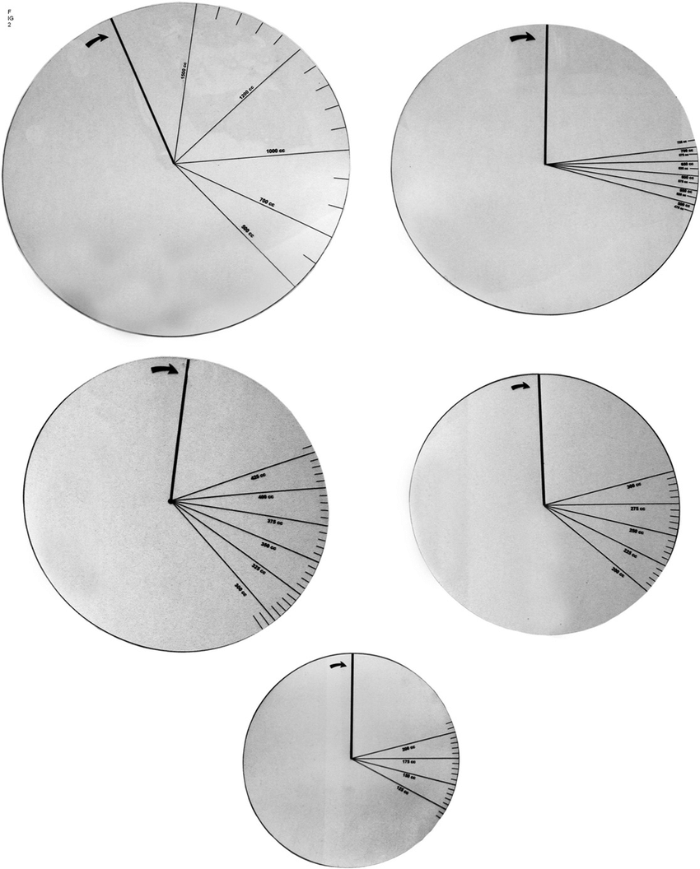 | - Cis women for reconstructive and cosmetic breast surgery procedures  - Geometrical methods  - Considers only volume | - RS device done half-seated and about 3-10mins  - It is a device made of a circular piece of plastic that forms a cone around the breasts and then the volume is read from a scale | - RS device costs $1  - High reproducibly but less accuracy  - Cheaper and requires less time
linear measurement  | - Cis women for reconstructive and cosmetic breast surgery procedures  - Geometrical methods  - Considers shape and volume | - Using a tape measurer done standing and takes about $5  - Camera + software analysis in 3D measurement done standing and can take about a minute  - The investigator measures linear distance between anatomical landmarks on the patient’s body and then uses formula to calculate volume.  - Formulas can be based on a calculation of the geometry volume of a come or based on polynomial regression of a large data sample such as Breast V | - Tape can be $1  - Other tool is just be the cost of a camera  - High reproducibly but less accuracy  - Cheaper and requires less time
X-ray 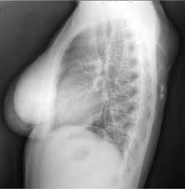 | - Cis women for reconstructive and cosmetic breast surgery procedures  - Geometrical methods  - Considers only volume  - Used in a clinical setting | - Mammography done standing and takes about 20 mins  - Length and wide of the mammogram and compression thickness is obtained. Breasts is considered as a cone or half-elliptic cylinder for calculation. | - Costs about $60  - Patient discomfort  - Radiology exposure is not recommended

Notes: https://link.springer.com/article/10.1007/s00266-014-0412-5
a) Natural Shape Methods – follow natural contour of the breast in volume measurement
b) Stereological/Cavalieri’s method - “Cavalieri stated that the volume of any object can be estimated from a set of two-dimensional slices through the object, provided they are parallel, separated by a known distance, and begun randomly within the object.” Volume = Σ_{i} Area_{i} × Height_{i}.
c) Geometrical methods – approximated to geometrical shapes (such as a sone or half-ellipsoid) and then volume is calculated by corresponding geometrical equation. Usually, linear measurements
d) Mathematical models – formula achieved by polynomial regression. Volume = a ₁ x ₁ + a ₂ x ₂ + ··· a _{n}

2.2 Summary of solution landscape
There are about 9 main types of measurements that can be used to quantify breast size or volume. Many of these tools have been used on cis women as a key metric for breast reconstruction surgery following mastectomy. A few systematic reviews have concluded that the use of 3D modelling and MRI are the most reliable tools to determine breast volume. These two solutions have also been used to measure breast development and breast anthropometric changes in people undergoing gender affirming hormone therapy in in literature. Though, these solutions are expensive, and MRI is used in a clinical setting.

While seeking solutions, it is important to keep in mind the following note:
- Body anatomy and morphology differs between cis women and patient undergoing gender affirming hormone therapy such as trans women and non-binary people. Many patients have undergone male puberty, thus, anatomical landmarks differ in position.

2.3 Solution alignment and gaps using acceptance criteria

Acceptance Criteria (Tweaked using deliverable 1 feedback)
- The solution is easy to use
- The solution is affordable
- Solution is time efficient
- Aid in tracking progress of breast development
- Can be done independently by patient

Green – true, Red – False/Complicated, white - unsure

Solution | 1 | 2 | 3 | 4 | 6
3D modelling
Water-dis
Cast
MRI
CT
Ultrasound
Grossman–Rounder
Linear (Tape/Camera)
Xray

2.4 Patients Journey

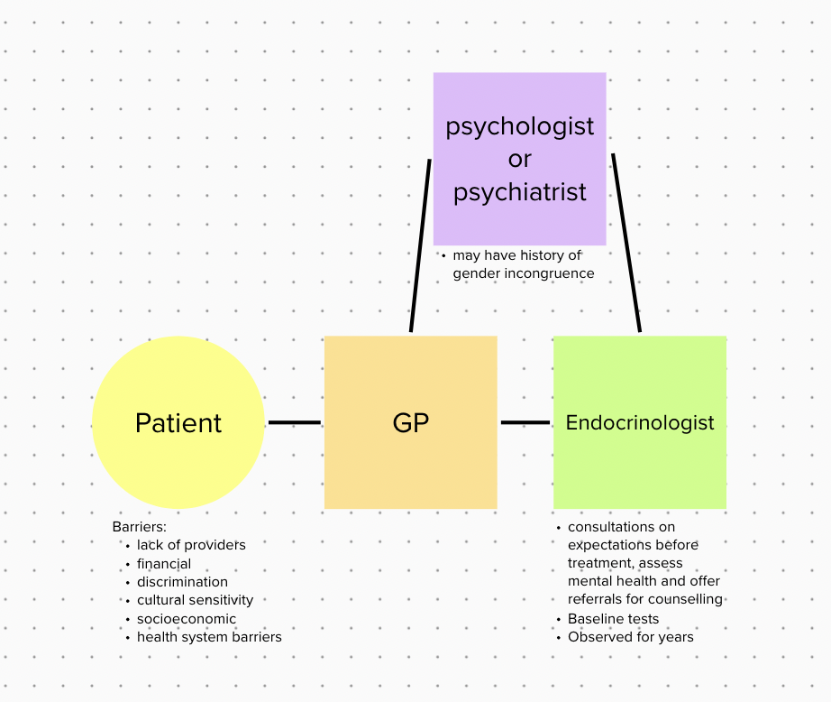
- There is no approved measurement tools used by endocrinologist to measure breast development in people undergoing estrogen hormone GAHT

