
MONASH HEALTHCARE INNOVATION SUMMER SCHOLARSHIPS (HISS)
PROJECT NAME: Activus
DELIVERABLES NUMBER: 2
PROJECT LEAD: David Cheng
1.5 Existing solutions & gaps in solution, failed solutions
Type | How, why, what | Solution Alignment | Gaps in solution
Exercise Device | Pedal machine – mounted  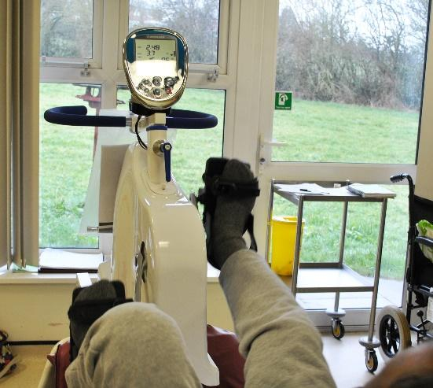 | Portability and ease of operation  Highly portable, easy to set up and easy to use. Staff likely required to set it up, but there should be no problems  Feedback/support  Feedback only invovles information regarding speed, distance travelled, etc. There is no support. They only offer short term experiences, and do not provide any patient progresss reports, nor do they provide supportive messages or encouragement.  Upper and lower limb:  Lower limb exercises only  Adherence features  No features to promote adherence  Dialytic settings  Suitable only for clinical settings, and for chairs that are in a more reclined position. | This solution is not suitable because it does not offer meaningful feedback and support to patients. Additionally, there are no adherence features, and are only suitable for clinical settings where the patient is on a reclined seating arrangement. It also does not offer any upper limb exercises.
Exercise Device | Pedal machine - free standing  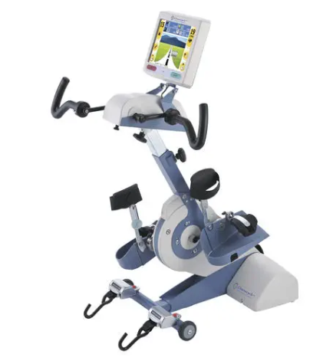 | Portability and ease of operation  Not portable and harder to set up and due to large size. It is easy and comfortable to use, but may require expert staff to set up.  Feedback/support  Feedback consists only of data such as speed, distance travelled, etc. with no supportive measures; there are no patient progress reports, nor are there messages of encouragement or support. Short-term experiences are all that is provided.  Upper and lower limb:  Both upper and lower limb exercises  Adherence features  Some very simple game functions can be found in these examples.  Dialytic settings  Suitable only for clinical settings. | This solution is not suitable because it is too big and bulky to be used widely. Additionally, feedback and support is limited in machines found, with no mention of any personalised routines to tailor exercise experiences for patients. Additionally, adherence functions seem like an afterthought due to the simple nature of the games available. Due to it's large size, it is only applicable for clinical settings.
Exercise Device | Small pedal machine  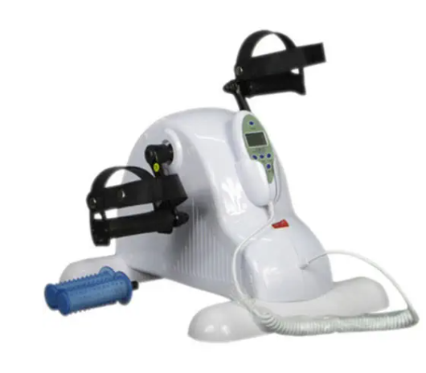 | Portability and ease of operation  This solution is highly portable. It is light weight, can be folded for easy storage, and does not require specialised personnel or equipment to move.  It is also easy and intuitive to use - a simple knob to increase resistance means the patient can tailor their exercise to their needs.  Feedback/support:  These devices offer little to no feedback or support. Data is not logged, and the only information given is basic such as distance, time, calories.  Upper and Lower Limb:  Can be used for both upper and lower limb exercises.  Adherence features:  No adherence features  Dialytic settings: Appropriate for any setting where the patient is seated. It is not suitable for patients who may be inclined. | This solution is not suitable due to very little feedback or support. There are no personalised routines for patients to follow, with the only feedback being simple and rather arbitrary performance information. There are no adherence features, and may not be suitable for those who prefer to be in an inclined position. In some devices, there is a problem with the ease of use, in that the resistance of the device cannot be operated in the seating position without significant movement.
Exercise Device | Resistance bands  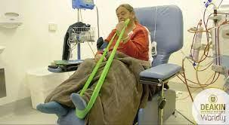 | Portability and ease of operation:  Highly portable with no weight or storage problems.  Not easily used, constant support is often required to train patients and to ensure.  Also note that these type of exercises may require patients to move when using these devices.  Feedback/support:  There is no feedback or support given to patients. Additionally, any feedback or control will likely rely on someone counting.  Upper and Lower Limb:  Upper and lower limb exercises are possible, with a wide variation. Note though that this type of exercise is a type of resistance training, not aerobic like some of the others. It is still expected to yield similar benefits for patients.  Adherence features:  There are no adherence features.  Dialytic settings:  Suitable for all settings. | This solution is not suitable due to the complete lack of support or feedback given by the device to the patient. There is no data logging of any kind, meaning patients will need to either track their own progress or rely on someone to track progress for them. There are no adherence features found either.
Exercise Device | Resistance machine  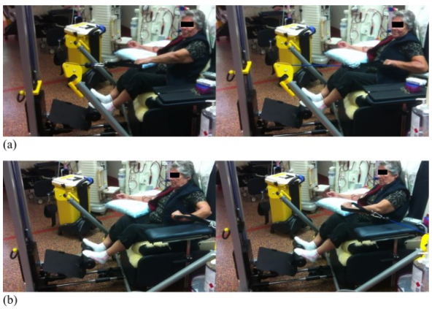  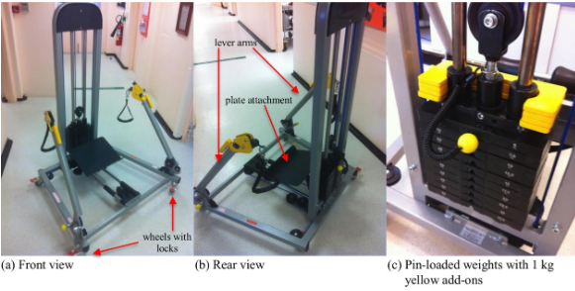 | Portability and ease of operation:  This machine is not highly portable. It is large and heavy, making it hard for storage. It is also moderately complicated to use, meaning training programs will need to be considered.  Feedback/support:  Feedback and support is lacking in this department. Unlike ergometers which can quite easily generate quantitative data, progress measuring devices are more limited for these types of machines.  Upper and Lower Limb:  This device can be easily used for both upper limb and lower limb exercises. These exercises will be resistive in nature.  Adherence features:  There are no features to promote adherence.  Dialytic settings:  The machine, while on wheels and can therefore be used for some clinical dialysis units, it is quite big and heavy, meaning it will be hard to be used at home or some of the smaller dialysis units.  Final Notes:  It is also expected that this solution will be very expensive, given the amount of metal and components that need to be considered. | This solution is not suitable due to the size and weight of the machine, meaning it will not be available in every dialysis unit, and movement will require staff to be trained and educated on how to use the machine. It is also judged to be moderately unintuitive to use, meaning training programs and supervision will need to be considered to avoid the potential for injury during usage.
Exercise Device | Dumbbells  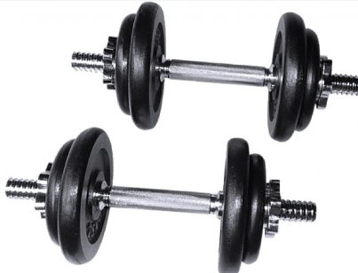 | Portability and ease of operation  Dumbbells are highly portable in size but not weight. They can be used in patients with moderate levels of training, but may pose a hazard if it is misused.  Feedback/support:  There is no feedback or support provided, with the only type data logging and support from manually counting reps and the associated weight.  Upper and Lower Limb:  Upper limb only. Lower limb exercises are not easily done without movement of the entire body.  Adherence features:  There are no adherence features present.  Dialytic settings:  Suitable for all settings.  Final Notes:  This solution is potentially dangerous for patients, especially if they become unconscious. | This solution is not suitable due to the complicated and potentially dangerous nature of training. It should be noted that during dialysis, patients may feel unwell or lose consciousness, meaning any weights will become a health hazard. There is no feedback or support provided, with progress tracking coming from the patient or a supervisor. Lower limb exercises are possible, but not easily. There are no adherence features.
Exercise Trackers or programs | Smart watch  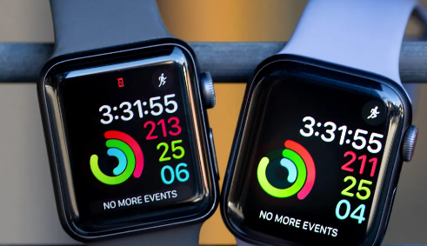 | Portability and ease of operation  Smart watches are portable in that they can be worn on the wrist. It may be hard to use for some patients, however, as it needs to be charged, and they may need to be trained on how to use it. Additionally, their small screens may be an issue with patients on dialysis as their vision may not be as great as the rest of the population.  Feedback/support:  A smartwatch can definelty provide feedback and support. Sophispcated smart watches are able to measure things like heart rate. It has trouble accurately measuring things that interface with the machine though. A custom app will be able to interconnect users.  Upper and Lower Limb:  N/A  Adherence features:  Adherence can be monitored, and feature sets can be added in the future to promote adherence.  Dialytic settings:  Suitable for dialytic settings at home and in clinical settings.  Final Notes:  This may also be expensive - can cost upwards of 300 dollars per patient. | This solution is not suitable due to the complicated nature of smartwatches, which also needs to be charged. Their small screens are also an issue as some dialysis patients have poor vision. They may also be quite expensive as a tracking device.
Exercise Trackers or programs | Ergometers  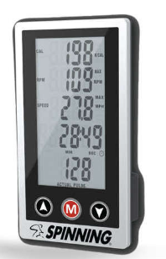 | Portability and ease of operation:  Often comes paired with the pedalling devices. They are often small, and provide basic information regarding the distance travelled, time spent exercising, etc. Typically small, easy to operate and use. Screen on the devices may be small though.  Feedback/support:  Does not offer much support, and feedback given is minimal.  Upper and Lower Limb:  N/A  Adherence features:  No adherence features  Dialytic settings:  N/A | This solution is not suitable due to the very limited information given to patients. They do not offer any support or feedback, nor do they have any adherence features.
Exercise Trackers or programs | Manual recording  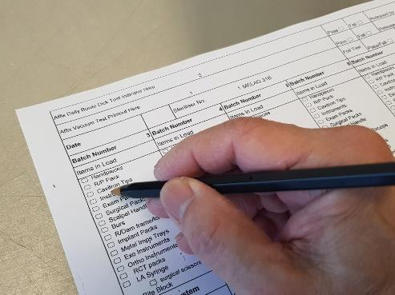 | Portability and ease of operation  Labour intensive, i.e, requires nurses or hospital staff to use.  Feedback/support:  Potential for lots of great feedback and support, namely encouragement from hospital staff.  Upper and Lower Limb:  N/A  Adherence features:  Social pressure may be an adherence feature.  Dialytic settings:  Only applicable for clinical settings. | This solution is a viable way to record patient progression in a clinical setting, but is not available in a home setting. Additionally, this sort of recording does not offer patients any feedback during their exercise routine, and may be draining on hospital staff.
Exercise Trackers or programs | Peloton style program (Cadence sensor + indoor cycling app)    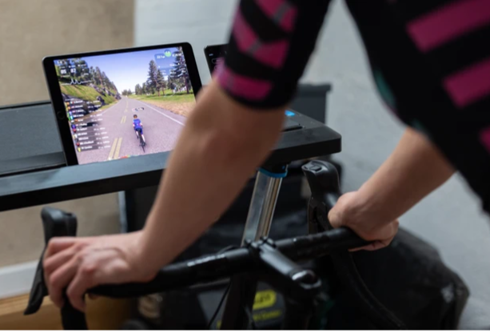 | Portability and ease of operation  Large screen required will be great for those who may be vision impaired, but training will be required to utilise the machine and it's features. Additionally, a power source and an internet connection may be required.  Feedback/support:  Lots of great feedback and support information is given. Users are able to see their progress, and compare it with others.  Upper and Lower Limb:  Upper limb and lower limb exercises can be measured.  Adherence features:  Gamification system is an adherence feature, coupled with detailed data logging gives users an incentive to keep exercising.  Dialytic settings:  Applicable for all situations. The power cable and internet requirement may be components which are difficult to set up. | This solution is a little complicated to set up. While this is fine for some of the younger patients, may be a barrier for some of the older patients or those who are not great with technology. Additionally, some of the icons and text may be too small for them to read. This solution is also uncontrollable from the seated position, meaning patients will need to call staff to operate the machine.

Note on Clinical, Economic, Utilisation profiles:
Clinical: The exercise machines shown are largely grouped into aerobic type machines such as those with a pedal, and resistance machines such as any devices that deal with weights or the resistance bands. These tow types of exercise are known to improve outcomes relating to sarcopenia and frailty.
Economic: The prices of the exercise devices vary greatly. It is expected that the larger machines such as the free standing cyclers and the resistance training machines are very expensive (>$5000 AUD), with much simpler examples already available for over $7000. Some of the smaller pedal machines are known to be relatively cheap in comparison, with some like the small pedaling machines available for under $100 AUD and the mounted cyclers reportedly under $500 AUD. These devices are also likely paid for by the dialysis unit, either through external funding (i.e government programs) or internal funds.
Utilisation profiles: All exercise machines are expected to require dialysis staff to set up or retrieve the machine for patients. These machines will then be used by patients until the end, whereby dialysis staff will put away the exercise equipment. Some patients and exercises will need to be supervised by staff to ensure safe operation.
Note on failed and state of the art solutions:
Clinical trials are invaluable for gaining insight into the efficacy of treatments for various conditions. However, patients often do not adhere to the exercise programs recommended during the clinical trial once it has ended. This can hinder the long-term effectiveness of the treatments and can lead to a relapse of symptoms. To address this issue, developing strategies for long-term adherence to the prescribed exercise program is needed. This can involve providing additional education and support for patients so that they understand the importance of sticking to the program for the best possible outcome. In some countries like Japan or Singapore, intradialytic exercise is common, and often involve relatively simple machines such as small pedaling machines, but with a robust program of feedback and support from dialysis staff.

