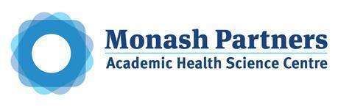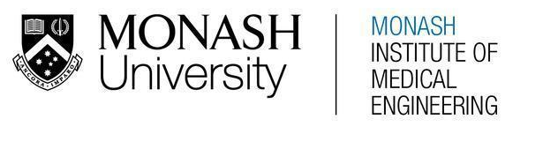
MONASH HEALTHCARE INNOVATION SUMMER SCHOLARSHIPS (HISS)
PROJECT NAME: THEIA
DELIVERABLES NUMBER: 1
PROJECT LEAD: PATRICK KWAN
- Mission Statement: To improve the accessibility of point-of-care COVID-19 rapid antigen tests towards members of the low-vision and blind population, by assisting individuals to conduct the test and to interpret the results independently.

- Acceptance Criteria:
- The solution improves the accessibility of point-of-care COVID-19 rapid antigen tests towards low-vision and blind users, through the following criteria:
  - The solution enables users to conduct and interpret all available point-of-care rapid antigen tests successfully without the assistance of another person, in comparison to existing practices.
  - The solution improves user’s convenience and ease-of-use conducting all available point-of-care rapid-antigen tests, in comparison to existing practices.
  - The solution increases user’s confidence in their ability to conduct and interpret the test.
  - The solution increases user’s willingness to conduct the COVID-19 tests, and increases COVID-19 surveillance amongst the low-vision and blind population.
  - The solution improves user’s privacy in interpreting all forms of rapid-antigen tests, in comparison to current practices.
  - The solution decreases user times taken to interpret all available point-of-care rapid antigen tests in Australia.
- The solution is cost-reducing in comparison to existing practices.
- The solution is scalable and can be used for other point-of-care medical tests (e.g. pregnancy tests).

- Needs Statement: To develop a solution that will improve the accessibility of point-of-care COVID-19 rapid antigen tests towards members of the low-vision and blind communities.
- Population: Vision-impaired, low-vision and blind population in Australia.
- Problem: Point-of-care rapid antigen tests cannot be conducted easily and interpreted independently by low-vision and blind users. This acts as a barrier and can disincentivize users from conducting tests, resulting in a higher probability of lowered COVID-19 surveillance amongst blind and low-vision communities.
- Outcome:
  - Decreased times taken to (1) interpret all available forms of rapid-antigen test in comparison to existing practices.
  - Improved user’s confidence in (1) conducting and (2) interpreting all available forms of rapid-antigen tests successfully, in comparison to existing practices.
  - Improved user’s willingness to conduct all available forms of rapid-antigen test.
  - Enables users to conduct all forms of rapid-antigen tests independently, without the assistance of another person.
  - Improves user’s privacy when interpreting results of all forms of rapid-antigen test.
  - Higher probability of increased COVID-19 surveillance amongst blind and low-vision communities.

- Disease State Fundamentals:
- Epidemiology:
  - In 2016, it was estimated that low vision and blindness impacted a minimum of 384,000 people in Australia, and is projected to increase to 564,000 individuals by 2030.
  - It disproportionately affects older populations, approximating a total of 100,000 people over age 50. The primary causes of blindness are age-related; and include:
    - Cataract: A condition which involves the clouding and hardening of the lens in the eye, resulting in loss of sight and eventual blindness if untreated; the primary cause of 40% of visual impairment in Australians.
    - Age-related macular degeneration: A disease of the macula that causes progressive loss of central vision, whilst not affecting peripheral vision, and affects 28% of Australians.
    - Diabetic retinopathy: An eye condition that causes vision-loss and blindness in individuals with diabetes.
    - Glaucoma: Loss of vision due to damage to the optic nerve.
  - In younger individuals, low-vision occurs due to unavoidable causes which affect 0.03% of the population at birth in high-income countries. These include oculocutaneous albinism, nystagmus, optic nerve hypoplasia, coloboma, retinal diseases and congenital cataract.
  - Only 15% of people with low-vision receive appropriate assessment and access to low-vision aids.
- Anatomy & Physiology:
  - 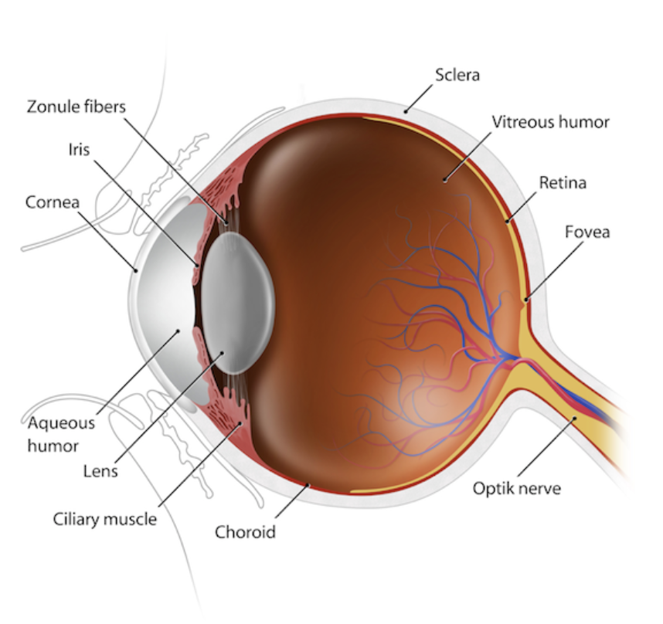
  - Lens is a transparent structure made up of epithelial cells and fibres, enclosed in a lens capsule (i.e. a membranous structure).
    - Its main function is to fine-tune the focussing of light onto the retina, which contains the photoreceptors or specialised cells responsible for processing visual stimuli and providing us sight.
    - Transparency depends on the tightly-packed structure of lens fibres and intracellular proteins to permit the transmission of light, and provide refractive power for focussing on near objects.
  - The lens consists of three layers:
    - Cortex (superficial) - contains younger fibres
    - Nucleus (deeper section) - contains older fibres
    - Capsule
    - 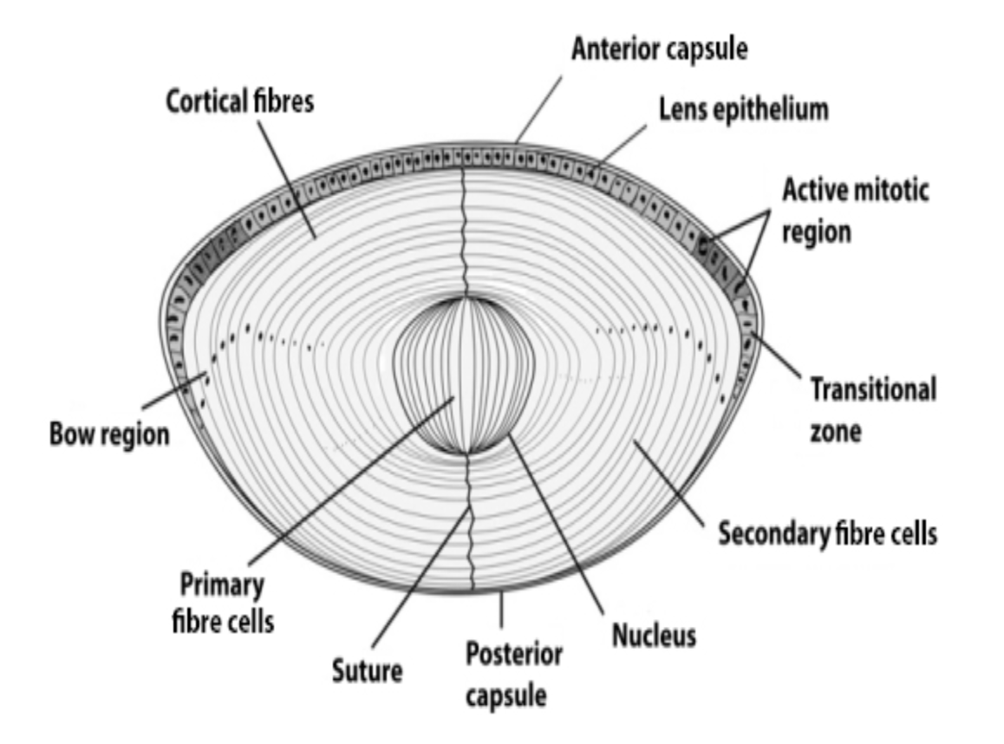

- Pathophysiology:
  - Causes of loss of vision vary widely, and may be genetic, congenital, acquired (i.e. from traumatic injury), or as a result of complication of disease.
  - The most common cause of blindness is cataract: known as the hardening and yellowing of lenses in the eye. There are several types of cataract, and it can be age-related (the most common aetiology), traumatic or metabolic.
    - Age-Related: Pathogenesis is multifactorial and not fully understood, but includes:
      - Nuclear sclerosis (i.e. the yellowing and stiffening of the fibres in the nucleus of the lens), resulting in becoming less flexible, less transparent.
      - Abnormal changes in lens proteins, and protein breakdown; resulting in accumulations which cloud the lens. As the lens becomes more densely clouded, light is occluded from passing onto the retina; resulting in blurred vision and blindness.
- Clinical Presentation:
  - Clinical presentation of cataracts predominantly depends on the location of the cataracts:
    - Nuclear Sclerotic:
      - Yellowing and hardening of the central portion of the lens, resulting in near-sightedness.
      - Symptoms include blurred distance vision, poor vision in dark settings, glare, decreased contrast, and increased myopia.
    - Cortical:
      - Predominantly results in glare, particularly from bright lights.
      - Glare, including halos or streaks around lights; difficulties with vision in the presence of bright lights
    - Posterior subcapsular cataracts:
      - Opacities located in the posterior cortical layer, directly under lens capsule.
      - Symptoms include glare, difficulties in seeing bright light, and impaired near vision.
  - Progression results in loss of vision and blindness.
- Clinical Outcomes:
  - Definitions of Blindness:
    - Total Blindness: Complete lack of light perception. Total blindness affects approximately 15% of individuals with eye disorders.
    - Legal Blindness: Clinical blindness presents as many forms:
      - An inability to see at six metres, what someone with normal vision can see at 60 metres; or otherwise with a certain visual acuity on the Snellen Scale that is less than or equal to 6/60 in both eyes; or
      - Constriction of within 10 degrees or less of the arc of central fixation in the better eye;
    - Low Vision: Low vision is defined as permanent vision loss that is unable to be corrected with standard refractive correction (e.g. glasses or conventionally eyewear). Whilst low-vision affects individuals’ daily functioning, users are typically able to use vision for the planning or execution of tasks.. It can present as a loss of sharpness of vision, or a loss of field of vision, increased sensitivity to light, distorted vision, and reduced ability to detect contrast.
    - Visual Impairment: Decreased visual function interferes with ability for the individual to perform everyday tasks including reading, driving and watching TV. Unlike the other forms, this is defined based on function, rather than visual acuity or visual field values.
- Economic Impact:
  - Costs to the healthcare system arise through two predominant causes:
    - Direct costs, through the provision of eye care services to individuals;
    - A large proportion of costs are not directly related to eye-related medical care, but to falls and other accidents due to visual impairment, and their effects on other comorbidities, including depression, cardiovascular disease, diabetes and hypertension.
  - Vision disorders resulted in an estimated $10.85 billion in 2014, and are projected to increase to $11.85 billion in 2024.
    - Direct costs account for $1.8 billion.
    - Indirect costs (e.g. carers’ costs, low vision aids, lost earnings, and other welfare payments and taxes) account for $3.2 billion.
  - An estimated amount of $500 million is spent in the hospitalisation of low-vision or blind patients in Australia, in comparison to patients without vision loss who are being hospitalised for similar conditions.

