
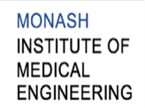



MONASH HEALTHCARE INNOVATION SUMMER SCHOLARSHIPS (HISS)
PROJECT SENTINEL: MONITORING SYSTEM FOR PATIENTS RECOVERING FROM ISCHAEMIC STROKES
DELIVERABLES WEEK 2
PROJECT MEMBERS: Calvin Zheng, Diana Kovaleva
1.1 Mission Statement
To create a solution that is able to monitor the stability of the neuronal activity of patients recovering from ischaemic stroke over time, and is able to provide continuous visual output to nurses and doctors to improve the efficiency and effectiveness of patient monitoring.

1.2 Acceptance Criteria
- Easy for hospital staff to read and interpret
- Offers continuous surveillance of the patient’s neuronal activity over a period between 30 minutes and 24 hours
- Does not require an operator to be continuously present to function.
- Is able to be improved upon over time
- Utilises existing hospital equipment
- Provides a ground truth about the state of the patient, and the severity and stability of the stroke.
- Cost effective

1.3 Needs Statement
A method of monitoring patients recovering from ischaemic strokes without the presence of medical staff over a long period of time, that is able to update doctors and nurses of the condition of the patient over the duration of the monitoring session in an easy to read format.

- Problem:
  - Current techniques for monitoring patients recovering from ischaemic strokes require the presence of medical staff to test the patient using visual methods, which is not efficient due to the ratio of stroke patients to doctors and the frequency of monitoring sessions. Current monitoring techniques are also unable to determine the stability of a patient and whether their condition is likely to improve or deteriorate.
- Population:
  - Population of patients that have suffered a preliminary (non-recurring) ischaemic stroke and are staying in hospital under surveillance for longer than 10 days.
- Outcome:
  - Reduce unnecessary use of more invasive imaging techniques
  - Monitor patients over a longer period of time
  - Monitor the stability of patients over time and provide an earlier detection for changes in situation than current monitoring techniques
  - Able to update medical staff of the current and historical condition of the monitored patient efficiently and effectively
  - Easy to use for medical staff

1.4 Disease state fundamentals
- Epidemiology:
  - Causes:
    - Embolic – artery is blocked by a blood clot, or an air bubble formed in another part of the body
    - Thrombotic – the blood clot grows on the wall of the blood vessel and block it
  - Distribution (2020 statistics):
    - Accounts for 85% of all stroke cases
    - 30 000 to 40 000 Australians experience stroke for the first time every year
    - Approximately 450 000 Australians are living with the effects of stroke
    - 24% of first time strokes occur in people aged younger than 54 years
    - Affects rural communities more than metropolitan areas
  - Control of disease:
    - No medical treatment for damage caused by stroke.
  - Therapies to eliminate clot:

    - Cerebral angiogram. Uncommon. A catheter is inserted through a small incision, usually in the groin, and is guided into the carotid or vertebral artery. Then a dye is used to make the vessels visible in an x-ray.
    - TPA IV medication within 3 to 4.5 hours after stroke. Injected in the arm.
  - Current methods of stroke detection:
    - Physical exam: Check heart rate and blood pressure. Also a neurological exam.
    - Blood test: Check for speed of clots, blood sugar level, and possible infections.
    - CT scan: Can show bleeding in the brain, an ischemic stroke, a tumour or other conditions
    - MRI: Can detect damages tissue
    - Carotid ultrasound: Use ultrasound to detect buildup of fatty deposits in the carotid arteries, which is a common cause for strokes.
    - Cerebral angiogram. Uncommon. A catheter is inserted through a small incision, usually in the groin, and is guided into the carotid or vertebral artery. Then a dye is used to make the vessels visible in an x-ray.
    - Echocardiogram. An echocardiogram uses sound waves to create detailed images of the heart. This searches for clots in the heart that may have travelled to the brain.
  - Current methods of stroke treatment:
    - Thrombolysis: using drugs that break down the clot
      - TPA IV medication within 3 to 4.5 hours after stroke. Injected in the arm.
    - Endovascular therapy:
      - Still using TPA, but injected with a catheter through the groin directly into the bloodstream. Longer time window than standard IV.
      - Using a catheter inserted through the groin to physically remove the clot. Useful for larger clots that can’t be dissolved. Used in conjunction with TPA. The catheter tip is either a corkscrew or a stent.
      - Perfusion imaging tests can help determine if endovascular therapy is needed.
    - Other procedures: Reduces the chance of future strokes
      - Carotid endarterectomy: removing plaque from the carotid artery.
      - Angioplasty and stents: widening the carotid artery with a stent.
  - Preventative techniques (80% of strokes are preventable):
    - Aspirin (also reduces chances of recurrent stroke)
    - Controlling blood pressure and cholesterol
    - Limiting alcohol and smoking (lifestyle)
- Anatomy and physiology
  - Circle of Willis - main circulatory system of the brain
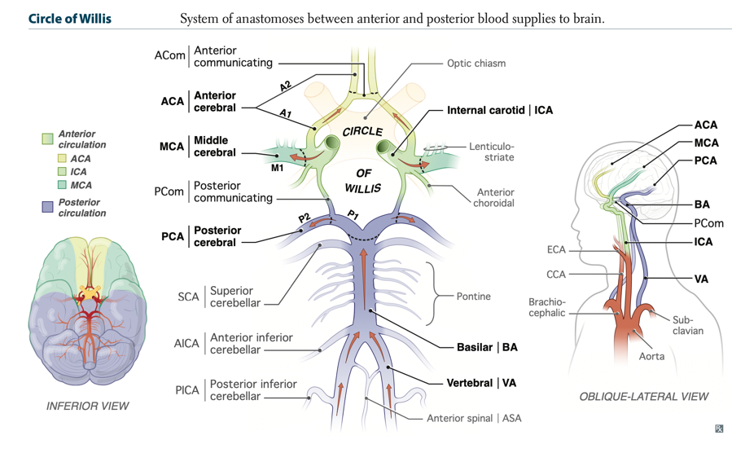
    - Different areas supplied by different arteries
    - Areas of the brain responsible for different functions
  - Carotid artery - located primarily in the neck
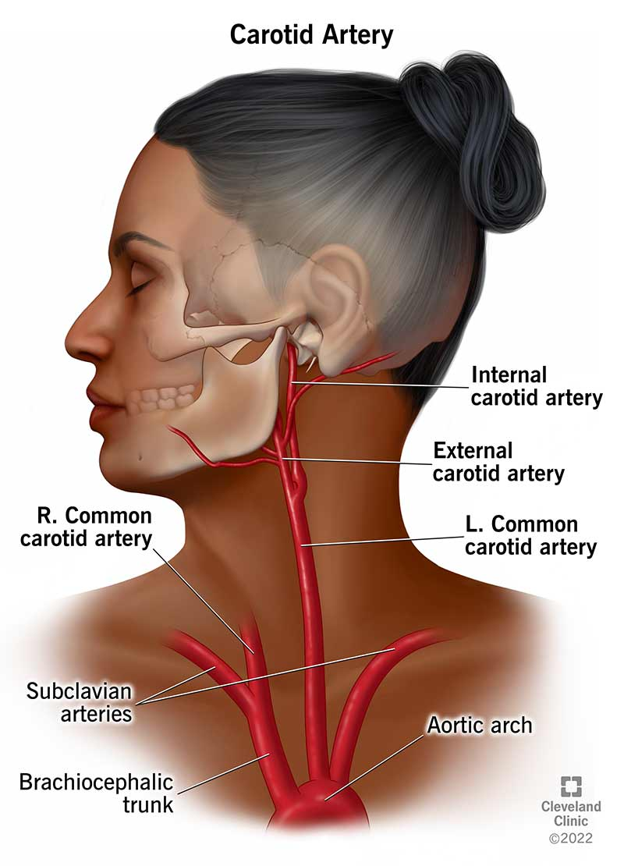
    - A common location for stroke causing clots to form is the carotid artery. Its usual function is to transport blood and oxygen to the brain and head.
- Pathophysiology
  - There are a range of effects, depending on localisation
  - Decreased cerebral blood flow (anterior cerebral, basilar, vertebral basilar, posterior cerebral, middle cerebral)
  - Decreased oxygen and glucose levels in the stroke location
  - Increased glucose metabolism in the penumbra (reversibly damaged tissue around stroke location)
  - Causes tissue necrosis and increases area affected by stroke
  - Neurons damaged in the affected area, cannot communicate via electrical signals, leading to loss of functionality of those areas
- Clinical presentation
  - Motor deficits, paralysis
  - Dizziness or loss of balance
  - Severe headache with no known cause
  - Sensory loss on one or both sides of the body
  - Cranial disorders: partial or full vision loss, facial paralysis
  - Hearing reception and perception deficits, reading difficulties
  - Aphasia - difficulty controlling and understanding speech
  - All symptoms occurs suddenly
- Clinical outcomes
  - Full recovery – 33% of those affected
  - Dependency on a daily basis – 33% of those affected
  - Recurrent stroke – 10% of those who have survived
  - Death – 33% of those affected
- Economic impact
  - 2020 statistics:
    - Costs Australia more than $6.2 billion per year in direct financial impact
    - Further $26 billion per year in terms of mortality and lost wellbeing
  - Economic impact of a stroke on the patient:
    - Between $1000 - 2000 per night they are in hospital for bed/room costs.
    - Average $800 per use of current scanning techniques such as CT or MRI scan. Medicare covers 75% - 85% of the cost.

