
MONASH HEALTHCARE INNOVATION SUMMER SCHOLARSHIPS (HISS)
PROJECT NAME: Project Prompt
DELIVERABLES NUMBER: 1
PROJECT LEAD: Nicole Chek
- Mission Statement
- To create a solution to improve bladder cancer patients' understanding of cancer care plans and reduce missed follow-up appointments in patients so that there is effective care coordination between patients and the treating team (hospital staff - doctors, nurses and administrative staff).

- Acceptance Criteria
- Easy for the treating team to use and track patients appointments.
- More affordable and accessible compared to current solutions.
- More efficient than current methods.
- Can be integrated into existing systems.
- Enables patients to understand their care plan and adhere to follow-up schedules.

- Needs Statement
- A way to improve care coordination between bladder cancer patients and the treating team to ensure understanding of cancer care plans and adherence to follow-up thus improving quality of care.

- Problem:
  - There is ineffective care coordination between patients and their treating team due to manual tracking of patient appointments. This results in patients being lost to follow up if patients forget about their care plan or appointment dates. This can also happen if hospital staff forget to input the appointment date in the system or send appointment recalls to patients to attend follow-up appointments.
- Population:
  - Bladder cancer patients and treating team
- Outcome:
  - Adherence to follow-up
  - Improved understanding of cancer care plan

- Disease State Fundamentals

Focus area | Description
Epidemiology | Cancer in general  - Worldwide, there are currently 19.3 million new cancer cases per year. This number is expected to increase to 28.4 million cases in 2040.  - In 2021, it was estimated that about 151,000 Australians were diagnosed with cancer (413 per day) and 49,000 died (135 per day) from cancer.  - In 2014-2018, 70.1% of persons (all ages) diagnosed with all cancers combined survived 5 years after diagnosis.  - There are over 1.1 million people alive in Australia who are either currently living with or have lived with cancer.  - The number of new cases of cancer diagnosed is estimated to increase to 185,000 in 2031.  Bladder cancer  - In Australia, it is estimated that about 3,219 Australians (2,470 males, 749 females) will be diagnosed with bladder cancer in 2022.  - More common in men and people aged over 60.  Risk factors/ Causes  - Tobacco smoking  - Occupational exposure to carcinogens such as aromatic amines, heavy metals  - Infection  - Medical procedures such as pelvic irradiation, previous intravesical bCG treatment and chronic indwelling catheters  - Genetic predisposition
Anatomy and physiology | Bladder anatomy  - The bladder is an organ of the urinary system. 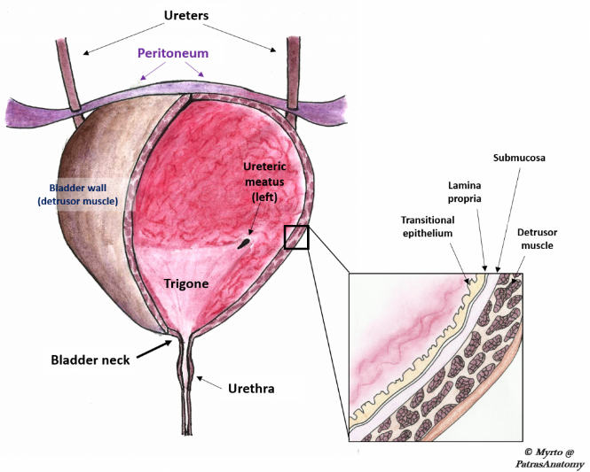  Bladder physiology  - The detrusor smooth muscle is the main muscle component of the urinary bladder wall. The smooth muscle can relax and contract allowing the bladder to store and expel urine upon receiving appropriate signals from the brain.
Pathophysiology | - Bladder cancer occurs when cells in the bladder’s inner lining grow and divide in an uncontrolled way. This is caused by changes (mutations) to the DNA within the cells.  - These abnormal cells can grow uncontrollably and damage or invade the surrounding tissues, or spread to other parts of the body, causing further damage.  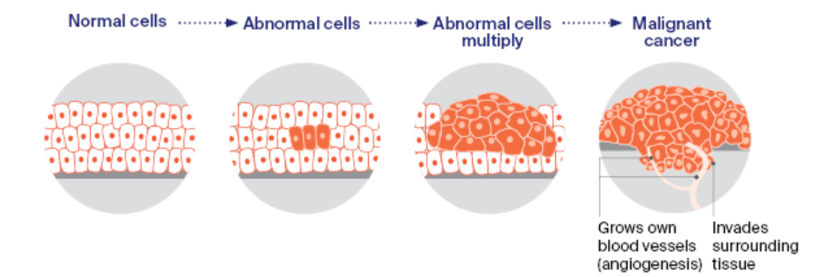  - The 3 main types of bladder cancer are:  - Urothelial carcinoma (80–90% of all bladder cancers)  - Starts in the urothelial cells lining the bladder wall.  - Squamous cell carcinoma (1–2% of all bladder cancers)  - Starts in thin, flat squamous cells in the bladder lining. It is more likely to be invasive.  - Adenocarcinoma (about 1% of all bladder cancers)  - Develops from the glandular cells in the bladder. It is likely to be invasive.  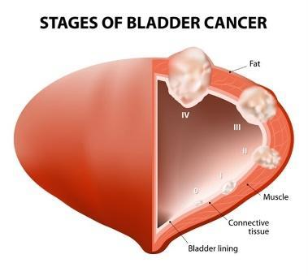
Clinical presentation | The signs and symptoms of cancer can differ based on the type and staging of cancer.  Symptoms associated with bladder cancer:  - Haematuria (blood in the urine)  - Difficulty passing urine due to obstruction  - Dysuria (pain on urination)  - Lower abdominal or back pain  - Urinary frequency  General signs and symptoms that are associated with, but not specific to bladder cancer:  - Fatigue  - Lump or area of thickening that can be felt under the skin  - Weight changes, including unintended loss or gain  - Changes in bowel or bladder habits  - Persistent indigestion or discomfort after eating  - Persistent, unexplained fevers or night sweats
Clinical outcomes | Management of bladder cancer depends on the type and staging of cancer:  - Non-muscle invasive: transurethral resection of bladder tumor (TURBT) with or without intravesical chemotherapy or immunotherapy  - Muscle invasive:  - Stage II/Stage IIIA: radical cystectomy plus neoadjuvant chemotherapy (multimodal therapy, preferred) or transurethral resection with chemoradiation (trimodal therapy, highly selected people) or partial cystectomy plus neoadjuvant chemotherapy (in highly selected people)  - Stage IIIB/IVA: cisplatin-based chemotherapy followed by radical cystectomy or chemoradiation or observation depending on treatment response  - Stage IVB (locally advanced; unresectable tumors): palliative radiotherapy  - Metastatic disease: cisplatin-based chemotherapy  - Metastatic disease but unfit for cisplatin-based chemotherapy: carboplatin-based chemotherapy  - Metastatic disease with contraindication for chemotherapy: checkpoint inhibitors if programmed death ligand 1 (PD L1) positive  - Squamous cell carcinoma or adenocarcinoma of bladder: radical cystectomy  Clinical outcomes of bladder cancer depend on the type and staging of cancer.  - In Australia, there is a 56% chance of bladder cancer patients surviving at least 5 years based on the data from 2014-2018.  - There is a high recurrence rate of cancer after transurethral removal of the bladder tumor (TURB) within 1 year (15–70%) and 5 years (7–40%).  - Recurrence and progression to a higher disease stage have a less favorable outcome. Therefore, continuous additional testing and repeated treatments are often needed.  - Social factors such as family, relationships, health and finances contribute significantly for determining good quality of life in people who have been diagnosed with bladder cancer.  - A high percentage of people with bladder cancer have anxiety and depression.
Economic impact | - Direct financial costs  - Out-of-pocket expenditures for ongoing treatments.  - 8.8% (or AU$11.7 billion) of the total health expenditure in 2018/2019 was incurred by cancer and other neoplasms.  - Indirect financial costs  - Lost productivity through premature deaths and time taken off from work  - Carer time  - Reduced household income  - Non-financial costs and intangible impacts  - Psychosocial and physical burden to patients and carers  - Psychosocial: anxiety, depression, fear of cancer recurrence  - Physical: fatigue, pulmonary, cognitive, neurological  - Disruption to family life  - Involuntary lifestyle changes

