
MONASH HEALTHCARE INNOVATION SUMMER SCHOLARSHIPS (HISS)
PROJECT NAME: NEMO
DELIVERABLES NUMBER: 1
PROJECT LEAD: David Levitz & Vishnu Sivakumar
- Mission Statement

To increase the accuracy of nerve conduction studies in patients with variant anatomy thus reducing their risk of harm.

- Acceptance Criteria
- By clinicians obtaining more accurate and reliable results, patients can be prescribed appropriate dosages of medications and severity of diseases/disorders can be diagnosed accurately.
- Effect on improving health outcomes: Accurate diagnosis leads to appropriate treatment and staging. A false positive diagnosis can lead to invasive investigations such as a biopsy which is associated with risk of infection, allergic reaction to the anaesthetic, and possibly permanent sensory loss. A prolonged nerve conduction study also subjects the patient to unnecessary discomfort.
  - Our solution should improve health outcomes
- The current clinical gap is approximately variation of 10 - 20%. Our solution should lead to results more accurate than this to be acceptable.
- Effect on affordability/ accessibility of care: An immediate accurate result means the patients do not have to take off work or pay travel expenses to have unnecessary further workup. It may also be more acceptable to the patient to only travel once (take off one day of work). If clinicians can reliably conduct the study in a shorter, more predictable amount of time patients can better plan their day, organise transport, a support person and time off work. In the case of unreliable diagnosis resulting in additional investigations, governments and patients are required to spend more on healthcare which can be avoided with an accurate diagnosis.
  - Our solution should increase affordability and accessibility of care
- Time / resources required to achieve results: Nerve conduction studies is a lengthy procedure to conduct. Optimising the procedure would allow clinicians to see more patients and decrease the duration patients are in pain. Improved ease of use as well.
  - Our acceptance criteria would require the test to take the same time as current standard practice or shorter (time neutral or time reducing)
- Anticipated market growth: Has a potential market of USD $730+ million.
  - Nerve Conduction Velocity NCV Testing Services Market Research Report 2020-2028 (dataintelo.com)
- Ease of use: The device should be as easy to use or easier for the clinician than standard practice at the moment.
- Physician and facility productivity: The device should increase the efficiency and confidence of the clinician. It should also reduce unnecessary follow up and investigation which is a burden to the facility.

- Cost neutral/reducing
- Time neutral/reducing
- Doesn’t require too much specialised training
- Increased reliability/accuracy of results
- More comfortable for the patient

- Needs Statement:
A way to address ambiguous nerve conduction test results due to uncertainties in the location of nerves in patients with anatomical variations, so that the level of discomfort experienced by patients is reduced and harm caused by unnecessary further investigations is minimised.

Population | Patients with anatomical variations making a landmark guided nerve conduction study unreliable.
Problem | Difficulty in localising nerves which is essential for an accurate nerve conduction study.
Control | - Time required for the test to be performed  - Nerve Conduction test procedure
Outcome | Increased accuracy in locating nerves improves the reliability of nerve conduction studies. This ultimately reduces the harm patients experience due to a prolonged procedure, inaccurate diagnosis or unnecessary further investigations.

- Disease State Fundamentals

Causes of alternative anatomy include:
- Swelling secondary to inflammation
- Increased body habitus
- Previous surgery
- Natural variation

There are many diseases nerve conduction studies are used to assess and grade:
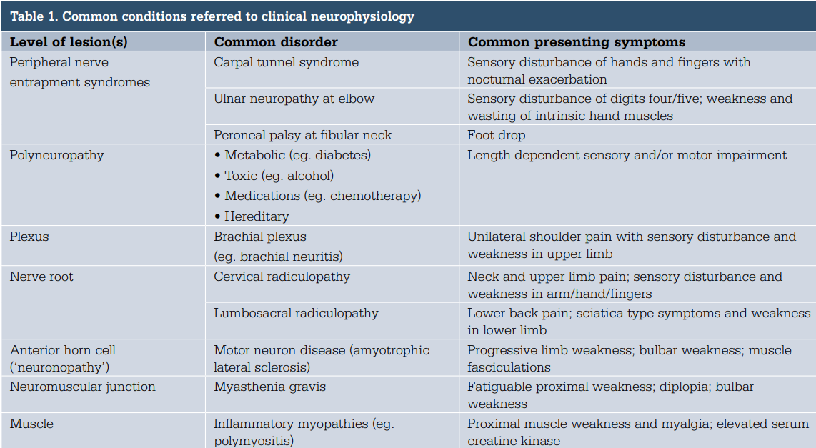
This table from the RACPG demonstrates some of them
Common conditions include:
- Carpal tunnel disease
- Diabetic neuropathy
- Trauma

Epidemiology
- Prevalence of peripheral neuropathy in the population is 10%
- In patients over 65 it increases to up to 25%
- Over 50% of patients with diabetes will develop neuropathy
- Likely unidentified risk with the rate of diagnosis being much less than the prevalence rate

- Anecdotally from our communication with clinicians 10 - 20% of patients have variant anatomy making a landmark guided nerve conduction study difficult.

Anatomy and physiology

- Most peripheral nerves are mixed: combination of motor, sensory and autonomic
- Nerve Conduction studies investigated generally are primarily motor or primarily sensory
  - Examples of motor nerves are median and radial nerve
  - Examples for sensory nerves are sural, superficial peroneal and superficial radial
    - Some nerves are more difficult to stimulate than others. e.g. motor nerves tend to be easier to assess than sensory. Sensory nerves such as the thigh tend to be difficult to assess
- Nerve conduction tests can usually just be used on the larger myelinated A - alpha fibers

Nerve fibre classification:
- A delta
- C fibers

Fibre type | Size and myelination | Functiom
A - alpha | Large myelinated | Most motor fibers and sensory touch, vibration, and position senses
A delta | Small myelinated | Cold temperature and pain
C fibers | Small unmyelinated | Warm, itch and pain

Somatic sensory function:
- Distal nerve endings with specialised structure to register specific sensory modalities
- Distal axon that heads to the DRG
- Proximal part of axon that leads into spinal root
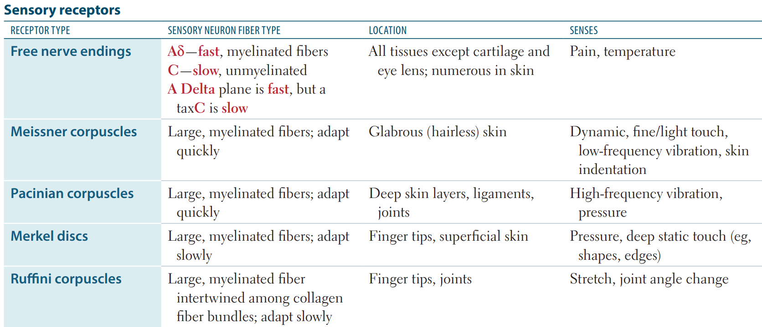

Acute demyelinating disease
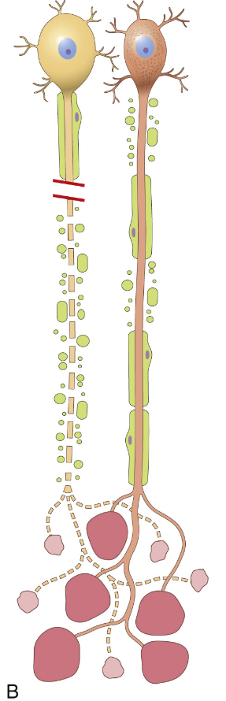
Myelin damaged axon preserved

Myelin is an insulating coating covering the axon to increase the speed of nerve transmission. Anatomically differentiating myelin pathology from axonal pathology is highly clinically relevant

Pathophysiology

Peripheral neuropathy can be caused by either:
- Axonal damage
  - Loss of axons means fewer muscle cells are excited
  - Summated action potential amplitude decreases
- Myelin damage
  - Slowed conduction velocity but normal amplitude
Local:
- Often anatomical processes such as inflammation or tendon thickening leads to entrapment of a nerve. This can cause weakness, pain and wasting
Systemic:
- May be a whole body inflammatory or autoimmune process targeting certain parts of the nerve and causing neuropathy

Clinical Presentation

Common clinical conditions include:
- Carpal Tunnel Syndrome
- Diabetic Neuropathy
- Trauma

Uncommon:
- Multiple sclerosis

Guillain Barre Syndrome
- Acute inflammatory demyelinating disorder
- Immunologically mediated that can lead to life threatening respiratory distress
- 1 in 100,000

Symptoms may include:
- Numbness and tingling affecting the hands or feet
- Muscle weakness
- Loss of sensation
- Pain - especially at night (e.g. carpal tunnel syndrome)

Clinical Outcomes

Complications of peripheral neuropathy:
- Unrecognised skin trauma
- Increase falls risk
- Decrease quality of life (https://www.dpncheck.com/wp-content/uploads/2020/10/DPNCheck-Brochure-PN2205539-Rev-A.pdf)
Treatment
- Correct diagnosis can lead to adequate treatment
- Sometimes lifestyle advice is sufficient such as resting the hand or avoiding repetitive movement. An accurate diagnosis would prevent the harm associated with further follow up in this case
- Anti - inflammatories are relatively safe drugs that can reduce inflammation and help with symptoms
- Steroids and disease modifying therapies may be necessary to slow a progressive autoimmune condition such as Multiple Sclerosis. Early treatment will improve patients quality of life
- Surgery may be used to decompress a nerve. Surgery in a patient where it is not indicated is associated with the potentially unnecessary risk of infection, bleeding and anaphylaxis

Economic impact
- On average from 2005 to 2012 medicare recorded an average of AUD $2.7 - $4.8 billion per year.
  - Economic benefit of carpal tunnel release in the Medicare patient population in: Neurosurgical Focus Volume 44 Issue 5 (2018) Journals (thejns.org)
- During the year of 2017 the total economic cost of diagnosed diabetes was USD $327 billion.
  - The Cost of Diabetes | ADA

