
MONASH HEALTHCARE INNOVATION SUMMER SCHOLARSHIPS (HISS)
PROJECT NAME: Implementing a clinical support system for lymphoedema
DELIVERABLES NUMBER: 1
PROJECT LEAD:
- Mission Statement
  - To improve the time efficiency of physiotherapists when identifying the appropriate compression garment to manage patients with lymphoedema.

- Acceptance Criteria
- Solution will have a clean intuitive UI/UX
- Solution will be able to quickly filter for appropriate compression garment based on patient
- Solution is more time efficient than current methods
- Solution can be easily integrated into the workflow of physiotherapist

- Needs Statement
A way to reduce workload of physiotherapists treating lymphedema in hospitals so that a more appropriate level of care can be given to patients diagnosed with lymphoedema.

- Disease State Fundamentals

- Epidemiology: Primary lymphoedema is caused by abnormal development of lymphatic development while secondary lymphoedema occurs when there is injury to the lymph nodes. Around 300,000 people are currently experiencing lymphoedema. Prevalence of primary lymphoedema is rare, at around 1.15/100,00 while secondary lymphoedema is more common and primarily affects cancer survivors, about 20% for breast cancer and about 40% of vulvar cancer survivors.

- Anatomy and physiology: Function of lymph nodes is to transport lymph fluids from body tissues back into the bloodstream.
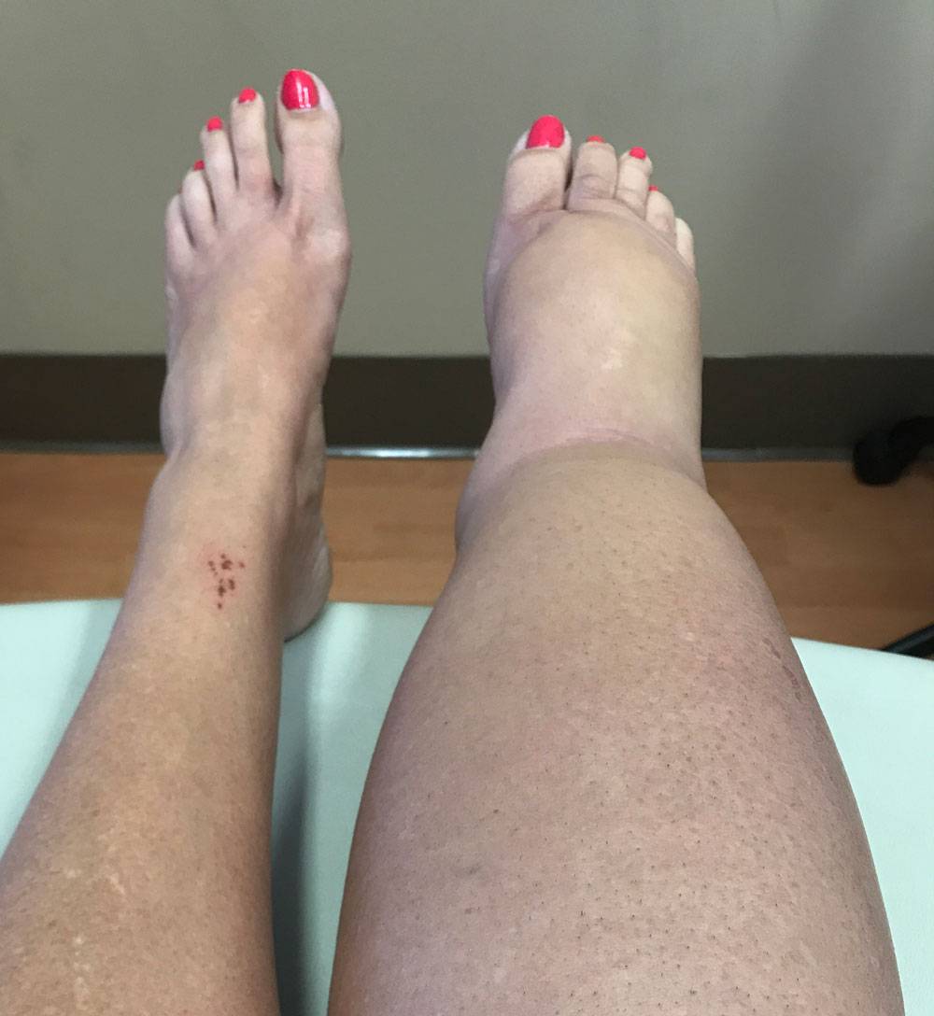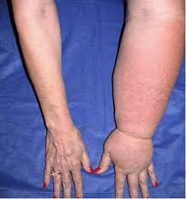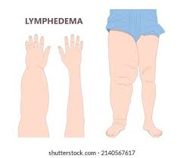
- Pathophysiology: When lymphatic vessels/nodes are damaged/not formed correctly, lymph fluid cannot be drained fast enough from the lymphatic system therefore causing swelling at lymph nodes.

- Clinical Presentation: Patient finds it hard and painful to move affected limbs as it swells up in the early stages. In the later stages of the disease, the skin tissue gets harder and skin changes such as thickening, hyperpigmentation, increased skin folds, fat deposits and warty overgrowth develop.

- Clinical Outcomes: Lymphoedema increases the risk of cellulitis, aka most common avoidable hospitalisation cause, therefore exposing the patient to systemic and sometimes life-threatening infections if left untreated. Patients often have to wear compression garments and undergo physio sessions to manage the swelling.

- Economic Impact: Hospitalisation costs around $1.3k to 4k in non-ICU cases, which can be avoided when timely care is given. Morrison Government has committed $2 million in 2020 for lymphedema support at national level while Marshall Liberal Government has committed $2.5 million from 2020 to 2022.

