MONASH HEALTHCARE INNOVATION SUMMER SCHOLARSHIPS (HISS)
Template Application for Funding Opportunities
Template application that helps projects to evaluate their needs and pitch their projects to gain funding support from external but interested bodies. Teams are invited to nominate both financial and non-financial support that could be provided. Nominate key areas where financial assistance would help achieve project milestones.

1 | Administrative details

1.1 | Title of project | Project Calculus:Stereotactic guidance and 3D visualisation tool integration in kidney stone surgery
1.3 | Current Project Team  - Jasamine Coles - Black:  - Founder and academic advisor.  - Nandini Pandya:  - Initial founder  - Involved with scientific research, prototyping and administration tasks.  - Upani Mapala - Gamage:  - co-founder (joined after week 1)  - Involved with scientific research, prototyping - engineering expertise.  - Mohairees Bin Sri Idzhan  - joined after week 7 -  - Involved with prototyping - engineering & commerce expertise.

2 | Project description

2.1 | Project aims and significance (Executive Summary) (1-2 pages)  Please outline the background and aims of your overall project, noting any changes to scope or targets that were implemented during the HISS program. Outline the particular niche area your project will address (be as specific as possible), the problem, specific target user(s) for the final product, the opportunity (i.e. market estimates), financials, traction to date, planned pathway to release of a (minimum) viable product, and any pre-existing competitors (highlighting your competitive advantages).
Percutaneous Nephrolithotomy (PCNL) is the procedure of choice for large and complex kidney stones. A significant issue is that the procedure has a steep learning curve and depends on surgeon expertise to determine the angle and trajectory of puncture from the initial patient imaging and free hand the puncture; this puncture is guided by relatively low resolution x-ray imaging. Due to this up to 1 in 10 patients will experience perioperative bleeding as well as risk of adjacent organ injury. In addition, limited visualisation of the puncture means that often surgeons will need multiple punctures to reach the stone, thereby increasing risk of bleeding and complications.
The outcomes we want to achieve: Reduction in blood loss, blood transfusion, risk of adjacent organ injury and fragments of kidney stone that are retained. We also want to decrease risk of organ failure and increase surgical confidence.
We aim to do this by introducing a 3D visualisation tool into the surgical workflow as well as a stereotactic guidance system (specific to the kidney) to support our outcomes and alleviate our problem.

No pre-existing competitors - 3D visualisation AI tools which are currently not trained for the kidney or recognise stone material. Also stereotactic guidance is not available for kidney procedures.
2.2 | Describe the market need or pain point you are targeting.
More accurate imaging, resulting in surgical confidence. Lesser likelihood of multiple punctures (approx. 10% reduction), better patient outcomes.
Reduced surgery time
2.3 | Explain the structure of the market (in particular the value/supply chain and relationships between suppliers, distributors, influencers and end customers) and your intended place in it. (porter’s five forces)
The total available market refers to the global kidney stone retrieval market and is valued at USD$ 2.66B, serviceable available market refers to the urological device market and is $72 million. The market which we can reach now with our current resources is valued at $6.7 million.
2.4 | Project progress (200 words)  Outline your summary of the progress that was made in your summer project.  Outline the current status of the project.
- Finalised on approach to solution, which is to use image recognition/machine learning to identify kidney and kidney stones from CT scans
- Assess the specificity of Nvidia AI-assisted annotation for 3D slicer is a medical image visualisation and analysis software which has a “fully automated segmentation” mode feature and its relevance to our project [GITHUB]. The computer running 3D slicer does not need to have any special requirements apart from fast network upload speed.
- However, this feature does not have pre-trained models specific to the kidney and cannot recognise stone material effectively. For PCNL we are looking to automatically segment the collecting system and the kidney itself in addition to this. We will also be able to use this to plan kidney cancer.

2.5 | Project planning (400 words - or GANTT chart)  List the key milestones that need to be met before this project will have measurable impact. Outline the immediate next steps needed to progress the project, short term goals and the projected pathway to real-world impact (e.g. direct sales, distribution channels, franchising etc.)
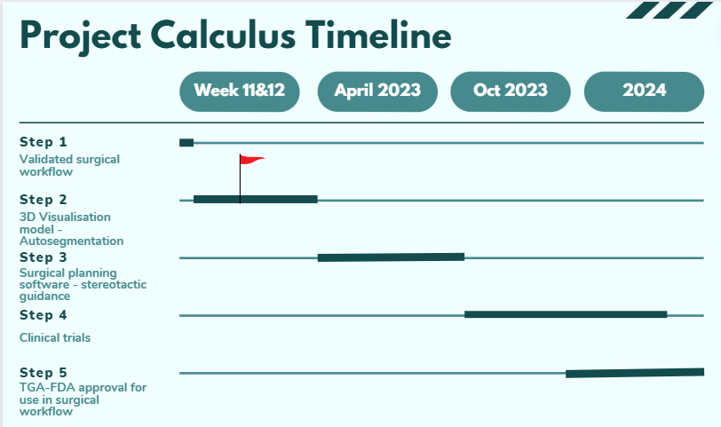
2.6 | Describe your business model – how will you make money?
The business model will be a combination of the sale of consumables/disposables and capital equipment that comes with service and maintenance contracts. Our solution is an updated workflow for PCNL surgery which will utilise an additional intraoperative visualisation technique and stereotactic needle guidance system. Generation of revenue will be via sale of proprietary single use sterile drapes, puncture needles, dilators, wires, stereotactic cage etc as well as through service fees. Each consumable used can be priced similar to competitors or made compatible with large established competitors to sell out e.g. cook nephrostomy pneumatic dilation is $2000.
2.7 | Outline any projected intellectual property (IP) and how this will be managed (200 words)  - If IP is projected.  - IP will be managed in accordance with the Monash University (Vice Chancellor) Regulations; see Part 5 of this linked document  - Clinical champions should confirm their IP agreements with their employer(s)  - If IP is not projected, describe your understanding of the IP landscape in which your project lies and explain why your team believes that no IP will be generated and your general pathway to achieving real-world impact and sustainability.  An IP agreement must be in place as a condition for any direct Phase II funding unless agreed by all parties.
The workflow is patentable due to the path finding aspect of it which will be developed down the line.

3 | Customer validation

3.1 | Describe your ideal first customer. Define your Unique Value Proposition to that customer.
*UVP: reduced the rate of complications (blood loss, adjacent organ injury, infection, organ failure, fragments of kidney stone that are retained) caused by inaccurate puncturing during PCNL surgery*

3.2 | Describe the current workflow and how your technology integrates or disrupts that flow.
- Imaging Patient Preparation: fiducial markers are placed on patient skin surrounding the approximated puncture area.
- Preoperative imaging: a preoperative CT scan with the fiducial markers is taken. The precise location of the markers can be drawn onto the skin and the fiducials are removed.
- Surgical Planning: planning is usually done prior to procedure using CT scans. New 3D reconstructed model could be used to plan the procedure.
- Patient Preparation: Patient is placed in the final position and optical reference is attached.
- Needle Calibration: Calibrate based on placed fiducials and fixed bony landmarks
- Patient to Image Registration: establish correspondence between the surgical scenario and planning
- Needle Guidance: needle is inserted using the real-time feedback provided by the navigation system. New 3D model would be implemented here for live-tracking.
- Position Validation: needle position is checked. The current method uses fluoroscopy to guide the needle, however, since it is not needed anywhere else in the new workflow we could validate needle position via endoscopy to check correct calyx is punctured. This avoids the hassle of wearing lead protection [14]
- Stone Removal: stone is removed as normal with a laser device or crushed.
In summary, our technology integrates into the workflow by providing surgeons with an extra set of “eyes” while operating on the patient.
3.3 | Describe the methodology used to validate the problem and your solution, including number of interviews and key insights from each of the following groups:  - End user or direct beneficiary, and  - Physicians or medical professionals closest to the problem  Show us what you have done, this can be in the form of market validation report, sample interviews, key insights.

4 | Request for non-financial support

4.1 | Please outline any in-kind support that would assist in progressing this project.  This might include:  - Capital currently available for project activities  - Connections to people currently outside the project with specialized skills or experience  - Access to facilities  - Access to workshops, accelerators and/or similar events on topics related to this project
Connections with organisations and labs such as CSIRO’s imaging and computer vision group for stereotactic guidance/3D visualisation and Monash Urology who has developed a technique using 3D visualisation to optimise the trajectory for puncture.

Also individuals with expertise in python, image recognition and machine learning as well as experience in developing surgical software and its integration with its hardware counterparts.

Access to view a PCNL kidney stone procedure and talk to surgeons to understand the integration of our workflow better.

4.2 | Student project teams  Please indicate if you would like to co-supervise a team within the MYMI Projects ecosystem to work on this project. This would involve:  - A small team (2-5) of students working in their spare time  - Students may be recruited with specific skills if needed  - Regular consultation (~ monthly) is still required with the student leaders of the team to monitor progress and plan future work, similar to HISS Program
We have not clearly spoken to Jas about this yet, but she would like the project to remain under her supervision. May not want this to be a MYMI project.

5 | Financial support

5.1 | Budget  Please outline any financial support that is required for continuation of the project, and the approximate timing when that support would be needed.  Describe any other funding streams that will be/might become available for the project.
5.2 | Funding Outcomes (200 words)  What concrete outcomes would become achievable if your project received the further funding described above?
Successful development of the software aspects, including selecting appropriate models to train, and able to pay for regulatory approval
5.3 | Sustainability (200 words)  Please outline plans to support your project in the long term or indefinitely. Is it possible for the project to become self-sustaining? If so, please explain how. If not, please detail the ongoing external support (financial and personnel) that would be required to keep the project running.
Yes it is self-sustaining as the models can iterate upon themselves as the software is used more often.
6 |  | Understanding the team

6.1 | Help us understand why you’re the right person to succeed in this opportunity.  Why you and not someone else?
6.2 | Do you currently have an advisory team. If so, please list their names. If not, write N/A.
Jasamine Coles-Black - Austin Health
Andrew Rodda
Khoa n. Cao
6.3 | Do you foresee the need for more team members to help keep the project running.  What is the overview of the role/s you would need?  What are desired attributes of the new team members e.g. we are looking for ‘x’  What are the responsibilities of the new team members?  What are the required qualifications of the new team members?
Yes, someone who is more familiar with AI and coding would be helpful as the foundation of this project is rooted in being able to automatically recognise and segment a kidney.

