MONASH HEALTHCARE INNOVATION SUMMER SCHOLARSHIPS (HISS)
Template Application for Funding Opportunities
Template application that helps projects to evaluate their needs and pitch their projects to gain funding support from external but interested bodies. Teams are invited to nominate both financial and non-financial support that could be provided. Nominate key areas where financial assistance would help achieve project milestones.

1 | Administrative details

1.1 | Title of project  Please provide a title  (no more than 10 words) | Project Sentinel
1.3 | Current Project Team  Please list all team members that will contribute to the project over the next year, including (1-2 sentences) the specific contributions that each will make and a 100-word bio for each of the cofounders.
Dr Thanh Phan - Clinical champion of the project. Information about the current clinical landscape, mentoring regarding the medical technology market and implementation strategy.

Calvin Zheng (cofounder) - Bachelor of Engineering (Honours) and Bachelor of Computer Science. Algorithm optimisation, prototyping.

Bio:

Diana Kovaleva (cofounder) - Bachelor of Engineering (Honours) and Bachelor of Biomedical Science. Research, grant and TGA applications, prototyping.

Bio:

2 | Project description

2.1 | Project aims and significance (Executive Summary) (1-2 pages)  Please outline the background and aims of your overall project, noting any changes to scope or targets that were implemented during the HISS program. Outline the particular niche area your project will address (be as specific as possible), the problem, specific target user(s) for the final product, the opportunity (i.e. market estimates), financials, traction to date, planned pathway to release of a (minimum) viable product, and any pre-existing competitors (highlighting your competitive advantages).
Market niche:
The project targets in-hospital patients recovering from ischaemic stroke, which have been prescribed a prolonged hospital stay (over 10 days).

Problem:
1 in 4 people will suffer a stroke in their lifetime, with almost 80% of all strokes being ischaemic (caused by blood clot). The severity and effect of a stroke differs from person to person, but for a third of the population, their strokes are severe enough to warrant a long term stay at a hospital. Unfortunately, stroke victims staying in hospitals in Australia have a 15% mortality rate within 90 days of their initial admittance. Deaths are commonly caused by an unforeseen and sudden occurrence of a follow up stroke. We seek to lower the 15% mortality rate of stroke patients in hospitals by solving one of the key problems in the current hospital system, which is the slow response time to the recurrent strokes. The slow response time is caused by a lack of continuous monitoring.

Target users:
The target users of the proposed solution are neurologists and nurses working in the neurology department. At the moment, the interpretation of EEG signals is challenging, and requires further training, even for certified neurologists. This means that at any given time, the neurology department has very few specialists that are able to interpret patient data and treat said patient accordingly. The novel visualisation methodology allows greater accessibility for a wider variety of hospital staff members, which will increase the quality of patient monitoring and decrease emergency response time.

Planned pathway to release:
According to initial estimates, research and prototyping should be completed by the end of 2023. After further clinical trials and TGA approval application, the solution is anticipated to be released by the start of 2028.
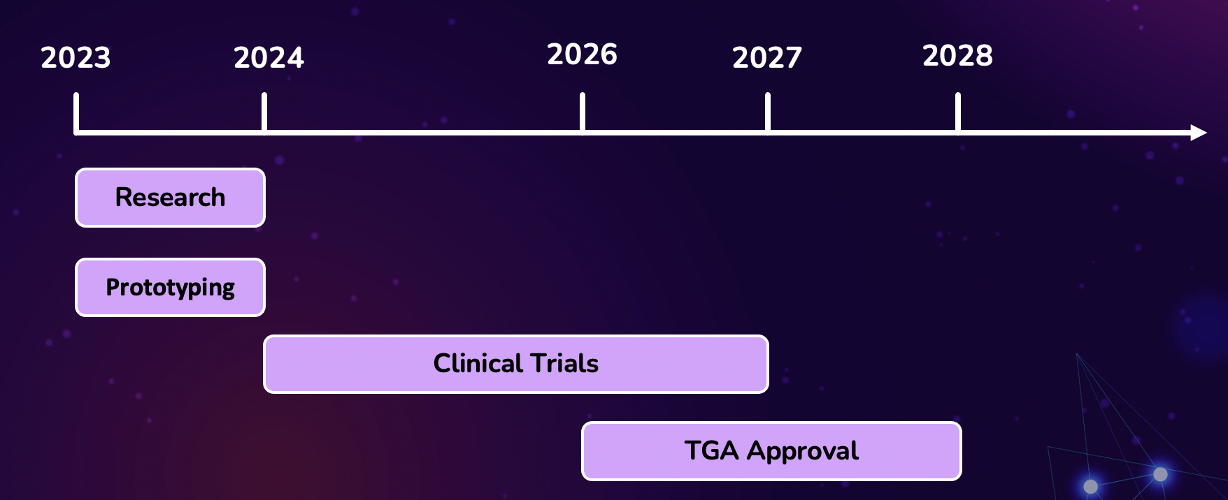

Competitors:
In terms of competitors, it has been found that the niche we are trying to take is currently unfilled. However, companies like SeerAustralia, NextGenNeuro and Neurotech already produce various forms of continuous monitoring EEG technology. None of the competitors directly produce visualisation software, but their services are more variable, so there is possibility of extension into the visualisation technology. Need for IP protection and barriers to entry reinforced.

Since we are a smaller start-up company, the proposed market strategy will be focused on product differentiation, which will provide a unique visualisation experience, giving us a competitive edge. Furthermore, taking advantage of partnering with well-known and trusted brands, such as Monash Health, MYMI and MIME should ensure that our product is trusted by the customers.

2.2 | Describe the market need or pain point you are targeting.
A method of monitoring patients recovering from ischaemic strokes without the presence of medical staff over a long period of time, that is able to update doctors and nurses of the condition of the patient over the duration of the monitoring session in an easy-to-read format, so that help can be provided in an efficient manner.

2.3 | Explain the structure of the market (in particular the value/supply chain and relationships between suppliers, distributors, influencers and end customers) and your intended place in it.
Using the $400 service fee model, the serviceable obtainable market from partnering up with Medtronic averages around $1.6 million within the first year. This figure was calculated through Medtronic’s financial reports, which indicates they are selling and maintaining over 4000 of their high end EEG systems. Medtronic will not need to make any new EEG device to accommodate our software; it should be possible to just install it into their existing EEG devices. For each of the 4000 units, our software installation will grant us $400, which will result in a total potential profit of $1.6 million. If the Australian market is successful for this business, the next area of expansion will be two fold: one will be to expand to other developed markets that can easily pay for a large sum of stroke monitoring systems, and the other area of expansion will be to partner up with other medical device companies, although this may be restricted due to contract terms.

Developed markets include: US, Canada, New Zealand, Japan, South Korea and Europe.

A key consideration for the future health of this venture is the growing neurological monitors market as it is expected to rise to USD 21.22 Billion and is expected to undergo a CAGR of 7.60% by 2029.

We expect that the medical companies we will sell the software to will equip their existing EEGs and then sell those to hospitals, or equip software onto existing hospital equipment for an additional fee.

2.4 | Project progress (200 words)  Outline your summary of the progress that was made in your summer project.  Outline the current status of the project.
Progress: The background research into the medical problem, evaluation of existing solutions and ideation have been completed within the duration of the program. First round of project selection has been successfully passed, allowing the project to move into the prototyping stage.

Currently, one of the focuses of the project is to estimate the potential financial value opportunity and select the correct market size for solution integration. This will involve getting in touch with some of the MedTech company representatives, and contacting other stakeholders, such as Monash Health.

In terms of prototyping, so far, the APIs for Matlaba and Python that could aid in testing the solution have been sources. Anonymous patient datasets have also been collected to test the proof of concept design. It was found that an MRI model of the human brain would need to be used if localisation of decreased brain activity was needed, however, after some user interviews, precision was found to be secondary to the alert function. It was decided to use the MNI 152 generalised MRI dataset to model the brain.

More work needs to be done in the area of recruitment, so that our team can be expanded to hit the projected milestones.
2.5 | Project planning (400 words)  List the key milestones that need to be met before this project will have measurable impact. Outline the immediate next steps needed to progress the project, short term goals and the projected pathway to real-world impact (e.g. direct sales, distribution channels, franchising etc.)
2.6 | Describe your business model – how will you make money?
The proposed business strategy will incorporate a B2B strategy, where we will sell the software directly to medical device producers. Amongst the proposed clients are MedTech giants such as Medtronic and Massimo. According to the research conducted by our clinician, the average cost of a software update by Medtronic is $2000. We are planning to take a service fee of only $400 per sold package, which should leave our clients with a profit of $400 - $1000.

Low fees should ensure attractiveness of the product to the clients, and prevent the equipment with the integrated solution from becoming unaffordable for hospital acquisition once the manufacturing process is complete.

2.7 | Outline any projected intellectual property (IP) and how this will be managed (200 words)  - If IP is projected.  - IP will be managed in accordance with the Monash University (Vice Chancellor) Regulations; see Part 5 of this linked document  - Clinical champions should confirm their IP agreements with their employer(s)  - If IP is not projected, describe your understanding of the IP landscape in which your project lies and explain why your team believes that no IP will be generated and your general pathway to achieving real-world impact and sustainability.  An IP agreement must be in place as a condition for any direct Phase II funding unless agreed by all parties.
Due to the competitive nature of the market we are trying to enter, there will be a need for IP protection, to ensure that we can maintain a market niche while dealing with existing competitors.

3 | Customer validation

3.1 | Describe your ideal first customer. Define your Unique Value Proposition to that customer.
Neurologist or nurse, working with patients who are recovering from stroke and need an extended hospital stay (longer than 10 days). Preferably someone who does not have training in interpreting EEG outputs, so that the intuitiveness of the UI can be tested.

3.2 | Describe the current workflow and how your technology integrates or disrupts that flow.
The current process is as follows:
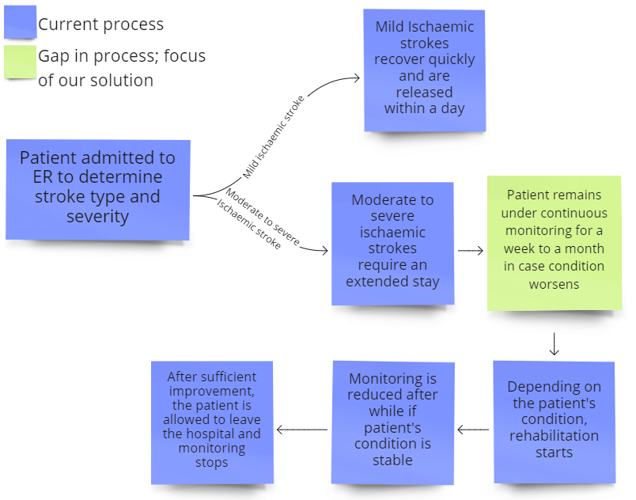
The current gap in the workflow is in regards to the continuous monitoring of patients while they stay in hospital. At the moment, patients are checked on once or twice per day, however, in the event of a recurrent stroke, permanent damage may be inflicted within one hour of onset. The proposed solution will act to notify medical staff of the change in the patient’s brain activity in a timely manner, to make sure that the treatment is provided quickly and efficiently.

3.3 | Describe the methodology used to validate the problem and your solution, including number of interviews and key insights from each of the following groups:  - End user or direct beneficiary, and  - Physicians or medical professionals closest to the problem  Show us what you have done, this can be in the form of market validation report, sample interviews, key insights.

4 | Request for non-financial support

4.1 | Please outline any in-kind support that would assist in progressing this project.  This might include:  - Capital currently available for project activities  - Connections to people currently outside the project with specialised skills or experience  - Access to facilities  - Access to workshops, accelerators and/or similar events on topics related to this project
4.2 | Student project teams  Please indicate if you would like to co-supervise a team within the MYMI Projects ecosystem to work on this project. This would involve:  - A small team (2-5) of students working in their spare time  - Students may be recruited with specific skills if needed  - Regular consultation (~ monthly) is still required with the student leaders of the team to monitor progress and plan future work, similar to HISS Program
A team of 2-5 people working on the project would be preferable. We are looking for students in the computer science field, specifically those who have had previous experience working with algorithms.

5 | Financial support

5.1 | Budget  Please outline any financial support that is required for continuation of the project, and the approximate timing when that support would be needed.  Describe any other funding streams that will be/might become available for the project.
$30 000 to cover:
- Prototyping ($8 000)
- Clinical trials ($20 000)
- TGA ($2 000)

Other funding streams:

Medtech Actuator - $50 000 funding

The Accelerator - $10 000 SEED funding
5.2 | Funding Outcomes (200 words)  What concrete outcomes would become achievable if your project received the further funding described above?
TGA approval - allows the software to be officially regulated in Australia and released into the medtech market.
Prototyping - need for proof of concept, so that the solution can be tested in a clinical environment.
Clinical trials - to solidify that the solution is viable, cheap and safe.

5.3 | Sustainability (200 words)  Please outline plans to support your project in the long term or indefinitely. Is it possible for the project to become self-sustaining? If so, please explain how. If not, please detail the ongoing external support (financial and personnel) that would be required to keep the project running.
6 |  | Understanding the team

6.1 | Help us understand why you’re the right person to succeed in this opportunity.  Why you and not someone else?
The team working on the final concept comprises diverse skills in the engineering, science and medical fields.
6.2 | Do you currently have an advisory team. If so, please list their names. If not, write N/A.
Yan Wong
Subramanian Muthusamy

6.3 | Do you foresee the need for more team members to help keep the project running.  What is the overview of the role/s you would need.  What are desired attributes of the new team members e.g. we are looking for ‘x’  What are the responsibilities of the new team members?  What are the required qualifications of the new team members?
Clinical trial coordinators to assist in finding volunteers and patients for the duration of the trials.

Additional 3-5 people on the development team to speed up prototyping. Preferably those with experience in coding in multiple languages, and familiar with modelling using the LORETA algorithm.

