MONASH HEALTHCARE INNOVATION SUMMER SCHOLARSHIPS (HISS)
Template Application for Funding Opportunities
Template application that helps projects to evaluate their needs and pitch their projects to gain funding support from external but interested bodies. Teams are invited to nominate both financial and non-financial support that could be provided. Nominate key areas where financial assistance would help achieve project milestones.

1 | Administrative details

1.1 | Title of project  Please provide a title  (no more than 10 words) | Project EBoard: Digital whiteboard to facilitate communication in the emergency department
1.3 | Current Project Team  Please list all team members that will contribute to the project over the next year, including (1-2 sentences) the specific contributions that each will make and a 100-word bio for each of the cofounders.
Current team members:
- Sahil Bhatia
  - Initial founder of Project EBoard, and primary team lead during Weeks 1-7 (part-time due to placement), established QR code form for the solution
- Lloyd Lok
  - Additional team member post-Week 7, working on proof of concept of how EMR data can be represented in a different form for patients to view
- Maria Zarco-Vera
  - Additional team member post-Week 7, working on proof of concept of how EMR data can be represented in a different form for patients to view
Team members as a MIME/MYMI Project:
- If Project EBoard were to progress further as a MIME/MYMI project, the current team would likely onboard a new group of recruits with the ideal skill set to begin the prototyping process.

2 | Project description

2.1 | Project aims and significance (Executive Summary) (1-2 pages)  Please outline the background and aims of your overall project, noting any changes to scope or targets that were implemented during the HISS program. Outline the particular niche area your project will address (be as specific as possible), the problem, specific target user(s) for the final product, the opportunity (i.e. market estimates), financials, traction to date, planned pathway to release of a (minimum) viable product, and any pre-existing competitors (highlighting your competitive advantages).
Hospital medical teams in Australia are becoming increasingly overwhelmed and burdened - a consequence of increased workload and resource scarcity. Currently, clinicians and nurses rely on static whiteboards or two-way verbal communication to update patients on their schedule and preemptively answer questions patients may have. However, time constraints and the inability to locate a whiteboard marker poses an inconvenience for already busy treating teams - resulting in whiteboards in the emergency department being either empty or incomplete. These current methods are inefficient and ineffective, which has contributed to poor information transfer. This information deficit in patients has led to poor compliance, exacerbation of current conditions, and increased use of resources. Through past research studies, patients that received written and verbal information felt better equipped to manage their conditions independently.

Therefore, creating a system that can automatically present information to patients, may play a role in improving workplace cohesiveness and patient satisfaction. Project EBoard aims to create a patient journey QR code system, drawing health information from the EMR and displaying this on a secure webpage, to improve communication of information between clinicians and patients in the emergency department. A QR code system will increase the efficiency of communication between patients and clinicians without the need for clinicians to manually input relevant information onto these static whiteboard, updating patients regularly with relevant information about their schedule and clinical goals.
2.2 | Describe the market need or pain point you are targeting.
Currently, patients experience poor information transfer in the emergency department as a result of inadequate communication. Communication is inadequate in the emergency department because of current ineffective methods, such as using erasable whiteboards. As a results patient conditions are exacerbated as there is a lack of adherence to the provided advice.
2.3 | Explain the structure of the market (in particular the value/supply chain and relationships between suppliers, distributors, influencers and end customers) and your intended place in it. (porter’s five forces)
New entrants may use the same data extraction processes, however the user interface may look different. Different interfaces and different pricing options may increase the number of competitors in the market.
Furthermore there is potential that competitors can also may make adaptations to patient portals to provide other required patient information. This may be unlikely because current patient portals are tailored for a different purpose, primarily to facilitate access to medical summaries and results after discharge which are typically populated days after discharge.
2.4 | Project progress (200 words)  Outline your summary of the progress that was made in your summer project.  Outline the current status of the project.
During Week 1-7, the initial identification stages of the biodesign process were completed. This included mission and needs exploration, existing solution research, stakeholder analysis, and analysis of the market. The invention stages also begun and are currently in progress. Through concept generation, the solutions physical form as a QR code wristband was established. Currently, post-pitch (Week 7), the team is working on the proof of concept for how data can be transferred from an EMR database to a web form that can be presented to patients as they scan their code. Contacts have been maintained with staff at Eastern Health, to learn more about the hospitals systems and the potential database access for future project members.
2.5 | Project planning (400 words - or GANTT chart)  List the key milestones that need to be met before this project will have measurable impact. Outline the immediate next steps needed to progress the project, short term goals and the projected pathway to real-world impact (e.g. direct sales, distribution channels, franchising etc.)
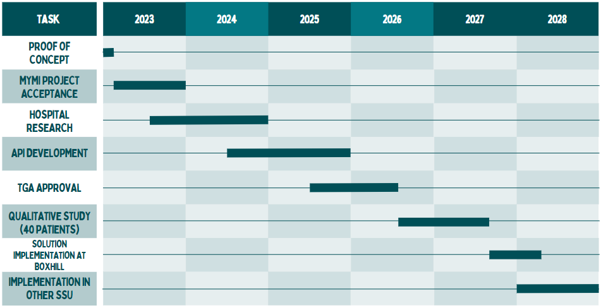
Project GANTT Chart:
- Ideally, after this HISS program, the project is accepted into MYMI/MIME
- Initially, project would require recruiting of members with the ideal skill-set
- During 2023, start user interviews and in-hospital research
- API development can start around the same time as hospital research during 2024, so that software feedback can be obtained simultaneously
- During 2025, TGA approval application may take place, a conformity assessment certification may be required
- Qualitative study would be conducted in 2026, would likely require funding to source that study. At the end of this study, obtain additional feedback, making potential adjustments
- In 2028, initial implementation at Box Hill Hospital, and potential extension to other hospital branches
2.6 | Describe your business model – how will you make money?
The proposed business model is a combined capital and fee-per-use model. Hospitals would pay an amount for the software upfront at the beginning, and then based on the number of patient users calculated at the end of the month, an additional fee would be paid per patient. This would be more attractive to hospitals that have smaller capacity emergency departments, so they are only required to pay based on the number of uses. Additionally this would be more beneficial than a subscription based model, which can be canceled at any time, as this business model would be better at securing an upfront payment and long-term utilization of the software.

2.7 | Outline any projected intellectual property (IP) and how this will be managed (200 words)  - If IP is projected.  - IP will be managed in accordance with the Monash University (Vice Chancellor) Regulations; see Part 5 of this linked document  - Clinical champions should confirm their IP agreements with their employer(s)  - If IP is not projected, describe your understanding of the IP landscape in which your project lies and explain why your team believes that no IP will be generated and your general pathway to achieving real-world impact and sustainability.  An IP agreement must be in place as a condition for any direct Phase II funding unless agreed by all parties.

3 | Customer validation

3.1 | Describe your ideal first customer. Define your Unique Value Proposition to that customer.
The ideal first customers would be hospitals that could benefit from a software that can provide patients with a digital copy of their data, which is automatically updated as doctors make changes. This can provide benefits to patients by increasing efficiency and effectiveness of information transfer. This can improve patient compliance and adherence to healthcare plans, which can increase patient conditions and wellbeing.

3.2 | Describe the current workflow and how your technology integrates or disrupts that flow.
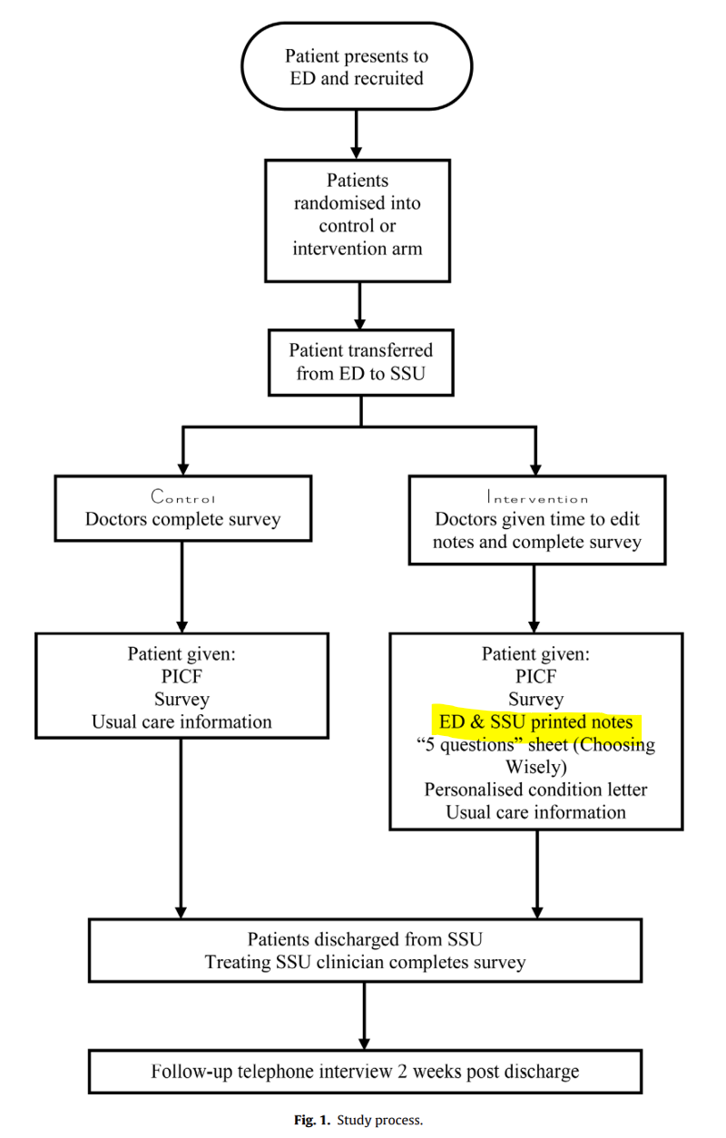
This flowchart is from a research article written by Paul Buntine (clinician) and other individuals from Eastern Health and Monash University - Improving the patient experience in the emergency department short stay unit. This chart does not replicate the current workflow, rather this represents the workflow of how patients were presented with information in the study. Project EBoard would ideally fit into the stage highlighted in yellow, where the information can be readily presented to patients in a digital form.
3.3 | Describe the methodology used to validate the problem and your solution, including number of interviews and key insights from each of the following groups:  - End user or direct beneficiary, and  - Physicians or medical professionals closest to the problem  Show us what you have done, this can be in the form of market validation report, sample interviews, key insights.
During early stages, some user interviews were conducted, two primary questions were asked:
- Is a solution necessary?
- If so, what method of demonstrating this information would be most appropriate?
The solution was found to be necessary, given that some patients did express concerns about the lack of awareness of relevant medical information surrounding their stay in the hospital. However, this was equally met with some patients who were not bothered by this problem - perhaps because they were near the end of their patient journey.
The most appropriate method of presenting the information to patients was found to be via the mobile phone - a large digital display may have caused privacy issues. Furthermore, the convenience of having a mobile phone makes this method of information delivery most suitable.
Furthermore, Paul Buntine (Project Eboard Clinical Champion) has written a research article on the effect of medical notes on patient experience in the emergency department (as described above). This concluded that simple intervention involving ED medical notes to patients during SSU admission can positively contribute to patient experience

4 | Request for non-financial support

4.1 | Please outline any in-kind support that would assist in progressing this project.  This might include:  - Capital currently available for project activities  - Connections to people currently outside the project with specialized skills or experience  - Access to facilities  - Access to workshops, accelerators and/or similar events on topics related to this project
The main point of support would be connections to individuals in other hospitals that work closely with the patient EMR databases and portal information. This could be helpful in understanding how other systems currently operate and whether simpler options already exist.

4.2 | Student project teams  Please indicate if you would like to co-supervise a team within the MYMI Projects ecosystem to work on this project. This would involve:  - A small team (2-5) of students working in their spare time  - Students may be recruited with specific skills if needed  - Regular consultation (~ monthly) is still required with the student leaders of the team to monitor progress and plan future work, similar to HISS Program
If Project EBoard were to progress further as a MIME/MYMI project, the current team would be involved in the recruitment and onboarding of a new group of recruits (around 2-3 members), however current team members will not have the time commitments to continue supervising the project.

5 | Financial support

5.1 | Budget  Please outline any financial support that is required for continuation of the project, and the approximate timing when that support would be needed.  Describe any other funding streams that will be/might become available for the project.
Further into the project in 2025/26, funding could help source the qualitative studies.
5.2 | Funding Outcomes (200 words)  What concrete outcomes would become achievable if your project received the further funding described above?
5.3 | Sustainability (200 words)  Please outline plans to support your project in the long term or indefinitely. Is it possible for the project to become self-sustaining? If so, please explain how. If not, please detail the ongoing external support (financial and personnel) that would be required to keep the project running.
This project has a long-term timeline, extending to the next 6 years, requiring members to be actively involved in communications with Eastern Health staff that can provide feedback and guidance on building the API. To sustain this project in the long-term, personnel/team members should ideally be committed, if not the entire tenure of the project, at least long enough for the completion of the entirety of a single subsection in the GANTT chart task list.

Additionally, funding would be required for the single qualitative study. Other than these financial and personnel supports, the project would be otherwise self-sustainable.
6 |  | Understanding the team

6.1 | Help us understand why you’re the right person to succeed in this opportunity.  Why you and not someone else?
Rather, we are currently not the right people to succeed at this opportunity.
Due to additional commitments during working university semesters, and lack of relevant skill sets required in this project, the current team members would not be best equipped to contribute effectively to the project. Therefore, a strong recruitment and onboarding process would be required, if the project were to proceed as a MYMI/MIME project.
6.2 | Do you currently have an advisory team. If so, please list their names. If not, write N/A.
Paul Buntine - Clinical Champion
Hamish Rodda - Eastern Health EMR Informatics
6.3 | Do you foresee the need for more team members to help keep the project running.  What is the overview of the role/s you would need.  What are desired attributes of the new team members e.g. we are looking for ‘x’  What are the responsibilities of the new team members?  What are the required qualifications of the new team members?
If Project EBoard were to progress further as a MIME/MYMI project, the current team would be involved in the recruitment and onboarding of a new group of recruits (around 2-3 members) with the ideal skill set to begin the prototyping process.
Team member desired attributes:
- Great communicator, to relay progress with team leads and clinicians
- Passionate about healthcare and technology, and there combined relevance in this project
- Hardworking and driven
Team member qualifications:
- Currently studying computer science / software engineering, or has extensive experience with coding languages
  - Understanding of data extraction (JSON files)
  - Familiar with use of APIs
- UI/UX designers
  - Formatting information on the web display for patients in an appropriate manner, or as suggested by patients

