MONASH HEALTHCARE INNOVATION SUMMER SCHOLARSHIPS (HISS)
Template Application for Funding Opportunities
Template application that helps projects to evaluate their needs and pitch their projects to gain funding support from external but interested bodies. Teams are invited to nominate both financial and non-financial support that could be provided. Nominate key areas where financial assistance would help achieve project milestones.

1 | Administrative details

1.1 | Title of project  Please provide a title  (no more than 10 words) | Project Blooming: Monitoring app for breast development in trans-women
1.3 | Current Project Team  Please list all team members that will contribute to the project over the next year, including (1-2 sentences) the specific contributions that each will make and a 100-word bio for each of the cofounders.
- Jacinta Patel
  - Initial founder of Project Blooming
Team members as a MIME/MYMI Project:
- If Project Blooming were to progress further as a MIME/MYMI project, the current team would likely onboard a new group of recruits with the ideal skill set to begin the prototyping process. Ideally someone with experience in computer science, math, physiology, and augmented reality.

2 | Project description

2.1 | Project aims and significance (Executive Summary) (1-2 pages)  Please outline the background and aims of your overall project, noting any changes to scope or targets that were implemented during the HISS program. Outline the particular niche area your project will address (be as specific as possible), the problem, specific target user(s) for the final product, the opportunity (i.e. market estimates), financials, traction to date, planned pathway to release of a (minimum) viable product, and any pre-existing competitors (highlighting your competitive advantages).
The focus for this project is an all-in-all an app for empowerment in people who are transitioning, providing them with the best evidence-based care through a health and wellness app, by measuring breast development in transwomen.
Mission: Statement: To develop a solution for transgender women and gender diverse individuals on feminizing hormone therapy to provide:
1. a validated tool for research into treatment options for breast size and shape
2. patient self-monitoring of breast development (i.e., breast size and shape) to improve satisfaction with gender affirming hormone therapy (GAHT).

Needs Statement: An accessible and accurate tool is needed to assess breast development, including shape and size determination, for individuals on feminizing gender affirming hormone therapy. This tool would address a clinical and research need and will be developed specifically addressing differences in breast development in cis and trans populations
Unmet clinical need: Breast development is a key feature of feminization and thus, important to transwomen. The current self-reported Tanner Scale is unreliable. Transwomen seek their health professionals on reassurance and guidance on their bodily development on GAHT and accurate assessment is not available. The only possible competitor Breast-V has not been validated in trans women and this app has not been updated since 2017. Other tools for measurement such as MRI and water displacement is for cosmetic purpose used in breast reconstruction and usually don’t take account both shape and size of the breasts. These tools have an accessibility problem such as price and time efficiency.
2.2 | Describe the market need or pain point you are targeting.
Now, endocrinologist do not have a gold standard to measure breast development in transwomen and gender diverse population as it is not an essential clinical feature used to gauge progress on gender affirming hormone therapy (GAHT) but rather satisfaction of the process.
Patients undergoing GAHT seek health professionals on changes with their bodies and those health professionals don’t have an official tool.
Tanner staging, used in literature on trans women, is limited by sensitivity to quantify changes in breast volume and has no external validation have only been “validated” in cisgender women and was initially made to pinpoint age. There is no novel specific tool made to address the problem for this population in clinical or research. The closest competitor is a free app called Breast-V which is based on a algorithm to calculate breast volume in cis-women (Apple app store, Breast-V App). Current breast volume measurements are either expensive and/or inaccessible and not tested in trans-women.
This app will address volume, size, and shape of the breasts and takes in to account anatomy and fat distribution of the person.
2.3 | Explain the structure of the market (in particular the value/supply chain and relationships between suppliers, distributors, influencers and end customers) and your intended place in it. (porter’s five forces)
New entrants’ threat in industry: Low barriers of entry, creating an app/software to be used on mobile is cheaper then building. This software is exempted from regulating so could be cheaper. Cumulative experience is needed to make the app successful.

Threat of existing substitutes: There is one direct substitute called Beast-V which is an app calculator app that gives a volume outcome but has not been updated since 2017. Other apps would be fitness or tailoring 3d apps that scan your body and out measurements though measurements are basic (width, length, and height). Patients could use before and after pictures, weight scales and tape to measure in home but depends on their time and motivations.

Power of customers: 31,000 GP and 622 endocrinologists would be possible customers using he software and therefore, the customers. Each customer (clinician) has several transgender women patients who may like to use the app (consent) such as about 20 trans women at Monash Health gender clinic. The price has to be very cheap per use (fee per use) as of right now, there may not be reimbursement available. Depends on the customers to use it or not but can possibly increase their patients service satisfaction.

Power of suppliers: No suppliers needed as it is an app. Customers will only need a smartphone with a camera.

2.4 | Project progress (200 words)  Outline your summary of the progress that was made in your summer project.  Outline the current status of the project.
The project is now it it’s prototyping stage after confirming there was no other available tools for this niche problem affecting transgender women. Now I am making a second summary report for Dr. Rita Upreti and using Figma to design how the app would look like and be layer out.
2.5 | Project planning (400 words - or GANTT chart)  List the key milestones that need to be met before this project will have measurable impact. Outline the immediate next steps needed to progress the project, short term goals and the projected pathway to real-world impact (e.g. direct sales, distribution channels, franchising etc.)
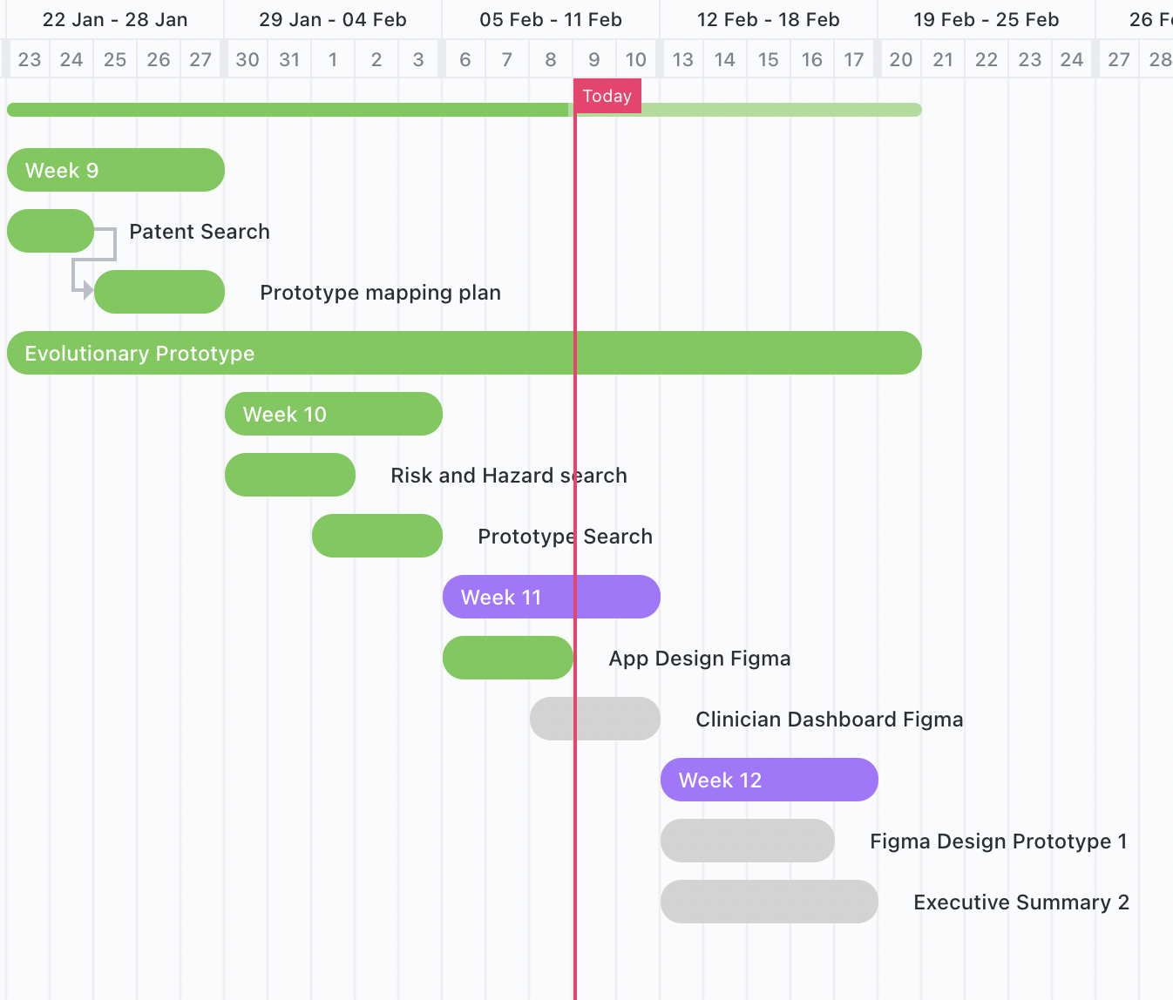
- Finish design app interface and layout on Figma
- Interview all stakeholders Dr. Rita had suggested
- Compile summary of work done, and stakeholder inters in the last 12 weeks.
- Create a set of questions for interviews
2.6 | Describe your business model – how will you make money?
The business model is fee per use and marketed towards clinicians (endocrinologists). Due to socio-political trends towards more funding and reimbursement in this area thus, possibility for crowd-funding and social impact investors.
This app would be classicized as a software based medical device but is not regulated under TGA.
2.7 | Outline any projected intellectual property (IP) and how this will be managed (200 words)  - If IP is projected.  - IP will be managed in accordance with the Monash University (Vice Chancellor) Regulations; see Part 5 of this linked document  - Clinical champions should confirm their IP agreements with their employer(s)  - If IP is not projected, describe your understanding of the IP landscape in which your project lies and explain why your team believes that no IP will be generated and your general pathway to achieving real-world impact and sustainability.  An IP agreement must be in place as a condition for any direct Phase II funding unless agreed by all parties.
- IP will be managed in accordance with the Monash University and Monash Health
- IP for the app may be held by the original inventor for the tool and clinician champion
- It’s not the aim for this project
- There’s a possibility of a trade secret on the software background processes or patent on novel measurement output

3 | Customer validation

3.1 | Describe your ideal first customer. Define your Unique Value Proposition to that customer.
First ideal customer would be an endocrinologist from the Gender clinic and works with Transgender women patients undergoing gender affirming hormone therapy. Their patients are dissatisfied with the service or requests for an analysis of the bodily changes on the hormone therapy.The unique value proposition to a customer is giving an accurate change data on patients without relying on visual accounts.
3.2 | Describe the current workflow and how your technology integrates or disrupts that flow.
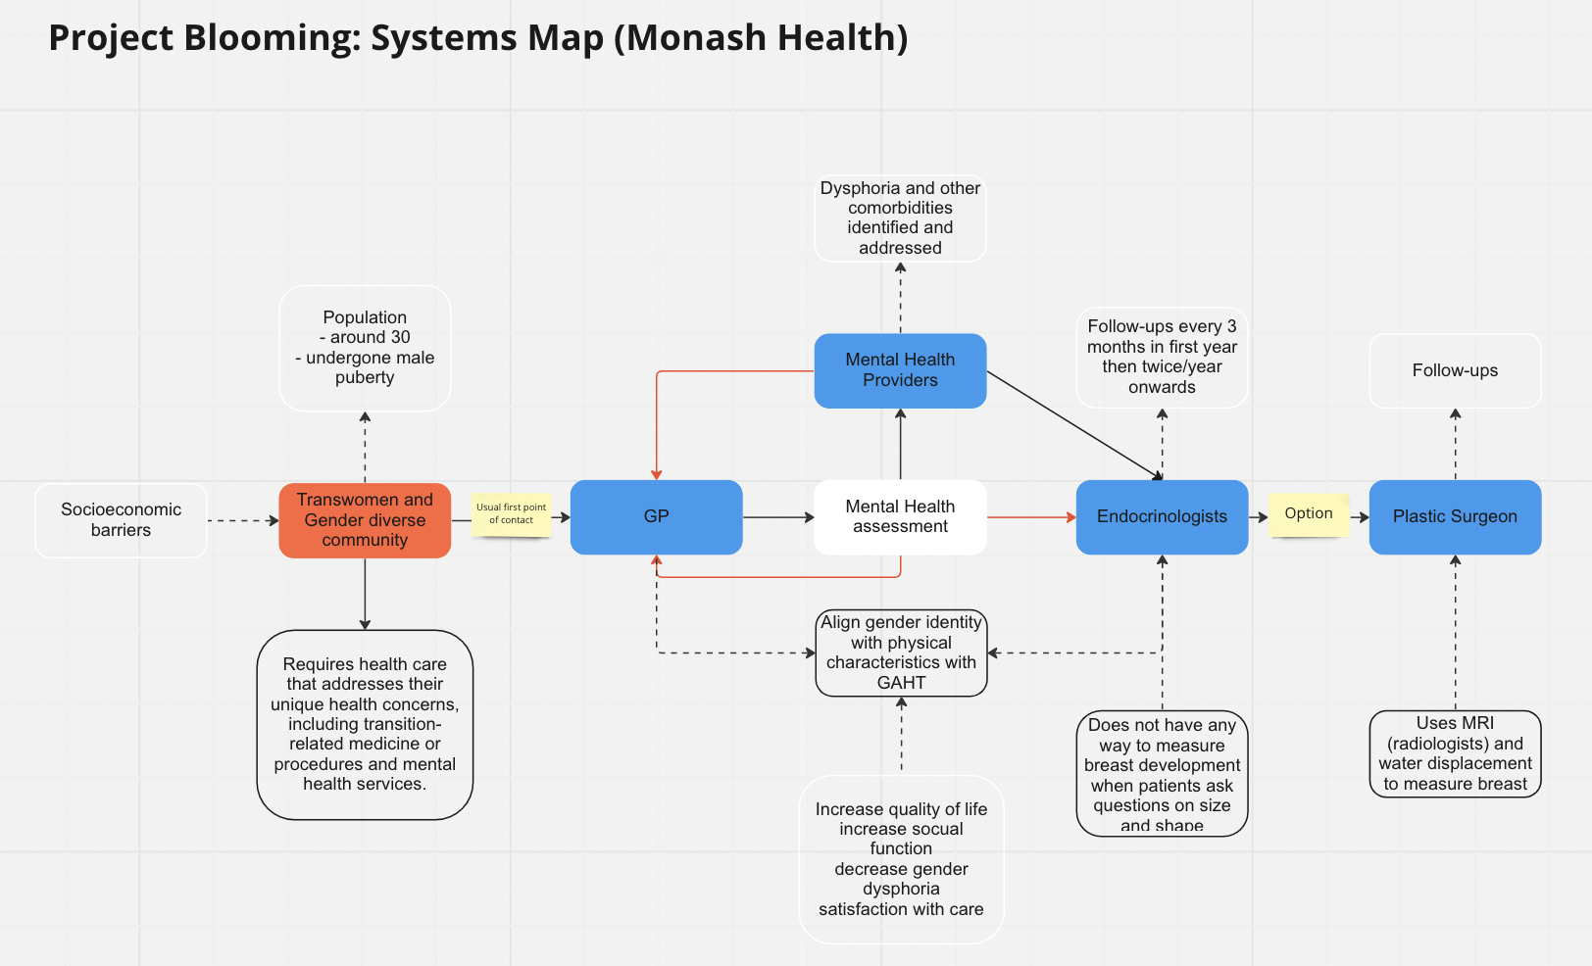
The above illustration depicts the system map project blooming will be integrated in. The app this project product will be used by GPs and endocrinologist on transgender women undergoing GAHT which is usually done after the mental health assessment.
3.3 | Describe the methodology used to validate the problem and your solution, including number of interviews and key insights from each of the following groups:  - End user or direct beneficiary, and  - Physicians or medical professionals closest to the problem  Show us what you have done, this can be in the form of market validation report, sample interviews, key insights.
I did a literature review of available studies on measurement tools used on transgender women for breast development. I investigated available tools of volume measurements in cis women as well and looked at available 3D apps used for weight loss.
As of now, I have interviewed five people of which full of them are very supportive of this project. I have two more people to interview before the end of HISS. I have learnt that trans women value breast development as it can help with presentation and that some document transition photos which were found to be rewarding how much the body changes. This would give objective measure on how the body changes that could be helpful and clinical settings and research. Though the population this project targets have a low socio-economic status and maybe vulnerable.

4 | Request for non-financial support

4.1 | Please outline any in-kind support that would assist in progressing this project.  This might include:  - Capital currently available for project activities  - Connections to people currently outside the project with specialized skills or experience  - Access to facilities  - Access to workshops, accelerators and/or similar events on topics related to this project
- Connections to other endocrinologists in other hospitals that work closely with the transgender women patients. This could clarify how other clinicals view this project and whether simpler options already exist.
- Connections to transgender women researchers and students who would like to help in the project.
- Access to the design and build studio computers at Monash woodside building
- Access to workshops, accelerators or seminars related to software apps and transgender women

4.2 | Student project teams  Please indicate if you would like to co-supervise a team within the MYMI Projects ecosystem to work on this project. This would involve:  - A small team (2-5) of students working in their spare time  - Students may be recruited with specific skills if needed  - Regular consultation (~ monthly) is still required with the student leaders of the team to monitor progress and plan future work, similar to HISS Program
If Project Blooming were to progress further as a MIME/MYMI project, the current lead would be involved in the recruitment and onboarding of a new group of recruits and would like to commit time to continue supervising the project. Dr Rita has also showed interest in future supervision.

5 | Financial support

5.1 | Budget  Please outline any financial support that is required for continuation of the project, and the approximate timing when that support would be needed.  Describe any other funding streams that will be/might become available for the project.
- A basic Augmented Reality app costs approx. $65,000 for companies like Tekrevol. (Overall)
- If novel measurement output, then about $20,000 to $50,000 for a qualitative or quantitative custom market research project is needed (The Farnsworth group). This would be needed after the prototype and before the finalisation of the project.
5.2 | Funding Outcomes (200 words)  What concrete outcomes would become achievable if your project received the further funding described above?
Using the estimated cost for a basic augmented reality app as humans that are experts in different parts of the field in making an app would be included and not only students. Thought this is not a need but would be desirable in the future after or around establishment. This project aims for novel output differ from tennis staging and bra sizes which would be difficult to justify without a market research study or a quantitative study.
5.3 | Sustainability (200 words)  Please outline plans to support your project in the long term or indefinitely. Is it possible for the project to become self-sustaining? If so, please explain how. If not, please detail the ongoing external support (financial and personnel) that would be required to keep the project running.
Project blooming does have a long-term timeline, extending to the next 2 years, requiring members to be actively involved in communications with Dr Rita Upreti who can provide feedback and guidance on building the app features and with the population in mind.

Due to vulnerable transgender individuals, extra measurements for clarifying ethics and security must be put in place. Making sure people know their right to consent.

Additionally, funding would be required for the single qualitative study if we were to implement a novel measuring output using raw measurements form the 3D scanning. Monash gender clinic does not have grants or funds at the movement with the required help from future team members, the project does look sustainable.

6 |  | Understanding the team

6.1 | Help us understand why you’re the right person to succeed in this opportunity.  Why you and not someone else?
I believe I’m the right person to succeed this opportunity because I have a keen interest in special issues and believe this app would help population with a niche need that tends to be overlooked. Though I believe, I am not the only right person and would love someone from the LGBTQIA+ community to be involved.
6.2 | Do you currently have an advisory team. If so, please list their names. If not, write N/A.
N/A
6.3 | Do you foresee the need for more team members to help keep the project running.  What is the overview of the role/s you would need.  What are desired attributes of the new team members e.g. we are looking for ‘x’  What are the responsibilities of the new team members?  What are the required qualifications of the new team members?
If Project Blooming were to progress, I, Jacinta, would be involved in the recruitment and onboarding of a new group of recruits with the ideal skill set to begin the prototyping process.
Team member qualifications:
- Mathematicians/ interest in anatomy
- Currently studying computer science / software engineering, or has extensive experience with coding languages abd/or augmented reality (3D scanning)
- UI/UX designers to format information on the app display for customers (clinicians) in an appropriate manner
Desirables:
- Passionate about healthcare and technology, and their combined relevance in this project
- Hardworking, passionate, friendly and driven
- Interest in social issues

