MONASH HEALTHCARE INNOVATION SUMMER SCHOLARSHIPS (HISS)
Template Application for Funding Opportunities
Project Activus

1 | Administrative details

1.1 | Title of project | Intradialytic exercise adherence to prevent sarcopenia and frailty. (Project Activus)
1.3 | Current Project Team
Project Lead: David Cheng
Clinical Champion: Dr Limy Wong.

2 | Project description

2.1 | Project aims and significance (Executive Summary) (1-2 pages)  Please outline the background and aims of your overall project, noting any changes to scope or targets that were implemented during the HISS program. Outline the particular niche area your project will address (be as specific as possible), the problem, specific target user(s) for the final product, the opportunity (i.e. market estimates), financials, traction to date, planned pathway to release of a (minimum) viable product, and any pre-existing competitors (highlighting your competitive advantages).
Sarcopenia and frailty are often seen in patients with chronic kidney disease or on haemodialysis, due to the sedentary lifestyle that arises from the stationary nature of haemodialysis. Exercise has been proven to be an effective treatment and preventative measure for these disorders, however there are a lack of quality intradialytic and interdialytic exercise programs available in Australia. This project seeks to identify the current implementations of exercise programs around the world, any problems that may arise from failed attempts, and the feasibility of introducing such programs into Australian renal units. Further, it will discuss a solution that will help to provide personalized intradialytic and interdialytic exercise routines for patients undergoing haemodialysis, to reduce these disorders, and help regain independence.
Intra- and inter-dialytic exercise programs are currently being regulated and monitored either manually or through self-directed protocols. For instance, in Japan and Singapore, dialysis facilities have implemented successful exercise programs that use commercially-obtained equipment and are accompanied by specific guidelines and procedures. In some cases, dialysis units may deny treatment if patients don't exercise as prescribed. Elsewhere, tailored exercise programs are administered by specialists or a dedicated team, while other facilities require patients to seek out a physiotherapist to help with their regimens. All of these solutions necessitate the involvement of experts, making implementation difficult and increasing dependence on the specialists.
The proposed concept of Retro-FIT is a service that facilitates the transformation of existing commercial exercise machines into modern, interconnected machines that are capable of tracking and recording exercise data. This data is then sent to clinicians via a specially designed smartphone app or fitness tracker, allowing for the monitoring of progress and identification of problem areas. As no hardware manufacturing is necessary, the machines and trackers can be easily recommended to renal units. These machines, which may include a pedalling machine and cadence sensors, are then connected to a custom-made fitness tracking software, allowing clinicians to monitor and analyse the exercise data.
Efforts as of February 2023 include the rapid prototyping and evaluation of software required and on the market. Tests involve a static bike coupled with various sensors and software to track workout performance metrics, identifying problems and strengths in each solution evaluated.
2.2 | Describe the market need or pain point you are targeting.
The pathophysiology of sarcopenia and frailty is complex and multifactorial. Long-term immobilisation due to either sedentary lifestyle or a disease-related condition can cause skeletal muscle degradation leading to low muscle strength and decreased physical performance. In addition, inadequate intake of energy or limited access to healthy foods can further contribute to this phenomenon. Individuals affected by sarcopenia and frailty are particularly vulnerable to falls, fractures, impaired ability to perform activities of daily living, cognitive impairment, loss of independence, need for long term care placement, and even death. This is especially true for individuals with chronic kidney disease (CKD). Frail kidney transplant recipients are more likely to experience early post-transplant complications, delirium and hospital readmission than those who are not frail.

Exercise is recognised as an effective method for managing sarcopenia and frailty, and should be an integral part of haemodialysis. Despite this, there are still challenges in achieving long-term patient adherence to these programs, as well as a lack of time for healthcare professionals to facilitate them. As a result, there are currently no major renal units in Australia that actively use exercise as part of dialysis.
2.3 | Explain the structure of the market (in particular the value/supply chain and relationships between suppliers, distributors, influencers and end customers) and your intended place in it. (porter’s five forces)
1. Bargaining Power of Suppliers: The suppliers of the exercise device, such as equipment manufacturers, have the power to increase the cost of the device. This could drive up the cost of supplying the device to renal units, making it less accessible to dialysis patients.
2. Bargaining Power of Buyers: Dialysis patients may be able to negotiate a lower cost for the device, depending on their bargaining power. If they are able to demand a lower price, this could reduce the profits of the suppliers.
3. Threat of New Entrants: The threat of new entrants into the exercise device market exists, as new manufacturers may enter the market and undercut the prices of existing suppliers.
4. Threat of Substitute Products: While there are no direct substitutes for the exercise device, dialysis patients may opt for alternative forms of exercise, such as swimming or physical therapy, which could reduce demand for the device.
5. Rivalry Among Existing Competitors: Competition from existing suppliers is likely to be fierce, as they will be competing for a limited pool of dialysis patients and renal units. This could lead to lower prices and higher quality devices in order to win market share.
2.4 | Project progress (200 words)  Outline your summary of the progress that was made in your summer project.  Outline the current status of the project.
Project progress includes the following;
- Evaluating current solutions on the market and how they may fit into the proposed solution
- Identifying major problems with the current solutions on the market, and areas of improvement that will massively improve the quality of the product.
- Investing in compatible exercise equipment to actively test software.
- Started identifying areas where improvements can be made and an MVP can be produced.
2.5 | Project planning (400 words - or GANTT chart)
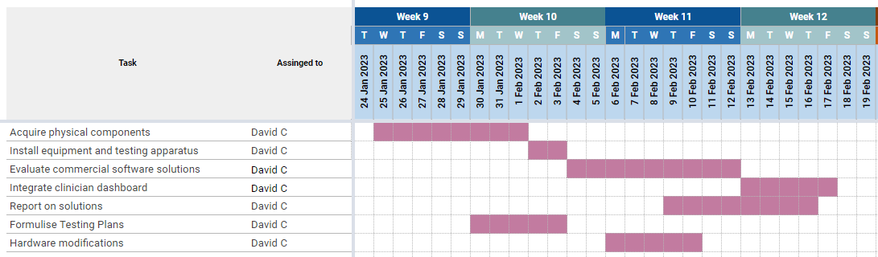
2.6 | Describe your business model – how will you make money?
The program will sustain itself through 3 different streams of revenue:
1. Consulting and installation services: Expertise can be provided in terms of selecting the correct commercial products to purchase and the special installation of these products to suit the requirements of the exercise program. A guidebook can also be sold if a renal unit chooses to pursue an exercise program on their own.
2. The app may involve some form of payment for access. This includes a onetime payment for each user, or a subscription model for using the app. The subscription costs may be used for any maintenance costs that are incurred - both for the exercise machines and associated software.
3. A standalone tracking device can be made and sold to renal units or patients that do not wish to use the smartphone app. It is not expected that this will be a popular option due to the ease of use of a smartphone app; but is an option for outlier cases and/or special cases where a smartphone app cannot be used. This includes patients that may not be able to or comfortable enough to use a smartphone app.
2.7 | Outline any projected intellectual property (IP) and how this will be managed (200 words)
Intellectual property is projected to be partly owned by Monash University, the clinical champion, the HISS program, and the project lead. There have been no concrete decisions made regarding the specifics, although one is expected to be created once a dedicated team is put together and the project progresses into next round of funding and development.

3 | Customer validation

3.1 | Describe your ideal first customer. Define your Unique Value Proposition to that customer.
The first ideal customer will be a renal unit willing to let a pilot program run. This is because once a pilot program is run, a lot of the adherence and other assumptions made can be tested. In return for the information given to the team regarding the effectiveness and areas of improvement of the solution, patients in the renal units will have access to free exercise programs, which is a low risk way to improve their health and independence.
3.2 | Describe the current workflow and how your technology integrates or disrupts that flow.
The current workflow problem is the complete lack of an exercise program. The integrated exercise bikes will disrupt the sedentary nature of haemodialysis, and will integrate into renal units via providing an extra data point to evaluate patient health. Additionally, it will give renal units a framework to use in order to provide patients a serious exercise program that will be lost cost, accessible, and effective. A systems map describing how it will integrate into a renal unit is shown below:
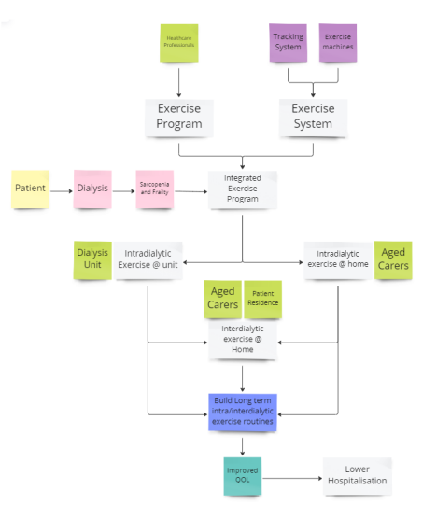
3.3 | Describe the methodology used to validate the problem and your solution, including number of interviews and key insights from each of the following groups:
A lot of time was spent on ensuring that the solution will be compatible with the current workflows and experiences of patients, nurses, and other renal unit staff members. Interviews were held with the clinical champion, who is a nephrologist that oversees haemodialysis patients, dialysis nurses were interviewed to identify the issues they were facing and what the perceived barriers were to exercise. Other heads of renal units were interviewed on their views, and physiotherapist gave their insight into the barriers and exercise requirements of patients. To address the adherence problem, which directly relates to the patients, studies that reported on the adherence of older patients on exercise. To validate these results and whether or not the current solution will improve outcomes, a pilot study will need to be conducted.

4 | Request for non-financial support

4.1 | Please outline any in-kind support that would assist in progressing this project.
Support required:
- Individuals that have app development experience.
- Monetary capacity to buy a wide range of exercise devices to evaluate strengths and weaknesses in a renal unit.
- Space to set up equipment to evaluate devices, and rapidly prototype software solutions.
4.2 | Student project teams
Students with a passion for app development to improve the lives of others will be useful. To ensure good progression, students with past experience are desired.

5 | Financial support

5.1 | Budget
Once it is decide which route to go on (using commercial software or custom), $2000 AUD would be required to evaluate a range of exercise equipment that may be suitable, and develop software. An additional $2000 AUD may be required if there are any specific hardware requirements.
5.2 | Funding Outcomes (200 words)  What concrete outcomes would become achievable if your project received the further funding described above?
To develop a range of MVP machines ready for a pilot program to run. Additional funding may be required to initiate a pilot program, but the heavy use of volunteers and low cost nature of the machines will mean the pilot program itself may not require a huge sum on money to sustain.
5.3 | Sustainability (200 words)  Please outline plans to support your project in the long term or indefinitely. Is it possible for the project to become self-sustaining? If so, please explain how. If not, please detail the ongoing external support (financial and personnel) that would be required to keep the project running.
The project will be self-sustaining if the pilot program goes well. This is because there will be massive opportunity to reach out to other renal units with the story of success, and the solution itself will be validated. It is expected that the cost benefit analysis for many renal units will make the solution a viable option to improve health outcomes.
6 |  | Understanding the team

6.1 | Help us understand why you’re the right person to succeed in this opportunity.  Why you and not someone else?
The project lead is expected to be involved with many extracurricular activities in the coming year. Therefore, he may not have the opportunity to fully dedicate himself into the project. The project deserves someone that is willing to spend a considerable amount of time and effort to prototype and implement the solution.
6.2 | Do you currently have an advisory team. If so, please list their names. If not, write N/A.
N/A
6.3 | Do you foresee the need for more team members to help keep the project running.  What is the overview of the role/s you would need.  What are desired attributes of the new team members e.g. we are looking for ‘x’  What are the responsibilities of the new team members?  What are the required qualifications of the new team members?
Roles required:
Project Lead: someone who can communicate with key stakeholders and ensure the progression of the project
Software Lead: someone who is experienced in developing software and internet of things systems
Software developer: works under the software lead to develop software for the project
Pilot study coordinator: someone who can take communicate with renal units, organize, plan and execute a pilot study.

