
MONASH HEALTHCARE INNOVATION SUMMER SCHOLARSHIPS (HISS)
PROJECT NAME: Project Blooming
DELIVERABLES NUMBER: 9 (Week 10)
PROJECT MEMBER(S): Jacinta Patel

Gantt chart:

This chart has been revised since last week and is predicted to keep changing.
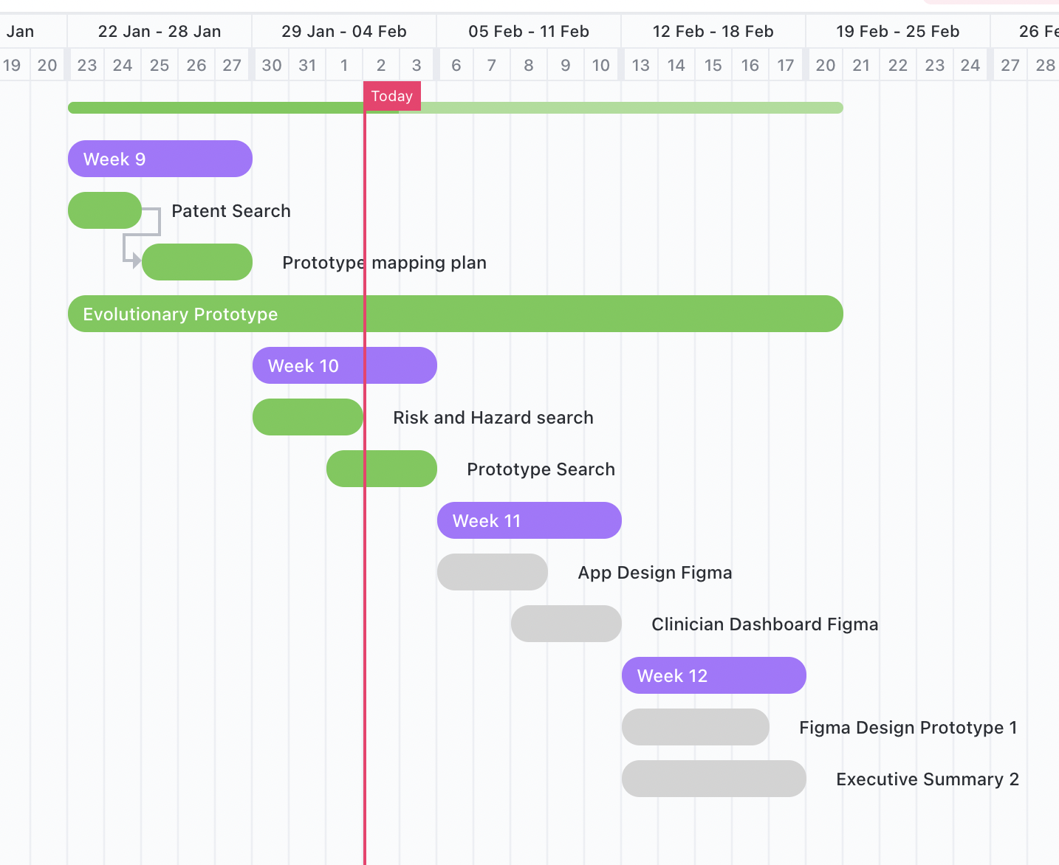
https://app.clickup.com/9003039425/v/li/900300539839

Regulation:
According to TGA in Australia, this project would come under software based medical devices which are medical devices that incorporates software or software.
- Its purpose is likely to be medical as it to either (1) monitor a state or (2) support of conception or (3) investigation of a physiological state.
- It is excluded as this product (1) does not provide specific treatment suggestions and (2) would possibly be a population based analytic that do not drive outcomes for individuals.
- Therefore, the software is not regulated by TGA. 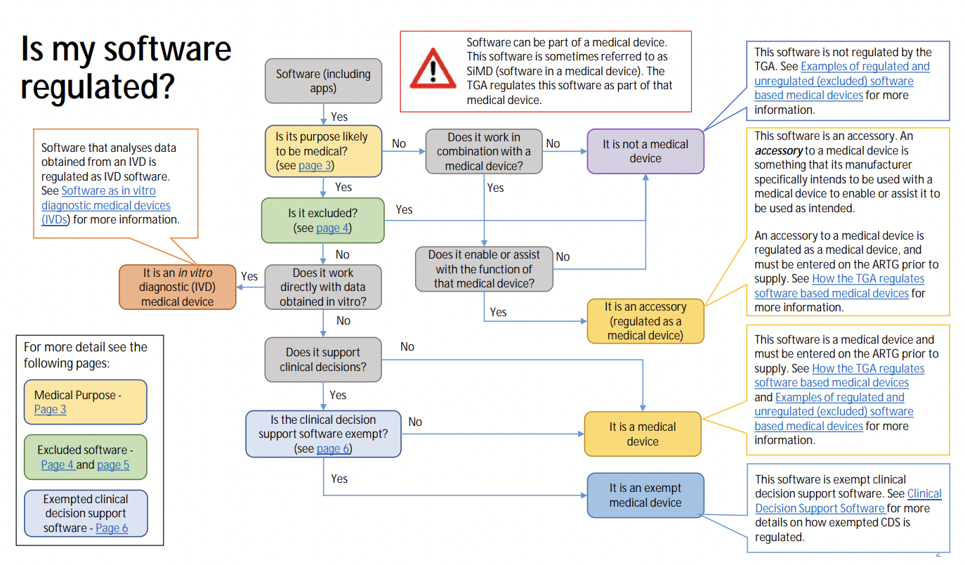
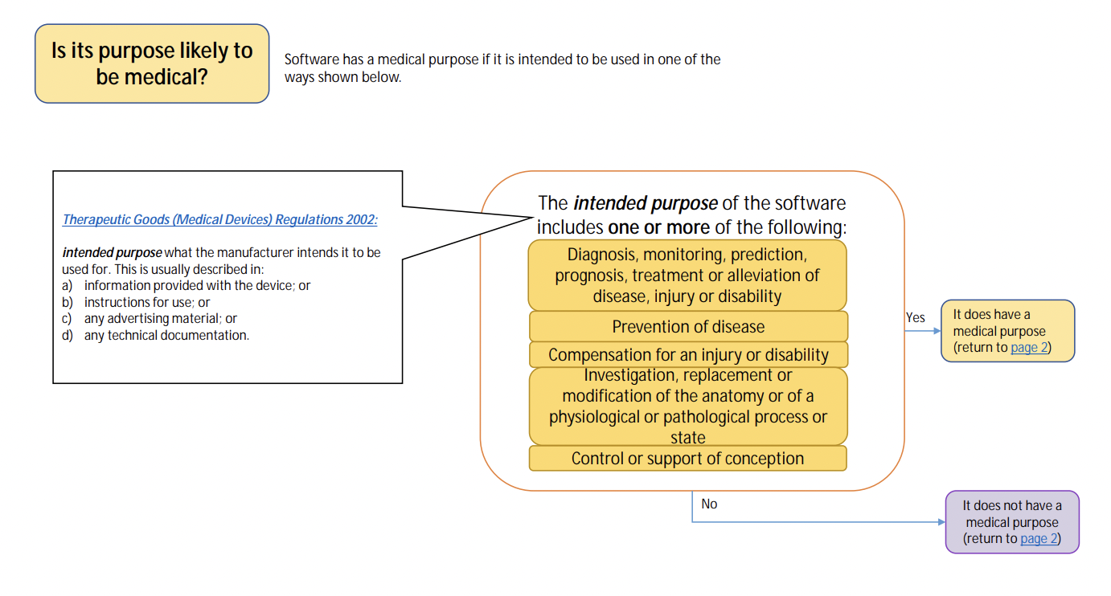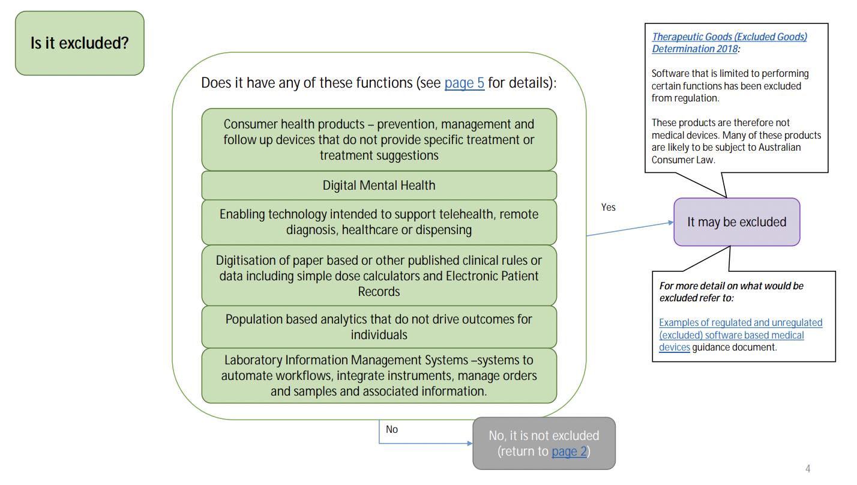
https://www.tga.gov.au/sites/default/files/my-software-regulated.pdf

Risk and Hazard Analysis:

Risk | Frequency of Scenario | Severity of Consequence | Class
- Patients with increased dysphoria | Low | High | Medium
Security of information | low | high | medium
Impaired perception due to low-quality AR | medium | medium | medium
Information overload for clinicians | low | low | low
https://www.allerin.com/blog/organizations-should-address-these-5-risks-of-ar

Mitigation strategy:
- Patience will only be able to use the app in the presence of a clinician therefore there is not much focus on someone’s changes apart from the consultation. Better than if it was self-monitoring.
- Security and privacy of the patient is very important and will only be accessible after they consent and only by the clinician or researcher. Measures to be taken to prevent hackers and malware which could lead to denial of service or overly wrong information or spread to the wrong people.
- To prevent impaired perception due to low quality they are when downloading the app from the App Store there will be a description listing what devices can use this app.
- Due to the condition of busy schedule and messy dashboards information of load can be prevented by easy user interface,

Of course, with every app there will be monitoring for feedback and redesigning purposes.

User Interview:
Will be asking Dr. Rita and peers for feedback on design. Will resume talking with stakeholders in the next week.

Prototyping progress:

Using my available skills, I have started to make a word document like the executive summary on what my clinician needs beyond HISS such as:
- how to develop a novel scale + timeline
- where this project could go if no novel scale is made and focuses on raw measurements + timeline
- question bank for stakeholders and patient
- All resources and interviews I have gathered

I have also started designing how the app would look lime on a smartphone and dashboard on Figma.

https://www.figma.com/file/ZUo4Dtseg9ZLqekvgVUJQm/Project-Blooming?node-id=0%3A1&t=qgnSQEjoQf8V8E8Q-1

Template: https://www.figma.com/file/AYHBUBhqrTBkpJGgIaDAkE/Augmented-Reality-Design-Kit-(Community)?node-id=3%3A1648&t=DXR6Dxcs0YJ1LaRl-0

