
MONASH HEALTHCARE INNOVATION SUMMER SCHOLARSHIPS (HISS)
PROJECT NAME: THEIA
DELIVERABLES NUMBER: 9 (Week 10)
PROJECT MEMBER(S): ERIKA LAY & WILLIAM CHEN

Gantt chart:

The Gantt Chart has been updated as follows:
https://miro.com/app/board/uXjVPu8pe-8=/?share_link_id=361316648760

Regulation:

- TGA:
  - COVID-19: Class 3 IVD Medical Device
    - Software application utilises image processing (i.e. an algorithm) to produce (i.e. ‘translate’) a diagnostic test results to users, in accordance to the following statement in the attached document:
      - “Software that analyses/interprets results from COVID-19 rapid antigen self-tests would be regulated as a Class 3 in vitro diagnostic (IVD) medical device analysis software and require separate inclusion in the ARTG.”
      - https://www.tga.gov.au/sites/default/files/software-use-covid-19-rapid-antigen-self-tests.pdf
- CE:
  - COVID-19: Class 2II IVD Medical Device
    - Software interprets images of self-diagnostic test window to produce (i.e. ‘translate’) the diagnostic test results, in accordance to the following guideline:
      - “Software intended to provide information which is used to take decisions with diagnosis or therapeutic purposes is classified as class IIa, except if such decisions have an impact that may cause:
        - death or an irreversible deterioration of a person's state of health, in which case it is in class III; or
        - a serious deterioration of a person's state of health or a surgical intervention, in which case it is classified as class IIb.”
  - Note that the CE Mark provides pathways for a ‘modular’ regulatory framework when applying for regulatory approval, whereby different modules within a software can be differentially regulated depending on the functions and specifications of the module. This enables a more cost-effective and timely process for attaining regulation for separate modules of a software device.
- FDA:
  - 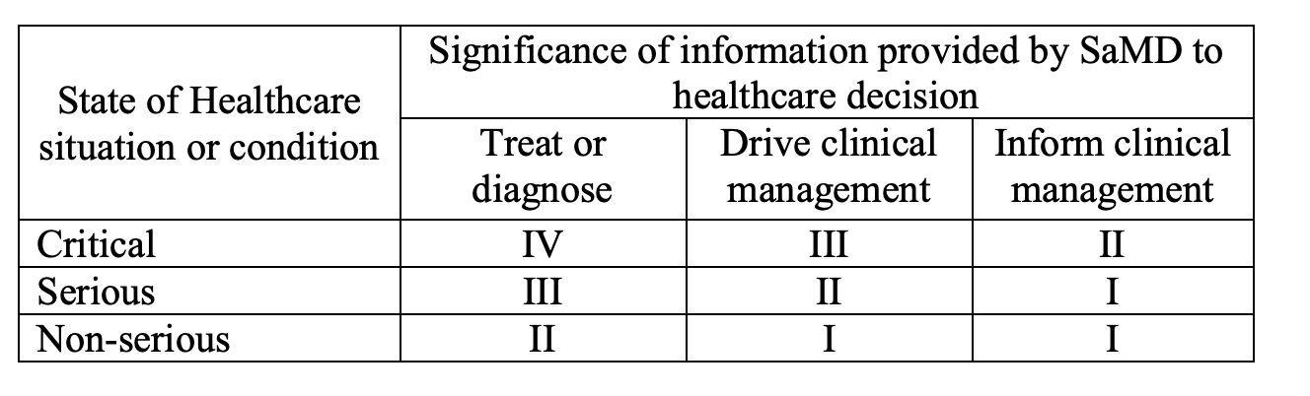
  - The device ranges from a Type IV to a Type II device, with the most likely being a Type III device, due to the following factors:
    - Severity of Healthcare Condition:
      - The classification of the device depends on the severity of the health situation or condition. This varies for COVID-19, as the severity of the effects caused by COVID-19 ranges from mild to severe depending on patient-specific demographics (e.g. age, underlying conditions, etc.). Due to the fact that the blind and low-vision population share similar patient demographics as the demographic of individuals most likely to develops severe side-effects from COVID-19 (e.g. diabetic, elderly age), it is likely that this device is classified as a critical condition.
    - Intended Use:
      - If we argue that THEIA provides treatment or diagnosis of COVID-19 based on the results of the self-test, then the classification would be Type III (Serious Condition) or Type IV (Critical Condition). However, it may be possible to argue that the intended use of THEIA merely aligns with intended use of self-tests: which claim to merely provide an ‘aid to diagnosis’ and thus ‘Drives clinical management’ (in comparison to the gold-standard diagnoses provided by PCR tests) (Ref):
        - 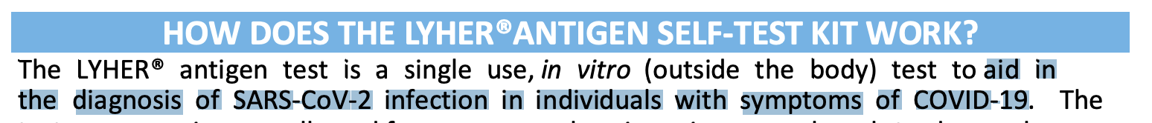 (Ref)
      - If so, then this device can be classified as Type III (Critical Condition) or Type II (Serious Condition) device.

The next steps for registering device involve contacting the relevant regulatory body (e.g. TGA) to confirm and compare the class of this medical device in reference to other devices previously regulated by the TGA (i.e. a digital COVID-19 reader, UnifAI, which received regulatory exemptions under the MHRA). As part of this conversation, we aim to scope out the possible scenarios by which this device might receive exemptions from classification as a Class 3 IVD medical device (e.g. exceptional circumstances due to the urgency of public health crises, borderline cases, as well as accessibility cases), and technical solutions that would enable this solution to not undergo regulation as a Class 3 IVD device.

Risk and Hazard Analysis:

- Lack of volunteer base - medium risk (low severity, high frequency).
  - This risk can be mitigated through marketing to a large population of individuals, and providing large financial incentives per annotation of an image.
  - A lack of a volunteer base would remove an interpretation option from individuals, but would not eliminate all possibilities for interpretation available for individuals - as such, this has been classified as ‘low severity’.
- Lack of user uptake - high risk (high frequency, high severity).
  - This can potentially be mitigated through liaising with official Australian advocacy and support organisations (e.g. Vision Australia), the Australian Department of Health, and general practitioners to assist with sponsorship and promotion of this device as a certified, accessible solution to self-diagnostic tests for the blind and low-vision population. Partnership with such recognised organisations as part of the device’s marketing campaign may increase the credibility of the device, and thus increase user receptiveness to download this application.
- Lack of funding or unfeasible cost model to support long-term maintenance of the application.
  - This can be potentially mitigated by downscaling this project to a student development team at universities, in order to mitigate the development costs of maintaining this application.

User Interview/Testing:

A single user interview has been conducted to scope out the need for this project, and preliminary preferences for the design of the test. Correspondence with Bill Jolley, the 2023 Chair of Vision Australia, has furthermore indicated the need for a more accessible solution for diagnostic self-tests. The findings are as follows:

- General Experience:
  - A well-verified need with “interest worldwide” (Bill Jolley, Vision Australia) for a more accessible solution to diagnostic self-tests.
  - The largest barrier for users when taking self-diagnostic tests is the period of time when users are first learning how to conduct the test for the first time, and conducting different types of tests (e.g. oral and nasal tests, different brands of tests).
- Conducting the Test:
  - Users have noted that the large number of small components comprising tests are difficult to use, and are a barrier for users with decreased motor control.
  - Users have noted that it is difficult to conduct tests across different brands, due to the different types of components used in different brands (e.g. some tests have a dropper attached to a pipette whereas others do not, some tests have the solution pre-filled in the collection tube as opposed to tests which do not, etc.).
  - Users have requested for a wide range of accessibility formats (e.g. Braille, audio feedback and haptics) to cater towards a larger spectrum of people with disabilities - and particularly individuals with deaf-blindness.
- Results Interpretation:
  - Users have indicated that their preference for interpretation modes in the following order:
- Software interpretation of test results.
- Sending the test results to friends and family.
- Sending the test results to an anonymous group of annotators.
- Cost Model:
  - Users have expressed interest in a higher price-range for the application than initially anticipated - demonstrating interest in using a subscription service to access a certain number of accessible instructions, as well as fee-for-service model per annotation.

Prototyping Progress:
- Developed an algorithm to select the five clearest images from a stream of images through a camera.
- Developed a method to align software-captured of self-test windows with initial instructions for interpretation, to facilitate the interpretation method utilizing a group of user annotations.
- Developed module to share images to contacts in smartphone for interpretation.

