
MONASH HEALTHCARE INNOVATION SUMMER SCHOLARSHIPS (HISS)
PROJECT NAME: Sentinel
DELIVERABLES NUMBER: 9 (Week 10)
PROJECT MEMBER(S): Calvin Zheng, Diana Kovaleva

Gantt chart:
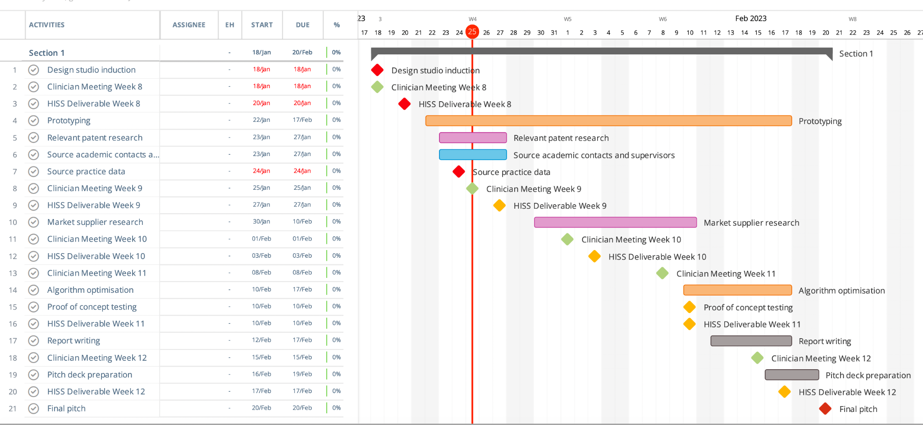
Completed:
- 2 weekly lab meetings → more user information and procedure details gathered
- Anonymous patient data sourced
- Relevant patent research conducted

To be completed:
- Relevant market supplier research → consultation with Khoa to further develop the market analysis completed during the masterclass this week
  - Research on gained insights to be completed in Week 11; potential stakeholders and market partners to be contacted after research is complete

Regulation:

Class IIa according to the TGA
- Low to medium risk level
- Intended to diagnose, treat or monitor patients by delivering or exchanging energy with the patient

Class 2 according to the FDA
- higher category of risk because they are more likely to come into sustained contact with a patient
- May encompass diagnostic devices
- “devices for which general controls are insufficient to provide reasonable assurance of the safety and effectiveness of the device.”

Class IIa according to CE
- Manufacturer must receive a declaration of conformity from a notified body following its conformity assessment

Next registration steps:

To register the device with TGA, after establishing that certification is required:
- Become the TGA client to apply for a licence or GMP certification
- Supporting documentation required:
- Statutory declaration
- Manufacturing licenses
- Submit TGA manufacturing license and GMP certification
- Pay application fee
- Determine application effectiveness

Risk and Hazard Analysis:

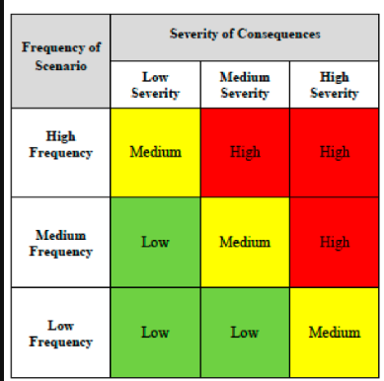

Risk | Frequency of scenario | Severity of consequences | Classification
Need for invasive imaging techniques to get precise localisation | Low | Variable | Low - Medium
Current inverse solution method will use standardised MRI data; may cause errors between visualised data and recorded data. | High | Medium | High
Use of EEG may induce seizures in patients with seizure disorder (flashing lights and noises) | Low | High | Medium
Patients’ condition on arrival may affect the accuracy of EEG readings  - Low blood sugar  - Body and eye movement  - Medicine (e.g: sedatives)  - Caffeine | Medium | Low | Low
Initial proof of concept will use existing API available online. Our own software product will require making everything from scratch to avoid IP issues. | Low | Medium | Low

Seizures - These occur very rarely in patients subjected to EEG, and are treated on urgent notice by neurologists. As part of extended functionality the proposed solution can also be expanded to notify specialists of occurring seizures in real time, so that help can be provided in a quick and efficient manner.

Patient condition - Patient history regarding any of the risk factors mentioned above needs to be accessible to the neurology department before the procedure can be conducted. Additional tests will need to be performed on patient arrival, however, due to the time sensitive nature of stroke, the test may need to be conducted once the EEG has already been applied.

Overall, the risks associated with EEG occur rarely. Multiple sources have stated that EEG is amongst the safest and least invasive monitoring methods, so the procedural risks are assumed to be low.

User Interview/testing:

Need for an easy-to-read format → found that even neurologists need specialised training to be able to read the EEG, so an intuitive UI will help to increase the amount of specialists that can be utilised to conduct the testing and monitoring.

No need for precise localisation at the moment. Potential for extension to the project in the later stages, but was found to be redundant currently.

From risk assessment → may need to screen patients prior to addressing the proposed solution, to exclude factors which may affect accuracy of EEG readings.

Prototyping progress:

A major blocker discovered last week was that 3D visualisation of EEG data requires a source model or a mapping of the physical structure of the brain to plot the data onto. The source model is commonly constructed from MRI data, but as our solution seeks to avoid usage of MRIs, this creates a problem. After a discussion with our clinician and academic supervisor, we have devised an alternative solution with unproven effectiveness. We will use standardised MRI data that’s available online that represent the ‘average’ human brain as our source model.The MRI dataset that we plan to use is MNI 152.

