
MONASH HEALTHCARE INNOVATION SUMMER SCHOLARSHIPS (HISS)
PROJECT NAME: Anantyash Dixit
DELIVERABLES NUMBER: 9 (Week 10)
PROJECT MEMBER(S): SeeSaw

Gantt chart:

Tasks | Week 9 | Week 10 | Week 11 | Week 12 | After
Wire Frames | Completed
Storyboarding | Completed
User Stories |  | ongoing
Start Coding |  | ongoing
Coding the Features |  | ongoing
Final Financial Proposal

Regulation:

At the moment theApp is only to be used by the therapists and might require a similar ISO certification to that of a cerner ORACLE software but since it is not qualify for clinical use so, does not require now and for later as a health App it will require a simillar ISO certification of Fitbit Health App

Risk and Hazard Analysis:
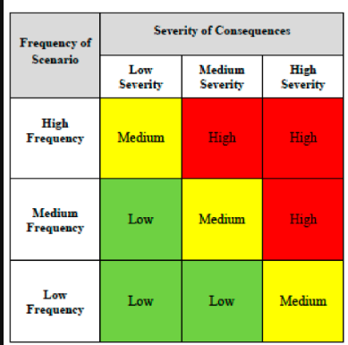

Risk Analysis: Medium to Low risk in general

Therapist Perspective: The App may Glitch during The test and records might not be saved - Low Risk

Patient’s Perspective: patient might fall during the exercise causing injury but in a safe and controlled environment. - Moderate Risk

Mitigation Strategy:

Therapist Perspective: The Internet connection should be fast enough to save data at each step and any bugs should be reported asap through the App.

Patient’s Perspective: Therapist should ensure padding around the patient and check the condition of the patient if he/she is in a complete state of mind to take the test.

User Interview/testing:

To ensure better usability and improve semantics of the application I interviewed one of the Monash Health Physiotherapists regarding the suggestions and improvement for the App. Through careful and vigorous testing, some of the additional features added to wireframes seemed to populate the User Interface which made the user overwhelmed, hence some features were removed. To improve the learnability and reduce short term memory load of the application, the features were divided into separate wireframes and some extra wireframes were added to the flow.

Prototyping progress:

Throughout the week, a lot of effort was put into preparation of layout of the homepage, login page and the Dashboard. All of this was designed using react the reason being its increased demand in the market, the integration of front end in the JQuery code itself and easy learnability and usability.
The User Interface has been developed but still needs some improvements for error handling (better coding practices for future extension), also, the application is being developed to be utilised over different operating systems (Windows, Android and Apple) and to be used over different devices, hence, pixel adjustment is required for better experience of the application by the user.

