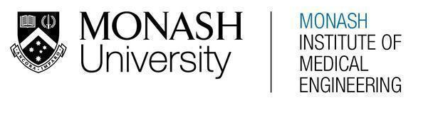
MONASH HEALTHCARE INNOVATION SUMMER SCHOLARSHIPS (HISS)
PROJECT NAME: Nemo
DELIVERABLES NUMBER: 9 (Week 10)
PROJECT MEMBER(S): David, Upani & Vishnu

Gantt chart:

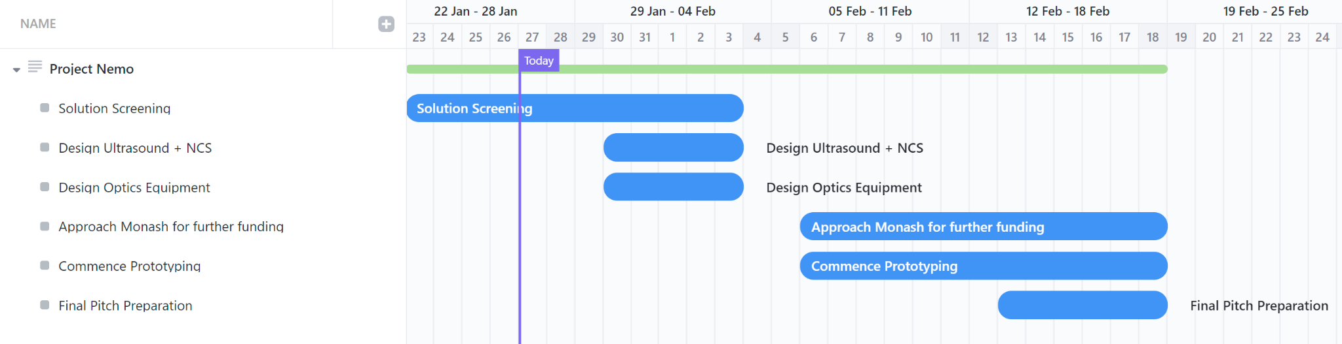

Regulation:

TGA: Class II - justification: ‘diagnosis or monitoring of a disease, injury or disability’
https://www.tga.gov.au/resources/what-classification-my-medical-device

Next steps for device registration in Australia:
https://www.tga.gov.au/products/medical-devices/medical-devices-overview
- Prove that the benefits of the device outweigh any possible risks
- Search for a medical device sponsor

CE Mark: Class IIa - Non invasive device for short-term use only
Koah’s presentation (week 6 folder and recordings folder)

Next steps for device registration in Europe:
https://laegemiddelstyrelsen.dk/en/devices/development-of-medical-devices/
- Data from clinical investigations
  - Assess whether the device meets the general safety and performance requirements
  - Since variants of parts of our device exist, we can use some or all of existing evidence to fulfil the requirement for clinical data.
- Evaluation plan
  - Intended purpose of the device
  - Intended target group
  - Methods used to determine if the benefit-risk ratio is acceptable
- Evaluation report
  - Include performance of the device and if meet the manufacturer’s expectations
  - Describe the safety of the device and whether the risk of any side effects and unintended follow-on effects of using the device is acceptable relative to the intended performance of the device.
  - Must continuously update the report throughout the device’s lifetime
- Post-market clinical follow-up
FDA: Special 510k - by stating similarities with existing technologies
Koah’s presentation (week 6 folder and recordings folder)

Next steps for device registration in Europe:
Koah’s presentation (week 6 folder and recordings folder)
- Provide valid scientific evidence
- Intended uses/target population
- Clinically significant results (show a comparison of existing machinery and prototype)

Risk and Hazard Analysis:

Solution Type | Risk | Mitigation | Frequency | Severity
Optics | Radiation leakage  Depending on the type of radiation and duration of exposure, it can be carcinogenic. | Isolation chamber or thin lead ‘screens’ around exposure area |  | Experiment required
Optics | Incorrect light frequency/wavelength setting | Factory set frequency/wavelength limits based on radiation exposure literature reviews
Optics | Prolonging exposure to radiation | Push button sequence trigger with a ‘cooldown’ timer
Ultrasound | Electrolysis of ultrasound gel  Since it is primarily composed of water, voltage+current will break it down into hydrogen and oxygen gas which is HIGHLY combustible |  |  | Experiment required
Ultrasound | Elastic and Plastic Deformation of device (due to physical pressure) | Use polymer materials, specifically those that are cost effective and with the characteristics of lightness and strength.
Nerve Conduction | Incorrect voltage and current settings | After a certain power output, the device asks for confirmation by the operator
Nerve Conduction | Incorrect pulse width | After a certain pulse width, the device asks for confirmation by the operator

KEY:
High
Medium
Low

Prototyping progress:

Over week 10, preliminary designs for our prototypes have been drafted. Following which, our 3D model was analysed for any design flaws and rectified them appropriately. Furthermore, aspects of the prototype designs were also marked for any risks and hazards. This was later summarised in a tabular format and were graded in terms of their frequency and severity. In addition to this, the TGA, FDA and CE mark device classifications were studied as we aim to launch our product in the American, Australian & U.S nerve conduction study market and eventually expand worldwide.

