
MONASH HEALTHCARE INNOVATION SUMMER SCHOLARSHIPS (HISS)
PROJECT NAME: Project Impetus
DELIVERABLES NUMBER: 9 (Week 10)
PROJECT MEMBER(S): Dan Lin

Gantt chart:

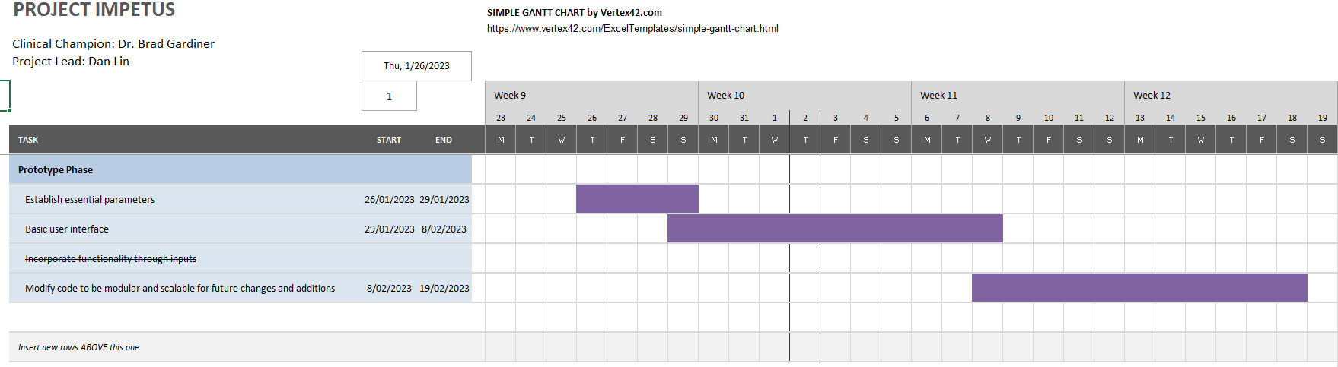

- On track with all the major tasks except for task 3: incorporate functionality through inputs.
- This task may not be feasible since more time is required to be allocated to establish the basic user interface and ensure that the current program can be scalable for future additions/modifications

Regulation:

- My software has a possibility of being classified as either an exempt medical device or as a Class IIa medical device, thus being regulated by the TGA.
- The main decider is whether the software is designed to:
- Completely replace clinicians’ decisions on the dosage of immunosuppressive drugs for patients, or:
- If it is only to be used as a support tool to guide their decisions.
    - If it is 1, the software will be classified as a medical device.
    - If it is 2, the software will be an exempt medical device
- I will discuss this with my clinicians in the following week

The following resources and flowcharts were used to guide my process in deciding on the classification of my software:

Is my software regulated? (tga.gov.au)
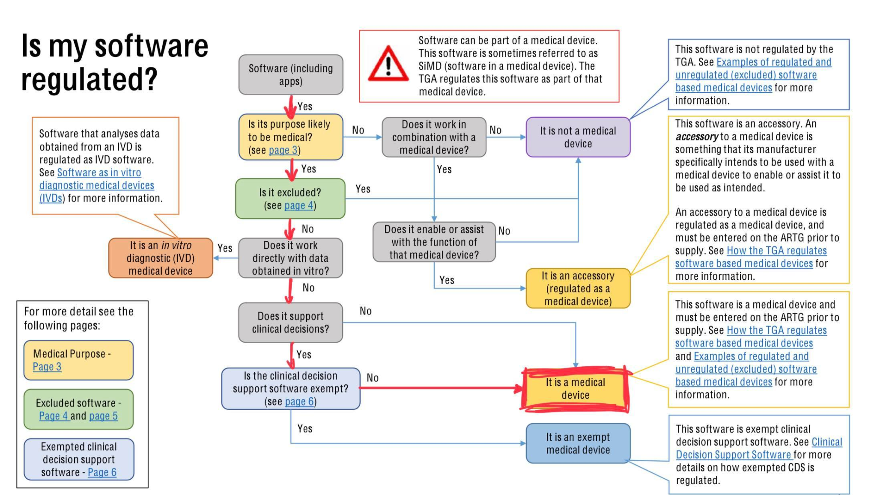
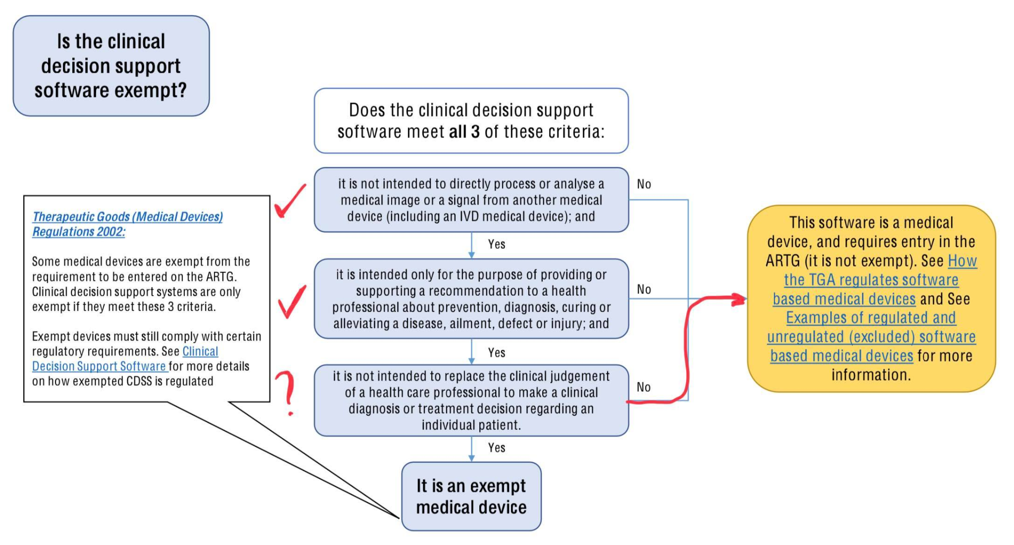

How the TGA regulates software-based medical devices
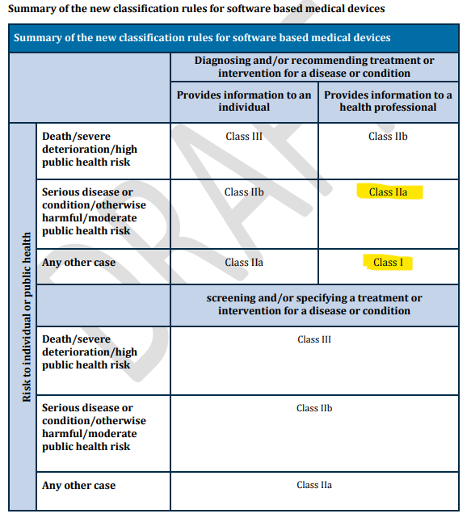

Risk and Hazard Analysis:
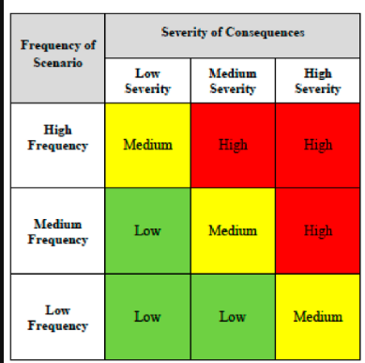
Risk:
The correlation between drug dosage and immunological assays may be affected by novel or undiscovered factors, possibly significantly affecting predicted drug dosages
- High severity (since it could affect a large number of patients depending on the undiscovered factor)
- Low frequency (given clinicians will be constantly monitoring the medical landscape)
→ Medium risk

Mitigation strategy:
Observe irregular patient symptoms after administration and have a dedicated team to determine whether the abnormalities are random or related with certain factors. Continuously update the software if needed.

User Interview/testing:
I am interviewing a transplant patient today (Friday 3/2), and planning to ask the following questions:
- How do you manage your medications and keep track of your dosages?
- Have you experienced any drug interactions or adverse reactions to your immunosuppressants?
- How do you work with your transplant team to adjust your immunosuppressive regimen as needed?
- Can you describe any symptoms that would prompt you to call your doctor for a change in your medication?
- How do you manage any potential side effects or complications related to your immunosuppressants?
- Have you ever had to make any sudden changes to your immunosuppressive regimen? If so, can you describe the reason and how it was handled?
These questions won’t directly help me with my software project, since my target audience is clinicians rather than patients. However, it will provide me with a better context of the problem after observing how dosage adjustments impact patients first-hand.

Prototyping progress:
- Changed layout of application, experimenting with different themes and software packages that allow for easier website creation
- In the process of updating the types of inputs required, this task is to be continued
  - Added the ability to add more drugs, but still investigating how to allow users to remove them
- Added a very basic output in the bottom panel that tells clinicians whether their patient is at a higher risk of infection based on the QFM value inputted
