
MONASH HEALTHCARE INNOVATION SUMMER SCHOLARSHIPS (HISS)
PROJECT NAME: EBOARD
DELIVERABLES NUMBER: 9 (Week 10)
PROJECT MEMBER(S): SAHIL BHATIA, MARIA ZARCO-VERA, LLOYD LOK

Gantt chart:
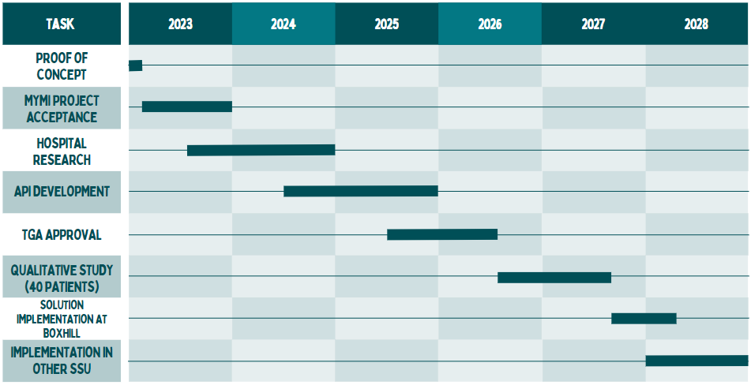

Currently, the project is still progressing under the proof of concept stages. Research is being conducted on how the solution will be envisioned. Further prototyping details are listed below.

Prototyping progress:

Week 10 Prototyping summary:
- Researched methods existing to obtain live data from a database
  - Web scraping
  - APIs
- Found out what platform current EMR data is stored on
  - EMR is on Cerner Millennium and uses an Oracle database.
  - ICT and Decision Support have access to an ODAC connection but the access is very tightly controlled.
  - For other purposes, a web service to fetch specific data via HTTPS has been developed.
  - ICT used Rhapsody integration engine to fetch the data, transform and pass it on to a receiving system outside of Eastern Health.
  - The response to the web service call can be JSON or XML.

This information has been obtained from the Director of EMR Medical Informatics. Currently, a lot of the above data retained is jargon and will be broken down deeper hopefully with the help of Jasbir, or even further communication with Eastern Health insiders.

Regulation:

This digitally synced whiteboard will be implemented in the Australian market (at least initially), hence would undergo regulation procedures of the TGA. This solution is considered a medical device as it helps to manage and monitor a patient's status during their stay in the emergency department.

This solution is software based and simply replicates data from the EMR platform to represent it in a user-friendly and comprehensive manner. According to the TGA classifications, this device is classified as a Class IIb device, as it is:
- A software that is used to “monitor the state or progression of a disease, condition or parameter” that may indicate that patients are in immediate danger, which may pose risks to public health
- Considered moderate-high risk

Hence to regulate this device, a conformity assessment certification for the manufacturer would be necessary before it is included in the Australian Register of Therapeutic Goods (ARTG).

Risk and Hazard Analysis:

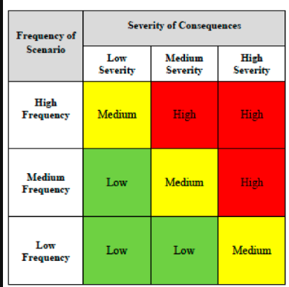
Risk | Classification | Mitigation
Patient misinterpretation of information | Medium (Medium Frequency and High Severity) -  If patients forget the doctor’s verbal notes, and rely solely on this digitised EMR information, they may interpret subjective information in the wrong manner | Doctors must provide verbal explanation of all the details included in the digitised EMR form. Additionally the information included should be clear and concise, but shouldn’t lack important details.
Security issues of ‘making copy’ of EMR data | High (Medium Frequency, High Severity) -  If the solution used to sync/extract this data is not protected/safe, then there is potential that a third party can gain access to classified patient data. | The solution should be able to control security directly and mitigate potential for this to happen. Further research needs to be done.

User Interview/testing:

During early stages, Sahil conducted some user interviews, two primary questions were asked:
- Is a solution necessary?
- If so, what method of demonstrating this information would be most appropriate?
The solution was found to be necessary, given that some patients did express concerns about the lack of awareness of relevant medical information surrounding their stay in the hospital. However, this was equally met with some patients who were not bothered by this problem - perhaps because they were near the end of their patient journey.
The most appropriate method of presenting the information to patients was found to be via the mobile phone - a large digital display may have caused privacy issues. Furthermore, the convenience of having a mobile phone makes this method of information delivery most suitable.

