
MONASH HEALTHCARE INNOVATION SUMMER SCHOLARSHIPS (HISS)
PROJECT NAME: Calculus
DELIVERABLES NUMBER: 9 (Week 10)
PROJECT MEMBER(S): Nandini Pandya & Mohairees Sri Idzhan
Gantt chart:

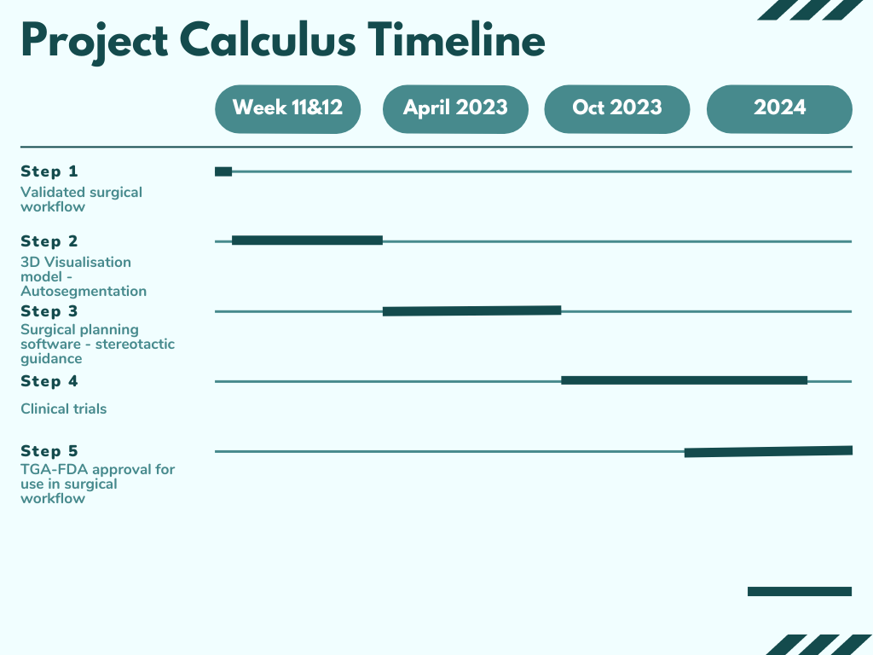

Regulation:

Stereotactic surgical guidance and 3D visualisation software is a part of our proposed surgical workflow.

For stereotactic surgical guidance:

TGA - Australia & CE mark for EU:
- Will be Class 1 - as a similar device (7D cranial image guidance system ARTG ID - 315227)is on market. [TGA] Will need ARTG registration for the guidance system relating to Kidney/abdomen surgeries.
- Medicare codes:
- Existing medical devices code: 36543
- other comparable codes: 36604, 36607, 36624, 36649, 36650

FDA for U.S:
- Classified under diagnostic device - Class 2 [FDA]
- under radiology devices/ diagnostic devices

For 3D visualisation software:
TGA - Australia & CE Mark for EU:
- Will be Class IIa (non-invasive devices for short-term use), will need ARTG registration.

FDA for U.S:
- Classified under diagnostic device/radiology device as it is using CT scans
- Class II

Risk and Hazard Analysis:

Risk | Severity | Frequency | Plan to solve/address vulnerabilities
Inaccurate segmentation of kidney/kidney stones |  |  | Train model until a sufficiently high level of accuracy and reliability is reached
Mislabelling of features |  |  | Training set data has to be comprised of scans with features that have been accurately labelled by clinicians

User Interview/testing:

No user testing conducted apart from running the workflow and further design plans with the clinician who is the intended user.

Prototyping progress:
- Finalised on approach to solution, which is to use image recognition/machine learning to identify kidney and kidney stones from CT scans
- Assess the specificity of Nvidia AI-assisted annotation for 3D slicer is a medical image visualisation and analysis software which has a “fully automated segmentation” mode feature and its relevance to our project [GITHUB]
  - This feature has pre-trained models and the computer running 3D slicer does not need to have any special requirements apart from fast network upload speed.

